**Zach Drone**

Justin Armenta

Elias Duque

Jonah Morris

Grayson Vansickle

**Final Report**

REVISION – 1.0

5 December 2018

# **Table of Contents**

**Concept of Operations 2**

**Functional System Requirements 1****6**

**Interface Control Document** **30**

**Execution Plan 4****2**

**Validation Plan 4****3**

**Tour Group Tracker Subsystem Report 4****4**

**Mobile Application Subsystem Report 55**

**Navigation Subsystem Report** **90**

**Drone Subsystem Report** **102**

**Zach Drone**

Elias Duque

Grayson Vansickle

Justin Armenta

Jonah Morris

###### **Concept of Operations**

REVISION – 1.0

5 December 2018

Concept of Operations

for

Zach Drone

Prepared by:

Team <17>

Approved by:

_____________________________

Project Leader Date

_____________________________

Prof. S. Kalafatis Date

_____________________________

T/A Date

# 

# ***Change Record***

|  |  |  |  |  |
| --- | --- | --- | --- | --- |
| **Rev.** | **Date** | **Originator** | **Approvals** | **Description** |
| **0.0** | 9/6/18 | Grayson Vansickle |  | Draft Release |
| **0.2** | 9/21/18 | Justin Armenta |  | Added Introduction and Scenario(s) sections |
| **0.4** | 9/24/18 | Jonah Morris |  | Added Executive Summary and Operating Concept sections |
| **0.6** | 9/24/18 | Elias Duque |  | Added Impacts section |
| **0.8** | 9/26/18 | Grayson Vansickle |  | Added Analysis section |
| **1.0** | 10/3/18 | Grayson Vansickle |  | Edited and Formatted |
| **1.2** | 12/5/18 | Grayson Vansickle |  | Updated information |

# **Table of Contents**

**Table of Contents 5**

**List of Tables 6**

**List of Figures 7**

**1. Executive Summary 8**

**2. Introduction 8**

2.1. Background 8

2.2. Overview 8

2.3. Referenced Documents and Standards 10

**3. Operating Concept 10**

3.1. Scope 10

3.2. Operational Description and Constraints 10

3.3. System Description 10

3.4. Modes of Operations 11

3.5. Users 11

3.6. Support 12

**4. Scenario(s) 12**

4.1. Small Personalized Groups 12

4.2. Large School Groups 12

**5. Analysis 12**

5.1. Summary of Proposed Improvements 12

5.2. Disadvantages and Limitations 12

5.3. Alternatives 13

**6. Impact(s) 13**

6.1. Economic & Time Impacts 13

6.2. Social & Business Impacts 13

6.3. Safety Impacts 13

**7. Citations 14**

# **List of Tables**

No tables at this time.

# **List of Figures**

**Figure 1 - Drone Logic Overview 10**

**Figure 2 - Overall System Diagram 11**

# 

# **1. Executive Summary**

Navigating a new building as large as Zachry by yourself can be difficult. Traditional tours with a tour guide do not always work around an individual's schedule. With the Zach Drone, tourists can take a tour anytime to anywhere inside of Zachry. Using a phone application, tourists will be able to tell the drone to take them to one of three different pre-programmed automated tours. While on the tour the drone will narrate important information about the building such as where it is going next and details of different art pieces in the building. After twenty minutes of use, the drone will return to the tour starting point where it can be recharged for the next set of tourists.

# **2. Introduction**

Zachry is the newest and most innovative of the Texas A&M engineering buildings. As the flagship of all the engineering buildings it is presented as a mixture of technology, innovation, and convenience. Since the building exemplifies these values, the tours given in the facility should convey these same values. This bold and innovative style is what inspired us to make a drone tour inside of the Zachry building. Guests will not have to wait for scheduled tours by people, but instead can ask for a quick and easy drone tour where the drone will tell customers key information about the building while also guiding its prospective tourists around the complex.

## ***2.1. Background***

Currently, tours are given by tour guides provided by the Texas A&M Engineering department’s communication team. It usually takes around 30 minutes for these employees to give a tour, and they have to give these tours at least twice a day. These are hours wasted every day for them where they are giving tours instead of doing other helpful jobs for the department. It also can be an inconsistent tour if the tour guide forgets about any of the key locations or information about the building. Also, the tour times would not be flexible since a human has to run on a scheduled time to give the tour every day with no room for flexibility. A drone tour of Zachry would solve these problems by offering a more customizable and innovative experience. The drone would free up employees to do other more important jobs that the department is working on. It would also allow tourists to choose the destinations they would like to see and have all the information about that destination told to them by the drone. Lastly, it would allow customers to choose a more convenient time for them to get their tour instead of being told by Texas A&M when they can come see the tour.

## ***2.2. Overview***

The drone will consist of a custom built drone made by a previous engineering team, Raspberry Pi 3 B microcontroller, a speaker, six ultrasonic sensors, and a camera. The Raspberry Pi will be used to process information received by the ultrasonic sensors and the WiFi connection from the tourist’s device. The microcontroller will connect to the camera to make sure the tourist’s stay close while also guiding the tourist towards the next destination in the tour. The ultrasonic sensors will monitor how close the drone gets to obstacles while the microcontroller will give commands to the drone to either stop or change its course of direction if an obstacle gets too close. A speaker will be used to give information to the customer about different destination points while also explaining where the drone is going next.

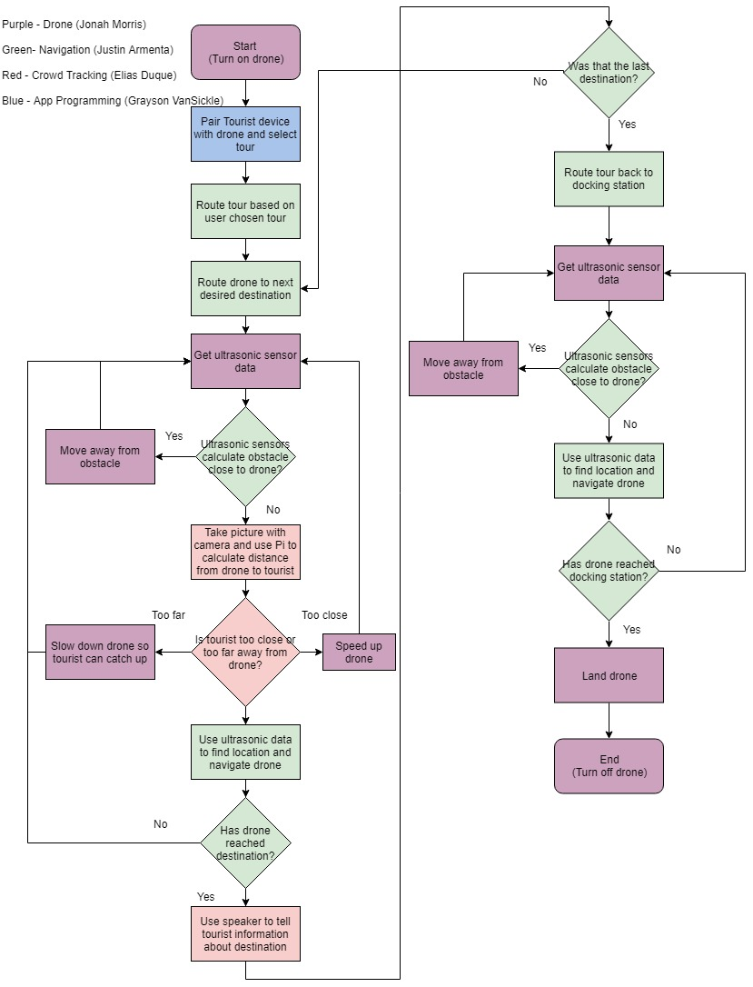

Figure 1: Drone Logic Overview

Figure 1 shown above displays the logic that the drone will follow throughout the process from the beginning of the tour to the end. Every function block is color coded based on who will be in charge of that particular function. As shown above Jonah (Purple) will be in charge of the placement and function of the components on the drone, Grayson (Blue) will be in charge of creating an app for the WiFi connection between the drone and the tourist, Elias (Red) will be in charge of making sure the drone stays within a certain distance of the tourists, and Justin (Green) will be in charge of making sure the drone knows how to get from one destination to the next.

## ***2.3. Referenced Documents and Standards***

<https://federaldroneregistration.com/?gclid=EAIaIQobChMIq9mDtIjN3QIVlIlpCh0-KAneEAAYASAAEgLrHPD_BwE>

<https://federaldroneregistration.com/know-before-you-fly>

<http://knowbeforeyoufly.org/>

<https://www.scienceabc.com/innovation/what-is-the-range-of-bluetooth-and-how-can-it-be-extended.html>

<https://zachry.tamu.edu/tours/>

<https://zachry.tamu.edu/>

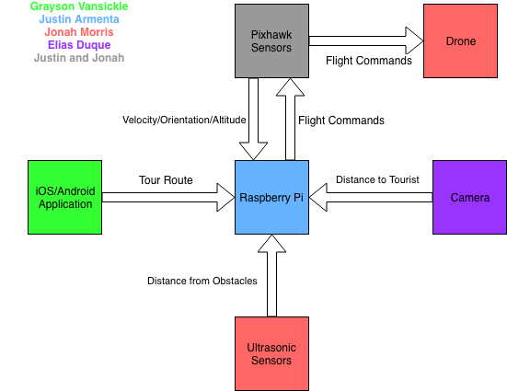Figure 2: Overall System Diagram

# **3. Operating Concept**

## ***3.1. Scope***

The Zach Drone is intended to fly inside Zachry where the drone will use ultrasonic sensors on the drone to navigate. The drone assumes that the tourists will not try to hit the drone or alter it’s path while it is flying. It will be controlled using a microcontroller that can be connected to phones through WiFi using an app interface.

## ***3.2. Operational Description and Constraints***

The Zach Drone will be used by small or large groups to tour Zachry. The drone will start from the Anadarko Welcome Center where the tourists will connect to the drone with their phone through the phone app. The user will then pick what type of tour they would like to take. The drone will use the ultrasonic sensors on the drone and compare those values to the known dimensions of the building to navigate through the tour while using a speaker to playback important information about the building. A microcontroller will monitor sensors, use the camera, communicate with the flight controller and take input from the phone application.

The constraints for the Zach Drone are as follows:

* The drone must start and end at the Anadarko Welcome Center to charge.
* Tourist must have a smart-phone with the app downloaded.
* The drone must not be intentionally hit by the user or others in the building.
* The tour can only last up to twenty minutes before needing to recharge the drone.
* The speed of the drone cannot exceed that of walking speeds.
* Zach Drone will not be functional in an overcrowded building because camera may not be able to detect the group leader
* The drone must be given two hours in between tours to recharge the battery.
* Must take open stairs to travel between floors and cannot pass through doorways.

## ***3.3. System Description***

The Zach Drone is made up of four main subsystems detailed below:

**Tourist Tracking & Speaker System**: This system is used to track the tourists to make sure that they do not fall too far behind while taking the tour and to give the commentary about the various points of interest in Zachry. The system will consist of a camera[M1] to analyze and track a crowd leader to gauge the distance between the crowd and the drone. Additionally this system includes a speaker to give the commentary. The tracking system will communicate with the microcontroller to determine if the drone should slow down to allow the tourists to catch up or speed up if they get too close.

**Drone & Sensors**: This subsystem consists of the drone itself and the sensors mounted on it. Sensors will be used to avoid collisions with people and objects inside Zachry. It will accomplish this by having the microcontroller telling the flight controller to move in the opposite direction of whichever ultrasonic sensor is outputting a close reading. This system tells the microcontroller how close the drone is to objects on all six sides of the drone. The microcontroller will determine if the drone will need to change paths and then communicate with the flight controller on the drone to tell it which direction to fly.

**Zach Drone App**: The drone will use a phone application to communicate with the tourists. This subsystem includes the user interface as well as the ability to talk to the microcontroller through a WiFi connection. The app will contain a connect-to-drone feature as well as options for what type of tour that the user wants to take. These options include an art tour, a classroom tour, and a standard tour. The user will also be able to stop or pause the tour from the app.

**Tour Navigation**: The Zach Drone will use ultrasonic sensors and the dimensions of the inside of Zachry to determine where the drone is at any given time. This system will receive signals from the ultrasonic sensors and then determine where the drone is within the building and in which direction the drone should fly based on this location.

## ***3.4. Modes of Operations***

There are three modes of operation for the drone. The first mode is the tour mode. During this mode, the drone will fly from destination to destination while guiding the tourist. The second mode of operation is the wait mode. The drone will enter this mode if the users are too far away for too long, the user presses the wait button on the app, or if connection is lost with the phone. In this mode, the drone will hover in air and wait for the condition to start again to be satisfied. The conditions for the drone to exit the wait mode and enter back into tour mode will be: the customer’s device has connection and is in range of the drone after losing connection or that the start button has been clicked again to resume the tour after a user-initiated pause. The drone will only wait until the maximum length of the tour is reached. Once the maximum tour length of twenty minutes is reached, the drone has successfully completed the tour, or the user cancels the tour the drone will it enter the third mode of operation which is the return to start mode. In this mode the drone will navigate itself back to the Anadarko Welcome Center where it will be picked up to charge.

## ***3.5. Users***

The Zach Drone can be used by anyone who would like to take a tour of the new Zachry building without having to follow the tour schedule. The drone provides more flexibility to those who are taking a short visit to the Texas A&M campus. Anyone with a smartphone will be able to download the app and take a tour.

## ***3.6. Support***

Commonly asked questions will be listed in the app.

# **4. Scenario(s)**

## ***4.1. Small Personalized Groups***

For tours with a small group of guests, the Zach Drone tour would be an ideal option. This would allow tourists to choose a personalized tour that meets their needs, whether it be looking at and listening about all the different art installations around Zachry or seeing what different learning and advising opportunities are available around the building. The drone will be able to easily guide small groups by having them follow behind the drone at whatever pace they would like since the drone will wait on you.

## ***4.2. Large School Groups***

For large groups such as a school field trip the Zach Drone would be a great option. Since all large groups on school field trips or general tours of Texas A&M will have group leaders such as teachers or actual guides it will be very easy to control the pace of the group by making the drone follow the leader. That way the leader of the group can control at what pace the drone gives the tour. This will also add a bonus incentive for people to stay with the group because of the interest that the drone tour will bring. Instead of having a boring tour guide that many people will ignore, the drone could be as big of an attention getter as the building itself. In addition to two other preset tours, the drone will have standardized tours for school field trips or prospective student groups.

# **5. Analysis**

## ***5.1. Summary of Proposed Improvements***

The use of the Zach Drone will allow tourists to have a more immersive experience while visiting the new Zachry Engineering Education Complex. The Zach Drone will give tourists the opportunity to custom fit a tour to whatever they preference using the Zach Drone App’s multiple tour feature. Using the Zach Drone will allow tourists to tour Zachry whenever they feel instead of having to wait for a tour guide. The Zach Drone will show the tourists some of the innovative ways Texas A&M University is utilizing the new building.

## ***5.2. Disadvantages and Limitations***

The Zach Drone will be limited to the time of the tours since it will be running on a battery. The tour given by the Zach Drone will only be able to be a maximum of twenty minutes since that is the longest the battery can run before needing to be charged. The Zach Drone App is the main interface to communicate with the Zach Drone, and without a smartphone the tourists won’t be able to select a tour.

## ***5.3. Alternatives***

* Camera vs. Bluetooth for crowd tracking
  + Using Bluetooth would be more unreliable due to the nature of Bluetooth connections.
  + Using Bluetooth signals would also lead to greater inaccuracies when calculating the distance between the drone and the tourists
  + Using Bluetooth signals would take less processing power than image processing.
* Ultrasonics vs ARUBA beacons for navigation
  + ARUBA signals would produce fuzzy data when used that is only up to 3m of accuracy which would cause the location of the drone to be incorrect.
  + Ultrasonics would only have a small degree of inaccuracy but could be difficult to use if the drone gets lost.
  + The ultrasonics would need the dimensions of all locations near the tour route to be used.

# **6. Impact(s)**

## ***6.1. Economic & Time Impacts***

Electricity is the only upkeep cost the drone will have; more specifically the cost of the amount of electricity it takes to recharge the drone battery. Charging a battery for an hour or two has a negligible cost.

Currently though the true cost of the Zachry tours is time. Tour givers are departmental members that volunteer to have time taken out of their day to give these tours. A drone tour would return that time back to them; allowing them to be put to better use. In other settings this can save a company the cost of an entire position.

## ***6.2. Social & Business Impacts***

In the case of the Zachry building the Zach Drone will act as an engineering feat to entice potential students. Its secondary purpose is to “wow” students & show them what engineering is capable of. For other business settings it will allow companies to give tours where they otherwise could not spare time or money to have someone else do it. It could even be used in an accessibility sense if we were to switch the speaker out for a screen or set of LEDs, the drone could be used to direct deaf people. Applicable settings could be museums, airports, & many others.

## ***6.3. Safety Impacts***

The propellers on a drone can spin at thousands of RPM & can pose a hazard. The drone will be set to fly as high as it can leaving enough room to not hinder its performance. Sensors will detect people & the drone will attempt to maneuver away should someone attempt to touch it by flying in the opposite direction of whichever ultrasonic had a reading that was too close in proximity.

# **7. Citations**

<https://federaldroneregistration.com/?gclid=EAIaIQobChMIq9mDtIjN3QIVlIlpCh0-KAneEAAYASAAEgLrHPD_BwE>

<https://federaldroneregistration.com/know-before-you-fly>

<http://knowbeforeyoufly.org/>

<https://www.scienceabc.com/innovation/what-is-the-range-of-bluetooth-and-how-can-it-be-extended.html>

<https://zachry.tamu.edu/tours/>

<https://zachry.tamu.edu/>

**Zach Drone**

Justin Armenta

Elias Duque

Jonah Morris

Grayson Vansickle

## **Functional System Requirements**

REVISION – 1.2

5 December 2018

Functional System Requirements

for

Zach Drone

Prepared by:

Team <17>

_____________________________

Author Date

Approved by:

_____________________________

Project Leader Date

_____________________________

Prof. S. Kalafatis Date

_____________________________

T/A Date

# ***Change Record***

|  |  |  |  |  |
| --- | --- | --- | --- | --- |
| **Rev.** | **Date** | **Originator** | **Approvals** | **Description** |
| **0.0** | 9/6/18 | Grayson Vansickle |  | Draft Release |
| **0.2** | 9/24/18 | Elias Duque |  | Added Introduction section |
| **0.4** | 10/1/18 | Grayson Vansickle |  | Added Applicable and Reference Documents section |
| **0.6** | 10/1/18 | Jonah Morris |  | Added System Definition subsection of Requirements section |
| **0.8** | 10/1/18 | Justin Armenta |  | Added Characteristics subsection of Requirements section |
| **1.0** | 10/3/18 | Grayson Vansickle |  | Edited and Formatted |
| **1.2** | 12/5/18 | Grayson Vansickle |  | Updated information |

# **Table of Contents**

**Table of Contents 18**

**List of Tables 19**

**List of Figures 20**

**1.** **Introduction 21**

1.1. Purpose and Scope 21

1.2. Responsibility and Change Authority 22

**2.** **Applicable and Reference Documents 22**

2.1. Applicable Documents 22

2.2. Reference Documents 22

2.3. Order of Precedence 23

**3.** **Requirements 23**

3.1. System Definition 23

3.2. Characteristics 24

3.2.1. Functional / Performance Requirements 24

3.2.2. Physical Characteristics 25

3.2.3. Electrical Characteristics 25

3.2.4. Communication Requirements 26

3.2.5. Environmental Requirements 26

3.2.6. Failure Propagation 27

**4.** **Support Requirements 27**

**Appendix A Acronyms and Abbreviations 28**

**Appendix B Definition of Terms 28**

# **List of Tables**

**Table 1 - Subsystem Responsibilities 22**

**Table 2 - Applicable Documents 22**

**Table 3 - Reference Documents 22**

# 

# **List of Figures**

**Figure 1 - In-Progress Image of Drone** **21**

[**Figure 2 -**](https://docs.google.com/document/d/1n09ldFWvXHJj68yTvu9yIJ_1ArYjvpiGjgB7cyc4aiA/edit#heading=h.44sinio) **Drone Subsystems & Responsibilities** [**Block Diagram**](https://docs.google.com/document/d/1n09ldFWvXHJj68yTvu9yIJ_1ArYjvpiGjgB7cyc4aiA/edit#heading=h.44sinio) **23**

# 

# **Introduction**

## ***Purpose and Scope***

The purpose of the Zach Drone is to give guided tours to a crowd of people that have signed up for a viewing of the new Zachry Engineering building. It shall communicate with an app that will sync up with the phones of the tourists so that it shall keep track of them. The drone must maneuver the hallways of Zachry and must give a spoken tour. It should give information on where labs and classrooms are, as well as draw the crowd’s attention to the installed art pieces. The drone shall detect via a camera that will track the crowd leader’s location. When the tour is over the drone must return to the Anadarko Welcome Center so that it shall recharge before the next tour.

The drone must be able to fly using its own power for at least 15 minutes to give a fully-fledged tour. It must have a speaker to give commentary on the surroundings and shall provide relevant information. The ultrasonic sensors on the drone shall be used along with known dimensions of the building to find the drone’s location and plot its course. The drone shall have ultrasonic sensors to prevent collisions with ceiling fixtures, walls, and pedestrians.

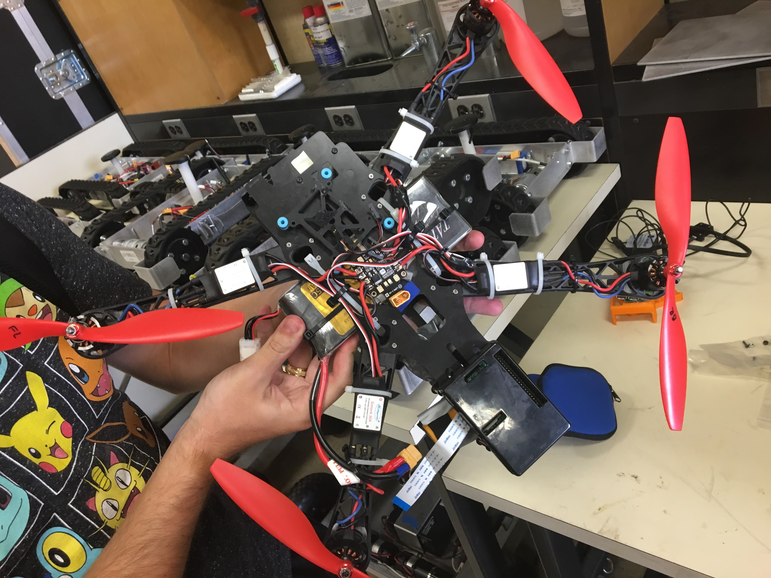

Figure 1 - In-progress Image of Drone

## ***Responsibility and Change Authority***

Jonah Morris is the team leader & shall be responsible for the oversight of the subsystems & ensuring that requirements are met according to the validation plan. Any changes to be made to the deliverable requirements must be approved by both Jonah Morris & Stavros Kalafatis.

|  |  |
| --- | --- |
| **Subsystem** | **Responsibility** |
| Drone & Assembly | Jonah Morris |
| Navigation | Justin Armenta |
| Crowd Tracking | Elias Duque |
| Mobile Application | Grayson Vansickle |

Table 1 - Subsystem Responsibility

# **Applicable and Reference Documents**

## ***Applicable Documents***

The following documents, of the exact issue and revision shown, form a part of this specification to the extent specified herein:

|  |  |  |
| --- | --- | --- |
| **Document Number** | **Revision/Release Date** | **Document Title** |
| NFPA 70 | 2014 | National Electrical Code |
| IEEE 802.15.4 | 2013 | Standard for Low Rate WPAN |
| FAA Part 107 | 2018 | Small Unmanned Aircraft Regulations |

Table 2 - Applicable Documents

## ***Reference Documents***

The following documents are reference documents utilized in the development of this specification. These documents do not form a part of this specification, and are not controlled by their reference herein.

|  |  |
| --- | --- |
| **Document Title** | **Publisher** |
| Raspberry Pi 3 B Data Sheet | Raspberry Pi |
| Pixhawk 2.1 Flight Controller Data Sheet | Pixhawk |
| Ultrasonic Rangefinder HRLV-EZ0 Data Sheet | Maxbotix |
| Python Standard Library Reference | Python |
| Swift Language Reference | Apple |
| Java SE Technical Documentation | Oracle |

Table 3 - Reference Documents

## ***Order of Precedence***

In the event of a conflict between the text of this specification and an applicable document cited herein, the text of this specification takes precedence without any exceptions.

All specifications, standards, exhibits, drawings or other documents that are invoked as “applicable” in this specification are incorporated as cited. All documents that are referred to within an applicable document are considered to be for guidance and information only, with the exception of ICDs that have their applicable documents considered to be incorporated as cited.

# **Requirements**

The drone will give guided tours to tourists who have set up a tour of Zachry. The drone must be able to connect with the tourist’s phone using a WiFi connection from an app, so that the user can set up locations they want to visit for the tour. The drone must be able to navigate through Zachry from one checkpoint to the next without colliding with objects.

This section defines the minimum requirements that the development item(s) must meet. The requirements and constraints that apply to performance, design, interoperability, reliability, etc., of the system are covered.

## ***System Definition***

The Zach Drone is an automated tour delivery system. Users connect to the drone using WiFi through a mobile app interface. They are given a lists of tours to choose from. Once the tour group has selected a tour, the drone will fly the route while using a speaker to playback important information about the building. For this project there are four major subsystems: mobile app, navigation, tour group tracking and the drone.

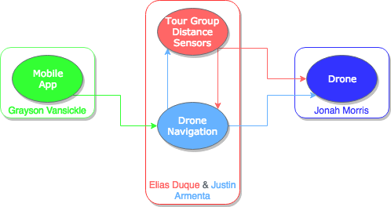

Figure 2 - Drone Subsystems & Responsibilities Block Diagram

The mobile application is the primary interface with the user. Once the user picks a tour to take, the mobile app will communicate with the navigation system and tell it where to go. The navigation system will use ultrasonic sensors on the drone to determine where it is, if there are obstacles, and what direction the drone should go next. The navigation system will then tell the drone’s flight controller which direction to fly in. The drone will fly towards the waypoint while the group tracking system controls the speed of the drone based on the distance from the group.

## ***Characteristics***

### **Functional / Performance Requirements**

#### **Smartphone Application**

An application shall be created on both Android and Apple platforms where the tourist can use their smartphone to access the app, and use it to select a tour route and when they would like a tour. The drone shall also have a speaker to tell the tourists information about Zachry. The app will continuously communicate with the drone allowing the user to change route or cancel.

#### **Drone Functionality**

The drone shall be able to fly for the full length of a 15 minute tour, while being able to avoid a collision with anything that comes near the drone. It will also be able to take off and land at the designated location inside of the Anadarko Welcome Center. The maximum time requirement of the tour is necessary since tours need to cover as much of the building as possible while also taking into account that our battery life is about 20 minutes. There also must be a designated take-off and landing location so people know where to go for the tour and a storage spot for the drone.

#### **Navigation of Checkpoints**

The drone shall be able to navigate, in an efficient manner, from any of the tour destinations to another successfully using the ultrasonic sensors on the drone as a guidance system. Without this capability the drone wouldn’t be able to lead a tour group to all the spots that the group would like to see.

#### **Crowd Guiding**

The drone shall stay within about 15 feet of the crowd using a camera to keep track of a crowd leader and their distance. 15 feet is recommended such that the connection between the leader’s mobile device and drone does not terminate which allows the tourists to pause or cancel at any moment and avoids forcing them to reconnect. If the crowd becomes closer than 8 feet the drone will speed up. If the crowd exceeds 25 feet away then the drone will slow down. If the drone is told to slow down twice consecutively then the drone will stop momentarily.

### **Physical Characteristics**

#### **Mass**

The maximum total mass of the drone shall be less than 3.06 kg. The maximum combined thrust for four motors produces a total of 4.6 kg. To efficiently take off the motors must be able to produce thrust equal to 150% of the weight of the drone which here is 4.6 kg. 4.6 kg is 150% of 3.06 kg making it the maximum weight we should target.

*Rationale: This is the maximum weight that can be carried by the drone such that it will fly at 75% throttle. 75% throttle simply means the motor can run at a higher thrust thanks to the stable conditions inside the building.*

#### **Volume Envelope**

The volume envelope of the Zach Drone shall be less than or equal to 150 mm in height, 525.4 mm in width, & 525.4 mm in length.

*Rationale: This is the smallest size that can house all components safely. Drone size affects weight so a smaller drone makes meeting out weight requirement easier.*

### **Electrical Characteristics**

#### **Inputs**

No combination of settings input by the user shall damage the Zach Drone, cause any

malfunction within the system, nor reduce performance.

*Rationale: The chance of user errors should be minimized by the design of the system.*

##### **Power Consumption**

The maximum peak power for the system shall not exceed 1050 watts.

*Rationale: The maximum power the drone motors can take is 259 watts per motor. The rest of the system requires less than 10 watts to power.*

##### **Voltage Level**

The output voltage of the battery will be between 14.8 and 16.5 VDC. The minimum input voltage levels for the sensors, motors, microcontroller and pixhawk flight controller are 2.8 VDC, 4.5 VDC, 4.75 VDC and 4 VDC respectively.

*Rationale: The nominal voltage levels for the sensors, motors, microcontroller and Pixhawk are 3.3 VDC, 5 VDC, 5 VDC and 5 VDC respectively.*

##### **External Commands**

The Zach Drone shall document all external commands in the appropriate ICD.

*Rationale: The ICD will capture all interface details from the low level electrical to the high level packet format.*

##### **Data Output**

The Zach Drone shall include a speaker for playback to the tourist.

*Rationale: This requirement was set by the customer.*

##### **Diagnostic Output**

The Zach Drone shall include a mobile application interface for control and data logging.

*Rationale: Provides the ability to manually control things for debugging.*

#### **Wiring**

The Zach Drone shall follow the connector guidelines set forth in the National Electric Code. Article NEC 300 details general guidelines for wiring methods and materials.

*Rationale: Conform to general wiring standards.*

### **Communication Requirements**

* + - 1. **Phone App to Microcontroller Connection**

The tourist’s phone shall use the app to tell the drone which tour to take, so the drone can navigate to all checkpoints one at a time. The app will also have an option to “Cancel Tour” during the tour if the user becomes uninterested in the tour or has other obligations and has to leave. There will also be a “Pause” option, in case the user wants to look at something for a while or go to the bathroom, where the drone will hover idly until the user clicks the “Resume Tour” option or enough time has passed that the drone will automatically cancel the tour.

* + - 1. **Microcontroller to Audio Connection**

The microcontroller will use a USB 2.0 connection to send an audio signal to the speaker on the drone to tell the tourists information about destinations on the tour.

* + - 1. **Microcontroller to Flight Controller Connection**

The microcontroller will use a serial connection to connect with the flight controller to command the flight controller where to navigate to, how fast, when to avoid an obstacle, and other important flight commands.

* + - 1. **Ultrasonic Sensors to Microcontroller Connection**

The ultrasonic sensors will be connected to one of the GPIO ports on the Raspberry Pi. These sensors will be used to navigate around Zachry as well as detect if the drone is close to colliding with something as well as for navigation.

### **Environmental Requirements**

The Zach Drone shall be designed to withstand and operate inside of the Zachry Engineering Education Complex.

*Rationale: This is a requirement specified by our customer because this is where tours will be held.*

#### **Thermal Requirement**

The Raspberry Pi 3 B on the Zach Drone will not exceed 70℃.

*Rationale: The Raspberry Pi 3 B is rated for temperatures of 0℃ - 70℃ by the manufacturer.*

### **Failure Propagation**

The Zach Drone shall account for connection failures as well as objects getting near the drone. The drone will have a manual override to land if the user observes a malfunction.

#### **Camera Tracking**

##### **Camera Failure**

If the camera used to track the crowd should malfunction to where the image can no longer be processed then the camera will shut off and the crowd detection functionality will be disabled. The crowd will be alerted that there has been a malfunction but will continue.

##### **Image Processing Failure**

If the image processing detection and tracking should fail such that the leader can no longer be tracked then the drone will attempt to re-initialize the crowd leader. Should this attempt fail then the drone will report that crowd tracking has been disabled and will continue on the tour.

#### **Object Proximity Detection**

##### **Ultrasonic Proximity Detection**

If an object gets too close to the drone, the ultrasonic sensors, which will be placed on each side of the drone, will be used to detect how close the object is to the drone. The microcontroller will then tell the drone to move away from the object by going in the opposite direction of the ultrasonic that was triggered.

#### **Navigation**

##### **Sensor Reading Errors**

If there is a small one time failure of an ultrasonic sonic, the error will most likely be ignored and not taken into account due to how the algorithm for navigating the drone works, which expects that the sensors won’t be perfect and may produce a false, one time, value. However if a sensor continuously is reading an incorrect value for multiple iterations, the drone will perform an emergency landing where it will announce that there has been a fatal error and the drone needs to land.

# **Support Requirements**

The Zach Drone requires that the battery be charged for two hours in between uses. The Zach Drone also requires the user to have a smartphone with the Zach Drone app downloaded.

# **Appendix A Acronyms and Abbreviations**

Zach Zachry Engineering Education Complex

USB Universal Serial Bus

℃ Degrees Celsius

GPIO General Purpose Input Output

APP Application

NEC National Electric Code

VDC Volts Direct Current

KG Kilogram

% Percentage

# **Appendix B Definition of Terms**

Flight Controller: A microcontroller that includes gps, compass and gyroscope that controls the motors to fly the drone.

Ultrasonic Sensor: A distance sensor that uses ultrasonic sound waves to determine distance to the nearest object.

**Zach Drone**

Justin Armenta

Elias Duque

Jonah Morris

Grayson Vansickle

###### **Interface Control Document**

REVISION – 1.2

5 December 2018

Interface Control Document

for

Zach Drone

Prepared by:

Team <17>

_____________________________

Author Date

Approved by:

_____________________________

Project Leader Date

_____________________________

Prof. Stavros Kalafatis Date

_____________________________

T/A Date

# ***Change Record***

|  |  |  |  |  |
| --- | --- | --- | --- | --- |
| **Rev.** | **Date** | **Originator** | **Approvals** | **Description** |
| **0.0** | 9/6/18 | Grayson Vansickle |  | Draft Release |
| **0.2** | 9/23/18 | Justin Armenta |  | Added Overview section |
| **0.4** | 10/1/18 | Grayson Vansickle |  | Added Communications Protocol section |
| **0.6** | 10/1/18 | Elias Duque |  | Added Physical Interface section |
| **0.8** | 10/3/18 | Jonah Morris |  | Added Electrical Interface section |
| **1.0** | 10/4/18 | Grayson Vansickle |  | Edited and Formatted |
| **1.2** | 12/5/18 | Grayson Vansickle |  | Updated information |

# **Table of Contents**

**Table of Contents 32**

**List of Tables 33**

**List of Figures 34**

**1.** **Overview 35**

**2.** **References and Definitions 35**

2.1. References 35

2.2. Definitions 35

**3.** **Physical Interface 36**

3.1. Weight 36

3.2. Dimensions 36

3.3. Mounting Locations 37

**4.** **Electrical Interface 37**

4.1. Primary Input Power 38

4.2. Voltage and Current Levels 38

4.3. Signal Interfaces 38

4.4. User Control Interface 38

**5.** **Communications / Device Interface Protocols 39**

5.1. Audio Interface 39

5.2. Device Peripheral Interface 39

**6. References 40**

# **List of Tables**

**Table 1 - References 35**

**Table 2 - Physical Weight 36**

**Table 3 - Physical Dimensions 36**

**Table 4 - Electrical Voltage, Current, & Power 38**

# **List of Figures**

# **Figure 1 - Electrical Interface diagram 37**

# 

# **Overview**

This document will cover the systems designed and used in the Zach Drone tour system. The drone that will be used to give tours of Zachry will be described on a functionally detailed level. The interface between the flight controller on the drone, the microprocessor, and all devices used to determine location will be described in terms of how they will function separately as well as how they will communicate with each other. The way the proximity sensors will interact with the microprocessor and flight controller will be addressed as well. The physical aspects of the drone such as its weight, dimensions, size, component location, and component size will also be described. Electrical aspects will be explained as well. This will include details such as power inputs and outputs for components, voltage, current and power levels at different points in the system, and signal interfaces for components. Lastly, the methods in which the user will interact with the drone will be explained.

# **References and Definitions**

## ***References***

|  |  |  |
| --- | --- | --- |
| **Document Title** | **Revision/Release Date** | **Publisher** |
| National Electrical Code | 2014 | NECA |
| Raspberry Pi 3 B Data Sheet | 2018 | Raspberry Pi |
| Pixhawk 2.1 Data Sheet | 2016 | Pixhawk |
| HRLV-EZO Data Sheet | 2015 | Maxbotix |
| SimonK 30A ESC Data Sheet | Revision 1.0 | Lynxmotion |

Table 1 - References

## ***Definitions***

g. Grams

kg. Kilograms

m. Meters

mm. Millimeters

V. Volts

A. Amps

mA. Milliamps

Ah. Amp hour

mAh. Milliampere hour

W. Watt

ESC Electronic Speed Controller

# **Physical Interface**

## ***Weight***

|  |  |  |  |
| --- | --- | --- | --- |
| **Component** | **Weight** | **Amount** | **Total Weight** |
| SunnySky X2212-13 KV980 II | 69 g | 4 | 276 g |
| 1045 Propeller | 7 g | 4 | 28 g |
| SimonK 30A ESC | 27 g | 4 | 108 g |
| Matek PDB-XT60 | 11 g | 1 | 11 g |
| Pixhawk 2.1 Flight Controller | 50.5 g | 1 | 50.5 g |
| Maxbotix Ultrasonic Rangefinders | 4.23 g | 6 | 25.38 g |
| Raspberry Pi 3 B | 49.7 g | 1 | 49.7 g |
| TATTU 4S 8 Ah 25C Li-Po Battery | 785 g | 1 | 785 g |
| Drone Frame | 90 g | 1 | 90 g |

Table 2 - Physical Weight

## ***Dimensions***

|  |  |  |  |
| --- | --- | --- | --- |
| **Component** | **Length** | **Width** | **Height** |
| SunnySky X2212-13 KV980 II | 28 mm | 28 mm | 40 mm |
| 1045 Propeller | 254 mm | 114.3 mm | 6 mm |
| SimonK 30A ESC | 216 mm | 25 mm | 8 mm |
| Matek PDB-XT60 | 50 mm | 36 mm | 24.2 mm |
| Pixhawk 2.1 Flight Controller | 94.5 mm | 44.3 mm | 31.42 mm |
| Maxbotix Ultrasonic Rangefinders | 22.36 mm | 15.52 mm | 20 mm |
| Raspberry Pi 3 B | 87 mm | 58.5 mm | 18 mm |
| TATTU 4S 8 Ah 25C Li-Po Battery | 165 mm | 65 mm | 53 mm |
| Drone Frame | 500 mm | 500 mm | 150 mm |

Table 3 - Physical Dimensions

## ***Mounting Locations***

### **Mounting Location for Control Electronics**

Electronics responsible for the control & flight of the drone include the flight controller & the Raspberry Pi which will manage the navigation. For optimum performance & accuracy the flight controller must be placed in the direct center of the drone’s mass. The Raspberry Pi will be placed behind the flight controller at the tail end of the drone.

### **Mounting Location for Power Electronics**

Electronics responsible for the power input, output, & distribution include the power distributor & the battery itself. The battery will be mounted in the lower half of the middle of the drone’s mass to keep it balanced. The power distributor must be in the middle of the drone below the flight controller to allow for the brushless motor controls to reach evenly.

### **Mounting Location for Motors**

The motors must be placed at the furthest end of the drone arms. Propeller blades are attached to the shafts of the motors. The brushless motor controls will be mounted along the arms themselves stretching from the motors to the power distributor in the middle.

### **Mounting Location for Sensors**

Ultrasonic sensors must be placed on all faces of the drone for maximum precision in collision avoidance. There will be one sensor per side: front, back, left, right, upward & downward.

# **Electrical Interface**

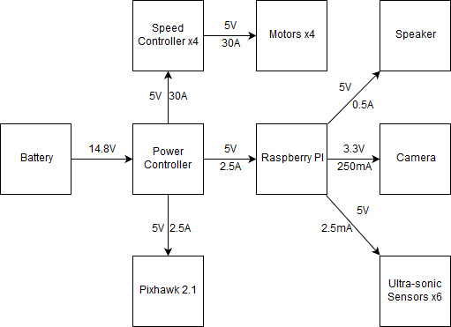

Figure 1: Electrical Interface diagram

## ***Primary Input Power***

The primary input power is the 14.8V 8000mAh battery pack that will be connected to the power distributor.

## ***Voltage and Current Levels***

|  |  |  |  |
| --- | --- | --- | --- |
| Component | Voltage [V] | Current [A] | Power [W] |
| Pixhawk 2.1 | 5 | 2.5 | 12.5 |
| Raspberry Pi | 5 | 2.5 | 12.5 |
| Speed Controller | 5 | 2 | 10 |
| Motor ESC | 0-5 | 0-30 | 150 (max) |
| Speaker | 5 | 0.5 | 2.5 |
| Ultrasonic sensor | 3.3 | .0025 | 0.00825 |

Table 4 - Electrical Voltage, Current, & Power

Detailed in Table 4 above are the wattages consumed by each part of the drone in one hour. Taking the amount of components into account it is not unreasonable to see a total of 215 watt hours. It is unreasonable & unnecessary that our drone will fly for an hour; our target is 20 minutes. In a 20 minute window our drone will therefore use a third of the the total watt hour amount, equaling 71.7 watts. Every component is vital to normal operation of the drone except for the speaker. There is no lower power operation mode of the drone though the speaker only consumes power when in use during tours.

## ***Signal Interfaces***

The signal interfaces included are as follows:

* Serial port connection from Raspberry Pi to pixhawk
* Pixhawk PWM signal outputs to speed controllers
* Raspberry Pi 3.5mm audio jack to speaker
* Ultrasonic sensors to Raspberry Pi GPIO headers

## ***User Control Interface***

The user control interface is a mobile application. The user is given options for tour destinations and the application communicates these choices to the drone’s Raspberry Pi via WiFi connection.

# **Communications / Device Interface Protocols**

## ***Audio Interface***

The drone will have an attached USB 2.0 speaker connected to the 4-pole stereo output port on the Raspberry Pi 3 B. The speaker will be powered by the one of the Pi’s four onboard USB 2.0 ports. This audio interface will be used to give the description of the point of interest the drone is currently located at.

## ***Device Peripheral Interface***

The sensors used by the drone will be attached to the Pi’s extended 40-pin GPIO header. The Pixhawk flight controller will also be connected to the GPIO header. These ports will be used to communicate between the sensors and microcontroller.

## ***WiFi Interface***

The Raspberry Pi 3 B has onboard BCM43438 wireless LAN (WiFi). Using the Pi’s WiFi connection, the Pi will be able to communication with the mobile application. The WiFi connection will comply with the IEEE 802.11 standards for wireless local area networks (WLANs).

# **References**

Ultrasonic Sensors

<https://www.maxbotix.com/documents/LV-MaxSonar-EZ_Datasheet.pdf>

Raspberry Pi

<https://www.raspberrypi.org/documentation/hardware/raspberrypi/README.md>

Pixhawk Flight Controller

<http://www.hex.aero/wp-content/uploads/2016/07/DRS_Pixhawk-2-17th-march-2016.pdf>

SimonK Speed Controller

<http://www.lynxmotion.com/images/document/PDF/Lynxmotion%20-%20SimonK%20ESC%20-%20User%20Guide.pdf>

# **Execution Plan**

|  |  |  |  |  |  |
| --- | --- | --- | --- | --- | --- |
|  | **October 15** | **October 29** | **November 12** | **November 26** | **Dec 3** |
| **Drone Subsystem** | Drone parts put together | Drone flies | Sensors added to drone and coded | Drone avoids collisions | Drone flight tested in Zachry |
| **Navigation Subsystem** | Raspberry Pi connects to beacons | All first floor dimensions are obtained | Algorithm for obtaining checkpoint is made | Model is made to simulate hallway | Simulation GUI is made to show drone |
| **Tour Group Tracker** | Get Pi camera feed | Recognize people | Create boundary update logic | React to distance by changing speed | Drone keeps distance |
| **Mobile Application** | Draft application layout | Start coding GUI | Connect to drone | Route selection | Send tour destinations to drone |

# **Validation Plan**

|  |  |  |  |  |  |
| --- | --- | --- | --- | --- | --- |
|  | **Stage 1** | **Stage 2** | **Stage 3** | **Stage 4** | **Stage 5** |
| **Drone Subsystem** | Confirm drone and components power on | Confirm drone hovers in place | Confirm sensors give accurate readings | Confirm drone doesn’t collide with anything | Confirm drone can fly a test path |
| **Navigation Subsystem** | Confirm Raspberry Pi connects to beacons | Confirm all wall changes and checkpoint lengths are found | Confirm algorithm outputs correct checkpoint when fed sensor data | Confirm model can create fake sensor readings and algorithm will do correct action | Confirm drone and map data match with the GUI output |
| **Tour Group Tracker** | Confirm video feed output | Confirm people in frame through boundary box | Confirm boundary update logic executes properly | Confirm range conditions execute (too far, too close, right) | Confirm real response is appropriate to distance measured |
| **Mobile Application** | Confirm group all approve of application layout | Confirm application can be loaded on iPhone and Android | Confirm application connects to drone | Confirm selection of tour is sent to drone | Confirm application tells drone the list of destinations for the selected tour |

**Zach Drone**

Elias Duque

###### **Tour Group Tracker Subsystem**

REVISION – 1.2

5 December 2018

**Table of Contents**

**List of Figures 46**

**List of Tables 46**

**1. Introduction 47**

**2.Theory 47**

**3.Design 48**

**3.1 Hardware 48**

**3.2 Software 49**

**4. Operation 52**

**5. Data Collection 52**

**5.1 Relative Distance 52**

**5.2 Tracker Decision 53**

**5.3 Logic Validation and Performance Measurement 54**

**6. Accomplishments 54**

**7. Future Work 55**

**8. Conclusion 55**

# **List of Figures**

**Figure 1 47**

**Figure 2 48**

**Figure 3 49**

**Figure 4 50**

**Figure 5 51**

**Figure 6 51**

**Figure 7 54**

# **List of Tables**

**Table 1 53**

**Table 2 53**

# 

# **1. Introduction**

The purpose of this report is to detail the working aspects and the validation of the Tour Group Tracking subsystem of the Zachry Tour Drone. The Tour Group Tracking is primarily software based with the only hardware being the necessary camera apparatus and the microcontroller. This subsystem interacts the most with the navigation subsystem as the data from this subsystem will change the speed of the drone either through slowing down or speeding up in order to keep an appropriate distance with the group. The Tour Group Tracking subsystem augments the tour by making it more comfortable for tourists allowing them to go at their own pace. This report will cover aspects such as the design, data collection, accomplishments, and admissions of necessary future work.

# **2. Theory**

The scope of the Tour Group Tracking subsystem is to create an appropriate response to the changing distance between the tour drone and the crowd of tourists. This response is necessary due to the variable pace that a crowd of people can move. As the drone reaches a point of interest it will begin to give commentary and without the appropriate responses may be giving the commentary to a crowd that has yet to catch up. This system monitors an appointed crowd leader and tracks them throughout the tour and uses them to gauge the distance of the overall crowd. OpenCV’s human descriptor detectors and MOSSE tracker will be used in tandem to track both the actual person as well as their relative distance. Based on that relative distance the drone may generate a response that is sent from the microcontroller to the flight controller. The only time a response is not generated is when the crowd is an acceptable distance away or during a malfunction. Should the crowd leader get 25 feet or further from the drone it will send a signal to the flight controller for a slower throttle. If the slowdown response is sent twice consecutively then on the third slowdown response the program will instead tell the flight controller to hover in place and wait. Should the crowd leader come closer than 8 feet then the microcontroller will send a signal to the flight controller to up the throttle.

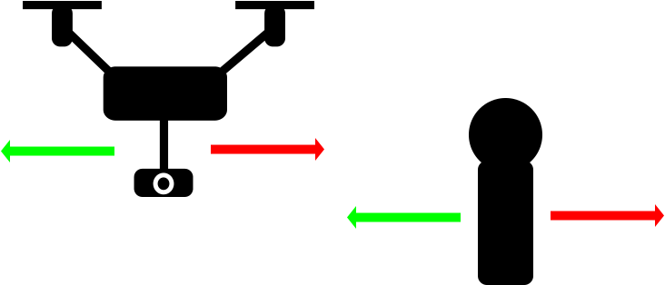

Figure 1: Conceptual Overview of System Response

# **3. Design**

## ***3.1. Hardware***

The only hardware unique to the Tour Group Tracker subsystem would be the Raspberry Pi Camera Module v2. The other hardware that could be considered part of this system would be the Raspberry Pi microcontroller, PixHawk flight controller, and the drone itself with all its components. The main interaction that this subsystem has with those other components is the signal that will command the drone to change speed. Otherwise this subsystem is mostly divorced from the other hardware and could function (though not do anything) without them. The camera hardware consists of the the camera module itself and later down the line will also consist of the casing and mounting that is currently not necessary. The Raspberry Pi Camera Module v2 uses the designated camera ribbon cable port on the microcontroller and runs off 3.3 V and 250 mA of current. Exact data is difficult to find but with the lower resolutions the camera is running at these numbers are subject to change. The camera is capable of high resolution but will be running at a locked 640 x 480 pixels where the frames are further downsampled to 533 x 400 pixels for speed. To further increase speed the camera is run at a lower framerate which is currently 5 frames per second. Due to the camera being manufactured specifically for this microcontroller with the microcontroller having a specialized port just for it no other hardware is necessary for the operation of the camera besides obvious necessities such as a power source.

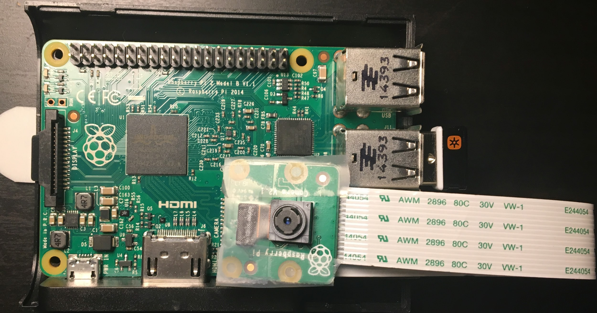

Figure 2: Camera Module attached to Microcontroller

## ***3.2. Software - Detectandtrackvideo3.py***

Since the Tour Group Tracker subsystem relies heavily on image processing to perform its duties it is very software intensive. Programming language Python was used for the coding and OpenCV 4.0.0 was used for all steps of image processing. The actual image processing requires minimal coding but the extensiveness of the program comes from the logic required to update the tracker and preserve what we are tracking. To begin the tour an elected crowd leader will stand on a red X where the drone will get into its initial position at 15 feet away. OpenCV’s Histogram of Ordered Gradients (HOG) detector is set to detect humans. The detection is performed and a boundary box around the crowd leader is drawn. This box has a width and height that are saved as references along with the equivalent area (width times height). A MOSSE tracker is generated and initialized with the generated boundary box. Movement of anything within this box will be monitored allowing us to stay on the crowd leader. The MOSSE tracker is fast but is less accurate than other trackers. Speed was the main determiner of the tracker eliminating most but the MOSSE was ultimately chosen for proving the best at occlusion out of the two to choose from. Having greater accuracy after occlusion means that we needn’t worry if non-tourists walk in front of our crowd.

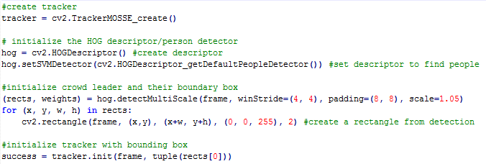

Figure 3: Code Excerpt of Detection and Tracking (Non-relevant code was omitted for brevity)

Once the tracker is initialized the tour begins. After a predetermined amount of time, currently 10 seconds, the HOG detector is run once more. Testing of the natural inaccuracy and drift of the MOSSE tracker showed that for slow regular movement there was virtually none. This means that there was no necessity to update our tracker with a new box for that reason unlike the MedianFlow tracker tested (more on that later). However the only downside to the MOSSE tracker is that the boundary box does not dynamically update its own width and height like the MedianFlow does. So while updating the tracker with a new box is unnecessary for reasons of accuracy it is necessary to get an updated bounding box for the purpose of finding relative distance. An arbitrary time of 10 seconds was chosen and can be adjusted at a later time. After humans in the camera frame are detected the logic loop begins. Firstly we want to ensure that we keep track of the right person so we need to eliminate the detections that are not overlapping with our leader. A function was defined that checks the left and right edges of both the detection being checked and the current tracker box. If the left edge of either box is past the right edge of the other box then they do not intersect. If the right of of either box is left of the left edge of the other box then they do not intersect. Meeting neither of these conditions means the rectangles intersect. Rectangles that do not pass the intersection test are removed from the array. In the figure below, ‘a’ and ‘b’ are arrays for rectangles with elements 0 through 4 corresponding with the x coordinate, y coordinate, width in pixels, and height in pixels respectively.

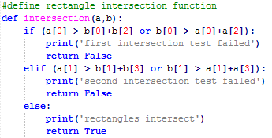

Figure 4: Intersection Test Function

To finally determine which rectangle we go with we check the weight values associated with the detections. The OpenCV HOG Detector outputs a weight value along with each rectangle that estimates how confident the detector is that what it has detected is a human. This is done to allow us to finally select a rectangle and helps eliminate false positives. Once the rectangle has been decided the tracker is re-initialized using this new box. The width and height of this box are saved and used to generate the associated area. The new area is compared to the original box area from 15 feet away and the appropriate response is sent out. If the new area is 25% greater than the original then they are too close and the program sends the signal to speed up. If the new area is only 60% of the original area (40% smaller) then we are too far and the signal is sent to slow down. If neither of these conditions is met then the crowd is an acceptable distance and no action is taken. In the code below appropriate messages are printed to the console as we have not currently integrated the systems. The messages are placeholders. The last mention to be made is if detection fails. Should the HOG detector find no humans in the frame then the program will initialize nothing and continue the tracking that it was already performing.

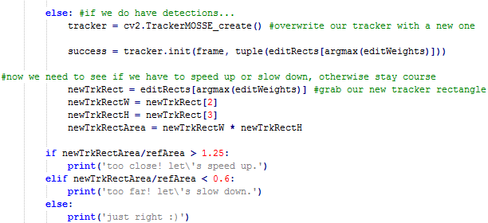

Figure 5: Excerpt of Tracker Re-initialization and Distance Response (some omission of validation print functions)

Figure 6: Flow Diagram of Crowd Tracker Program Logic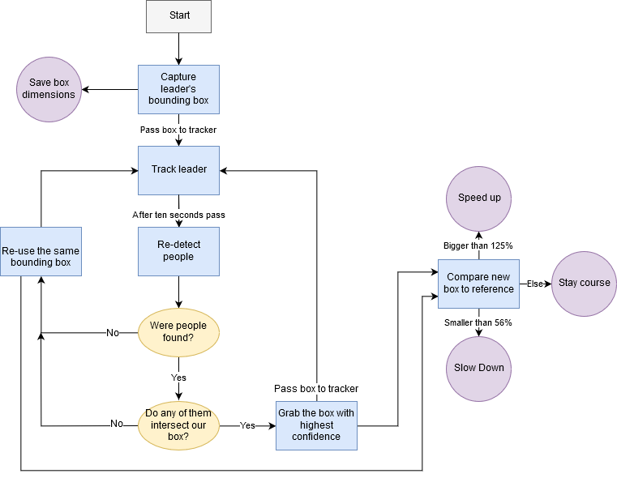

# **4. Operation**

Since the entirety of the the Tour Group Tracker subsystem consists of image processing all steps of validation and execution are performed visually. Currently the program is set to display the images that it is processing on the monitor but when the systems are fully integrated those commands will be omitted since there is no screen.

As the code currently stands the way that tests are validated is through visual inspection of the output from both the console and the displayed images. During the initial calibration the program outputs an image of the first video frame with the detections drawn on it. The system continues on with a window displaying the frames with the tracking boundary drawn over it. When re-calibration begins another window is created showing all the new detections and the current tracker box. For each of these tests validation was a matter of visual confirmation. First a visual confirmation that the box detected the only person in the frame, secondly a visual confirmation that tracking is successful as the program iterates over the video frames, and lastly as the tracker is re-initialized a visual confirmation that the correct detection was used to reiterate the tracker. The other component, the distance response, is confirmed through the console. The ratio of the new box area to the reference area is output to the console so the following message of ‘just right’, ‘too far’, or ‘too close’ is cross-referenced with the conditions to confirm.

During normal operation the program will be validated through the real responses in the drone. With no screen to reference we must rely on what actually happens to confirm functions. Range responses and tracking can be checked through moving further and closer to the drone to see the response. If the appropriate action is taken then the tracker is tracking the correct person and the responses execute properly. Should the responses be inappropriate or there be no response then the tracking failed.

Once everything is complete and integrated the system will be unnoticeable for the tourists (save for the initial calibration) unless a malfunction occurs. Were one of the components of this subsystem to fail then the drone will still be able to continue the tour either after an attempt to recalibrate or a surrender should the camera itself fail. An announcement may be given stating the dynamic speed has been disabled and that the crowd must keep up.

# **5. Data Collection**

Much of the data gathered is simply a yes or no to whether a condition executed properly. Being an image processing heavy subsystem means visual confirmation was required for everything tested.

## 5.1. Relative Distance Data

The first data to be collected was how the area of the boundary boxes changed with respect to the distance. The crowd leader’s boundary box area is used as a reference as opposed to an actual calculation of distance using focal length because of the variation of human height. By using the initial boundary box area we dynamically create a constant tailored to that person’s height and width as opposed to dictating an average that would “hopefully” work for everyone.

By using the box area instead of a direct distance a method needed to be established to determine how much they’ve changed distance. The ratio between the new area and the reference area was chosen. To determine this a test was performed where a teammate stood on a measuring tape and a test program was set to run such that the ratio of the box to the new area was calculated and printed. Several iterations were run such that the boundary box varied naturally and an average box area for that distance was calculated. Finally, the percent difference between the boxes at the maximum and minimum distances were calculated for those averages, giving us an average percentage change from the reference at that distance.

Reference Area = 18432 px^2

|  |  |
| --- | --- |
| Distance (ft) | Avg. Ratio to Reference |
| 25 | 0.56 |
| 7 | 1.22 |

###### Table 1: Distance Ratios

## 5.2. Tracker Decision

The next set of data that needed to be collected was which tracker to be used. After narrowing down to the Median Flow and the MOSSE trackers due to their speed and efficiency it had to be chosen which tracker performed the best at its job. A set of cases were set up and each tracker was initialized to find their strengths and weaknesses. Each of them performed as expected. Median Flow is the least costly but fails under occlusion and large motion. This held true as during the occlusion and large motion tests the tracker failed. The data has been compiled in the following table.

|  |  |  |
| --- | --- | --- |
| Test / Tracker | MOSSE | Median Flow |
| Normal Motion | Pass | Pass |
| Occlusion (with movement) | Pass | Fail |
| Large Motion | Fail | Fail |

###### Table 2: Tracker Test Cases

As can be seen in the table above both trackers did not do well with large movement. This is mainly because they are meant for slower normalized movement (such as walking down a hallway). As lamentable as a failing test is the choice is clear; the MOSSE tracker failed the least and thus was the obvious choice. Both succeeded in normal fluid motion but only the MOSSE passed the test where a teammate passed in front of the teammate being tracked. The MOSSE tracker successfully reset itself on the right person after being occluded. For now, large motion will be treated as an anomaly seeing as a crowd of tourists are not expected to make wild sweeping motions across the hallways.

## 5.3. Logic Validation and Performance Measurement

The tests for whether the logic for the various components of the subsystem were correct are purely boolean; did the correct thing happen? The code was run and the output images and console text analyzed to see if what should have happened in that scenario happened. This data is not wholly quantifiable beyond the fact that everything worked as expected. An example of a test is shown below. In the image we can see the output of the detector, the current tracker, and the console. In the console we see the correct output that the person being tracked is not too far away. We can also see the three humans detected previously and that in the above window the correct person (in the middle) is still being tracked.

Since image processing is difficult on the CPU and we are using a mere Raspberry Pi the total load on the CPU needed to be measured. At 5 fps, the program averaged about 30% load on the CPU with a brief spike to 53% when detection is performed.

###### Figure 7: Example of Program Output, Used for Validation

# **6. Accomplishments**

There were a number of landmark accomplishments in the development of the Tour Group Tracker subsystem. Small programs were written to test the various components that makeup the entire subsystem for testing and verification. Interfacing them together was another issue.

The first hurdle that had to be passed was actually choosing to use the camera for this subsystem. There were a few proposed ideas that were tossed around and considered before the camera due to the relative complexity. It seemed overkill to use a camera and image processing to simply detect how far away a crowd was from the drone. As it turned out the complexity was important as most other methods, namely Bluetooth, proved too simple to provide accurate measurements. Bluetooth signal to distance conversion was the initial choice for tracking the crowd distance. This proved disastrous as Bluetooth signals are not reliable. With all other choices stricken the camera was the only choice left.

Once the camera was chosen and the various components of the actual tracking were confirmed to work the problem of integration became apparent. Many hours were spent attempting to get the HOG human detector to interface with the tracking; mostly due to ignorance and a lack of documentation or examples. With plenty of work they eventually integrated.

The last big accomplishment was the logic for re-initializing the tracker. Many more hours were spent watching trial after trial fail due to an error in logic somewhere. The loops were built outside in with the beginning and ends of everything written first and the more complex inner functions added afterward. First the loop to break after a certain amount of time was created with the loop to perform new detections following. With new detections performed there needed to be a way to iterate through them and eliminate unnecessary ones. This as more conditions and checks were needed as the logic was amended and new cases needed to be considered.

In the end a working program that could detect a crowd leader, track them, reinitialize itself, and respond to their distance was created.

# **7. Future Work**

While the program works well and takes many possible cases into consideration there is still more than can be done. The re-initialization logic could be slimmed down and less clunky with possible errors and shortcomings eliminated with more time. More conditions can be implemented for possible cases not yet considered. The greatest work that still must be finished is getting a live version of the program working. Currently the program reads a video as opposed to the camera itself. It was decided that getting the program working on videos first would be more beneficial as more consistent tests could be performed and validation would be a video away as opposed to requiring a computer desk in the middle of an empty hallway to perform the tracking and detection checks live.

# **8. Conclusion**

A lot was learned this semester. What was originally thought to be a hardware heavy project turned out to be one where everyone ended up programming. I learned a lot about programming in general as well as Python specifically. Image processing was a subject I had never dipped my feet into and for this project I dove into the deep end. This required lot of research into how detection is done and what others have accomplished with it. I’d like to say that I have gained a few new skill sets through this class and I am proud of the work that I have accomplished. The Tour Group Tracker subsystem is by no means perfect and will definitely need more work for it to be as robust as would be necessary for something that will be used by Texas A&M. On the whole the project came out better than was expected at our low points. All of us encountered troubles that we did not expect but were able to adapt and overcome them to get to the point where, even with compromise, we achieved what we set out to do.

**Zach Drone**

Grayson Vansickle

###### **Mobile Application Subsystem**

REVISION – 1.2

5 December 2018

# **Table of Contents**

**Table of Contents 57**

**List of Figures 58**

**List of Tables 59**

**1. Introduction 60**

**2. Theory 61**

2.1. Mobile Application Code Logic 61

**3. Design 61**

3.1. Swift Code 61

3.2. Java Code 68

3.3. Python Code 85

3.4. Mobile Application Layout 86

**4. Operation 88**

**5. Data Collection 89**

**6. Accomplishments 89**

**7. Future Work 90**

**8. Conclusion 90**

# **List of Figures**

**Figure 1 - Mobile Application Subsystem 59**

**Figure 2 - Application Logic used for the code 60**

**Figure 3 - Load MainViewController function 61**

**Figure 4 - Client struct and load view function defined 61**

**Figure 5 - Connect button function defined 62**

**Figure 6 - Pause button function defined 62**

**Figure 7 - Resume button function defined 63**

**Figure 8 - End button function defined 63**

**Figure 9 - Disconnect button function defined 64**

**Figure 10 - Load view function and art tour destinations defined 64**

**Figure 11 - Art start function defined 64**

**Figure 12 - Load view function and classroom tour destinations defined 65**

**Figure 13 - Classroom start function defined 65**

**Figure 14 - Load view function and basic tour destinations defined 66**

**Figure 15 - Basic start function defined 66**

**Figure 16 - Art Activity strings and booleans defined 67**

**Figure 17 - Art Activity on create function defined 68**

**Figure 18 - Art Activity switch pages function defined 69**

**Figure 19 - Art Activity art function defined 70**

**Figure 20 - Classroom Activity strings and booleans defined 70**

**Figure 21 - Classroom Activity on create function defined 71**

**Figure 22 - Classroom Activity switch pages function defined 72**

**Figure 23 - Classroom Activity classroom function defined 73**

**Figure 24 - Basic Activity strings and booleans defined 73**

**Figure 25 - Basic Activity on create function defined 74**

**Figure 26 - Basic Activity switch pages function defined 75**

**Figure 27 - Basic Activity basic function defined 76**

**Figure 28 - Drone Activity strings and booleans defined 77**

**Figure 29 - Drone Activity on create function defined 78**

**Figure 30 - Drone Activity switch pages function defined 79**

**Figure 31 - Drone Activity connect function defined 80**

**Figure 32 - Drone Activity pause function defined 80**

**Figure 33 - Drone Activity resume function defined 81**

**Figure 34 - Drone Activity end function defined 81**

**Figure 35 - Drone Activity disconnect function defined 82**

**Figure 36 - Main Activity strings and booleans defined 82**

**Figure 37 - Main Activity on create function defined 83**

**Figure 38 - Main Activity switch pages function defined 84**

**Figure 39 - Defined functions and variables for client.py code 85**

**Figure 40 - Android Application Layout 86**

**Figure 41 - iOS Application Layout 87**

**Figure 42 - Terminal output for iOS and Android applications 88**

**Figure 43 - Terminal output for Raspberry Pi 3 B on drone 88**

# **List of Tables**

No tables at this time.

# **1. Introduction**

The purpose of the Mobile Application subsystem of the Zach Drone, which is an automated drone tour throughout the new Zachry Engineering Education Complex, is to allow the user to connect to the drone and tell it which tour to take. The mobile application will also allow the user to pause and resume the tours if someone in their tour group needs to use the bathroom or needs to stop for an extended period of time, and the user will be able to end the current tour and select a new tour. This subsystem will involve a user interface between the user and the drone and will be connected using a WiFi signal to communicate between the mobile application and the microcontroller on the drone, a Raspberry Pi 3 B. The mobile application will be available for the user to download on both Android and iOS platforms. Based on the user input, this subsystem interacts with the navigation subsystem to communicate which tour and tour destinations the user has picked. The user input is a major factor regarding the navigation of the drone, since different tours will need to be navigated differently in order to visit all of the destinations specific to the tour. The mobile application consists of a main page, an art tour page, a classroom tour page, a basic tour page and a drone page. The three tour pages will show the user which destinations are on the tour of the page they selected and will allow the user to start the tour on the page. The drone page will allow the user to connect and disconnect from the drone, along with pause, resume and end the current tour. The Raspberry Pi 3 B will have a message decoder running to ensure the drone performs the correct action in response to the user’s input. The subsystem overview is shown in Figure 1. This document will describe the theory, design, operation, data collection and validation of the mobile application subsystem.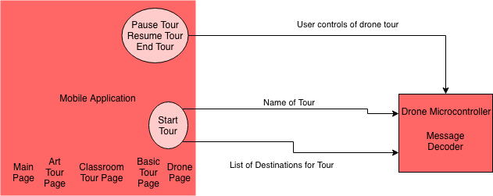

Figure 1: Mobile Application Subsystem

# **2. Theory**

## ***2.1. Mobile Application Code Logic***

The mobile application will connect to the drone’s onboard Raspberry Pi 3 B. This connection will allow the user to communicate with the drone to give it commands. The logic used in the iOS and Android applications follow the diagram below. The logic in the figure gives the user some control of what the application sends to the drone but restricts them to an extent that they won’t make the drone malfunction due to an overload of messages. The users must first connect to the drone before any other function of the application will work. After the user connects to the drone, they will then be able to start a tour and disconnect from the drone. The pause and end tour buttons only function after the user has started a tour. The resume tour button only functions after the user has paused a tour.

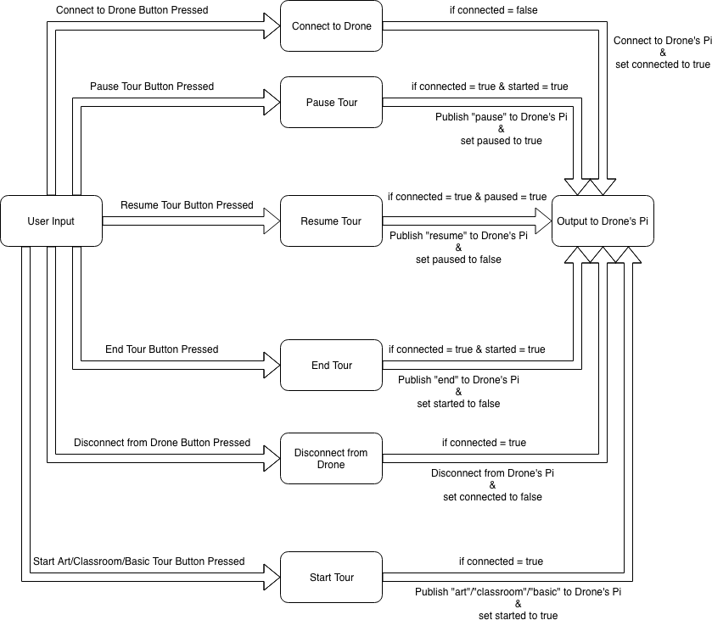

Figure 2: Application Logic used for the code

# **3. Design**

## ***3.1. Swift Code***

The backend of the iOS application is written using Xcode in the Swift programming language. The logic of the the following swift files follows the logic defined in Figure 2 in the Theory section.

#### ***3.1.1. MainViewController.swift***

MainViewController.swift contains only one function and that function is used to load the view. This function is needed so that the iOS application shows the correct page of the app. There is a print statement included in this function which was used when debugging that shows that the correct view was loaded.

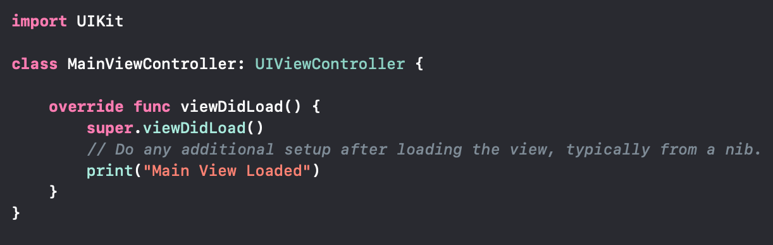

Figure 3: Load MainViewController function

#### ***3.1.2. DroneViewController.swift***

DroneViewController.swift contains a struct used for the client details and six functions. This struct contains the client itself and three boolean values used to make sure the user can online push certain buttons. The client uses the CocoaMQTT external library which is given a client id name, a host ip address and a port number. In this case the client id name is Zach Drone iOS Device, the host ip address is the ip address of the drone’s Raspberry Pi 3 B on the WiFi network, and the port number is 1883. The three boolean values are connected, paused and started. The connected value is used to make the user connect to the drone first before doing anything else. The paused value is used to make the user pause a tour first before resuming a tour. The started value is used to make the user start a tour first before pausing, resuming or ending a tour. The six functions in DroneViewController.swift are load view, connect button, pause button, resume button, end button and disconnect button functions. The load view function is the same as the load view function in MainViewController.swift, but it loads the drone view instead of the main view.

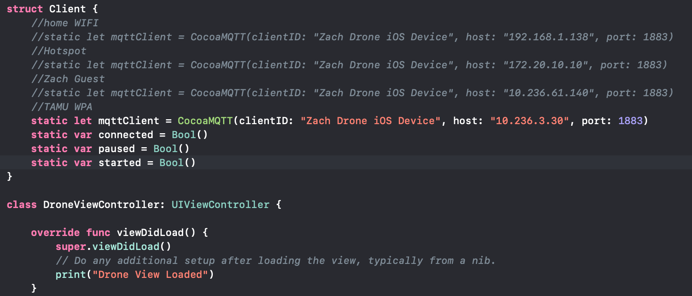

Figure 4: Client struct and load view function defined

The connect button function is executed when the Connect to Drone button is pressed. This function checks to see if the drone is already connected to first, if the connected boolean value is true. If the connected value is true then the function will publish the message “connect” to the topic used for this project, “zach/drone/rpi/tour”, and print “Already connected to drone” for debugging. There will be an alert that pops on the screen to tell the user that they have already connected to the drone. If the connected value is false then the function will connect the the mqttClient defined in the Client struct, print the client’s host name along with connect, and set the connected value to true.

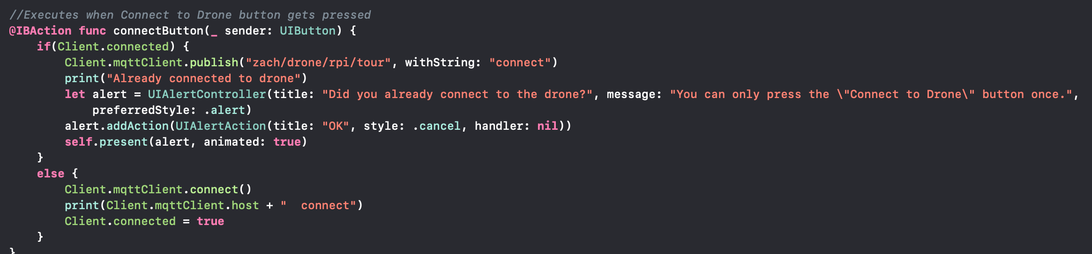

Figure 5: Connect button function defined

The pause button function is executed when the Pause Tour button is pressed. This function checks to see if the drone is already connected to first and a tour has already been started, if the connected and started boolean values are true. If the connected and started values are true then the function will publish the message “pause” to the topic used for this project, “zach/drone/rpi/tour”, print the client’s host name along with pause, and set the paused value to true. If the connected boolean value is true but the started boolean value is false then the function will print “Need to start a tour first” for debugging and an alert will pop on the screen to tell the user that they have to start a tour before pausing a tour. If the connected and started boolean values are false then the function will print “Need to connect to drone and start a tour first” for debugging and an alert will pop on the screen to tell the user that they have to connect to the drone and start a tour before pausing a tour.

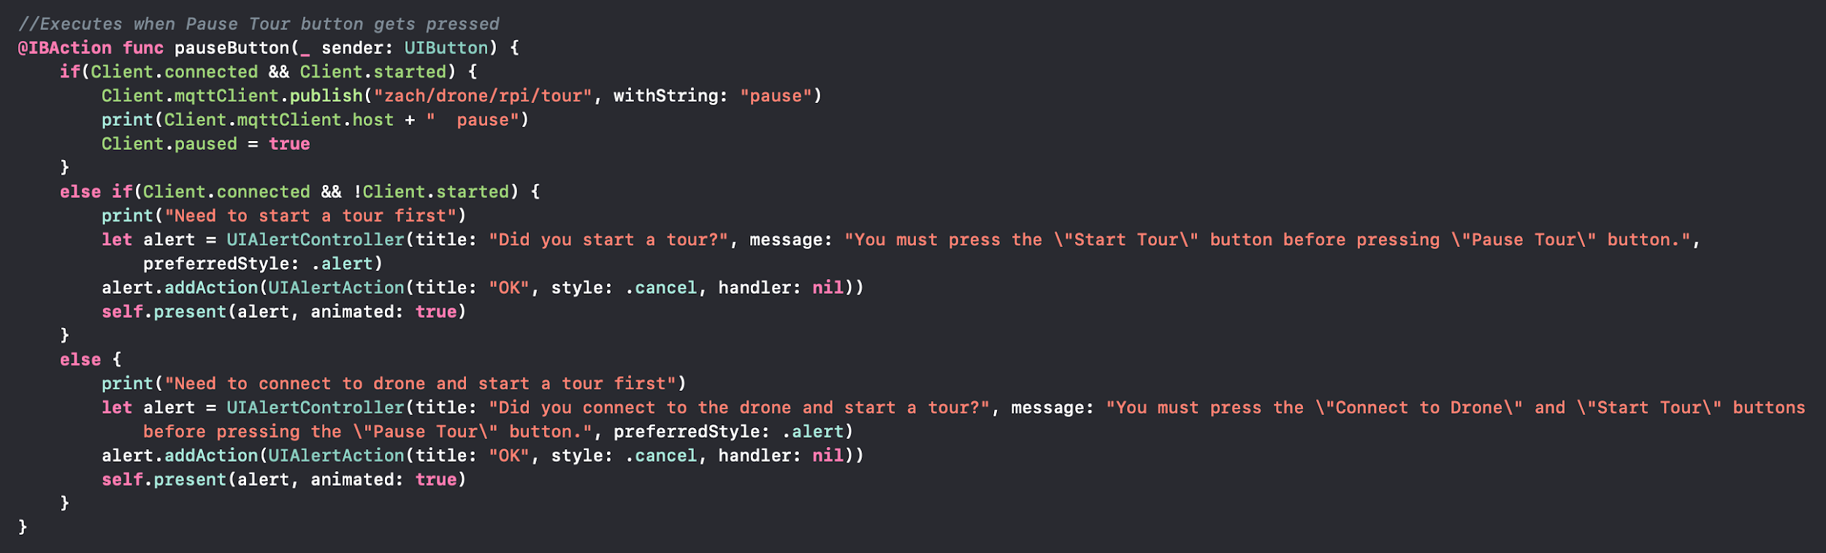

Figure 6: Pause button function defined

The resume button function is executed when the Resume Tour button is pressed. This function checks to see if the drone is already connected to first and a tour has already been paused, if the connected and paused boolean values are true. If the connected and paused values are true then the function will publish the message “resume” to the topic used for this project, “zach/drone/rpi/tour”, print the client’s host name along with resume, and set the paused value to false. If the connected boolean value is true but the paused boolean value is false then the function will print “Need to pause tour first” for debugging and an alert will pop on the screen to tell the user that they have to pause a tour before resuming a tour. If the connected and paused boolean values are false then the function will print “Need to connect to drone and pause a tour first” for debugging and an alert will pop on the screen to tell the user that they have to connect to the drone and pause a tour before resuming a tour.

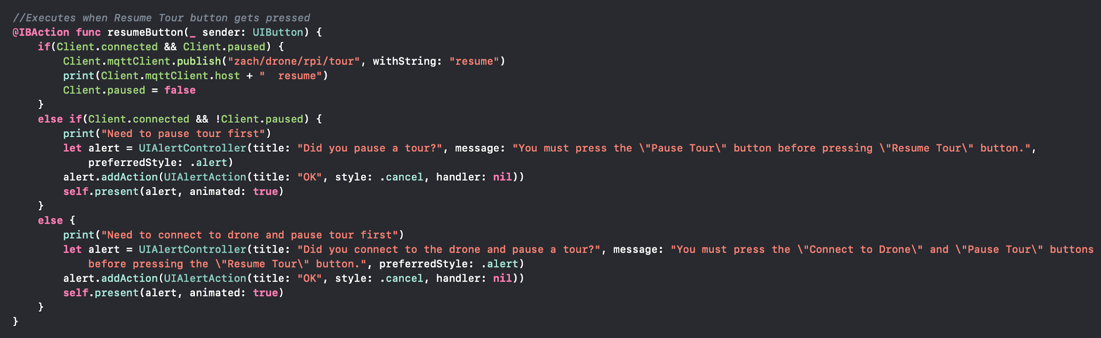

Figure 7: Resume button function defined

The end button function is executed when the End Tour button is pressed. This function checks to see if the drone is already connected to first and a tour has already been started, if the connected and started boolean values are true. If the connected and started values are true then the function will publish the message “end” to the topic used for this project, “zach/drone/rpi/tour”, print the client’s host name along with end, and set the started value to false. If the connected boolean value is true but the started boolean value is false then the function will print “Need to start a tour first” for debugging and an alert will pop on the screen to tell the user that they have to start a tour before ending a tour. If the connected and started boolean values are false then the function will print “Need to connect to drone and start a tour first” for debugging and an alert will pop on the screen to tell the user that they have to connect to the drone and start a tour before ending a tour.

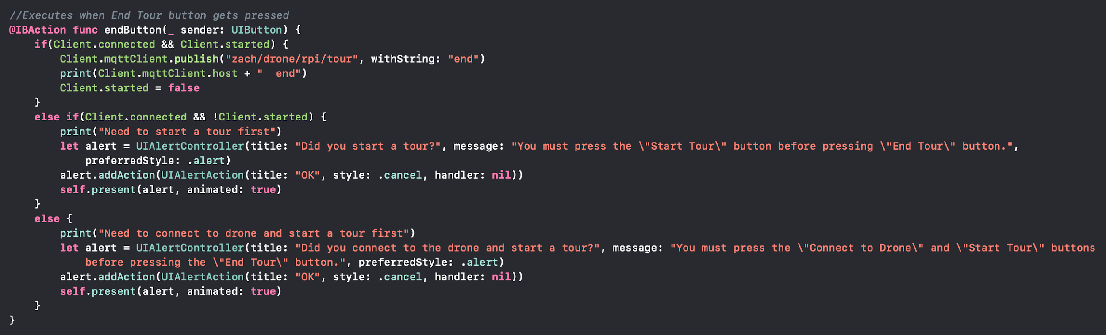

Figure 8: End button function defined

The disconnect button function is executed when the Disconnect from Drone button is pressed. This function checks to see if the drone is already connected to first, if the connected boolean value is true. If the connected value is true then the function will publish the message “disconnect” to the topic used for this project, “zach/drone/rpi/tour”, print the client’s host name and disconnect, disconnect the mqttClient defined the the Client struct, and set the connected value to false. If the connected value is false then the function will print “Need to connect to drone first” for debugging and an alert will pop on screen to tell the user that they have to connect to the drone before doing anything else.

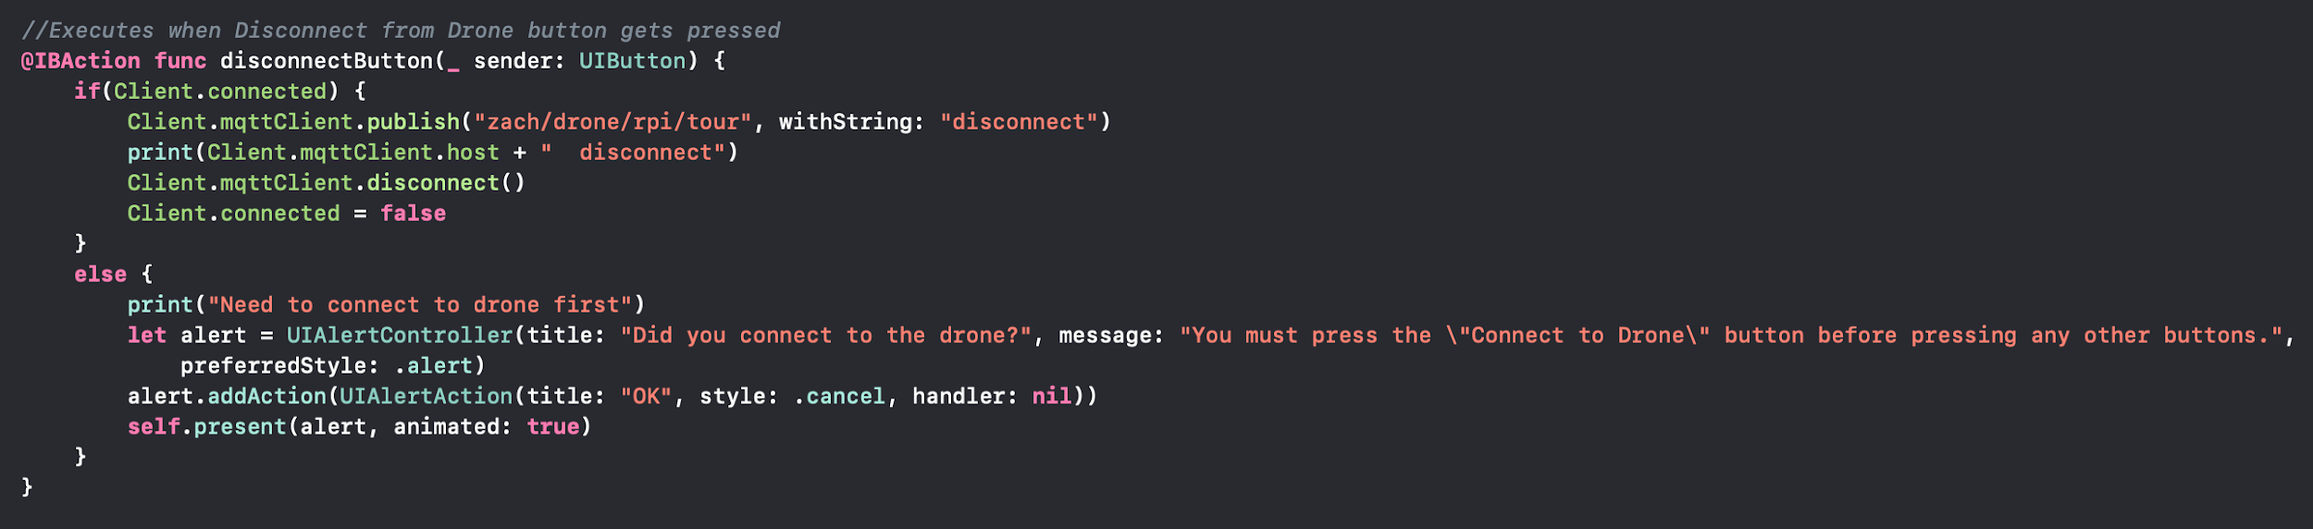

Figure 9: Disconnect button function defined

#### ***3.1.3. ArtViewController.swift***

ArtViewController.swift contains two functions and an array of strings. The two functions are the view load and start art button functions. The array of strings contains the list of all the destinations that the art tour will visit. The load view function is the same as the load view function in MainViewController.swift, but it loads the art view instead of the main view.

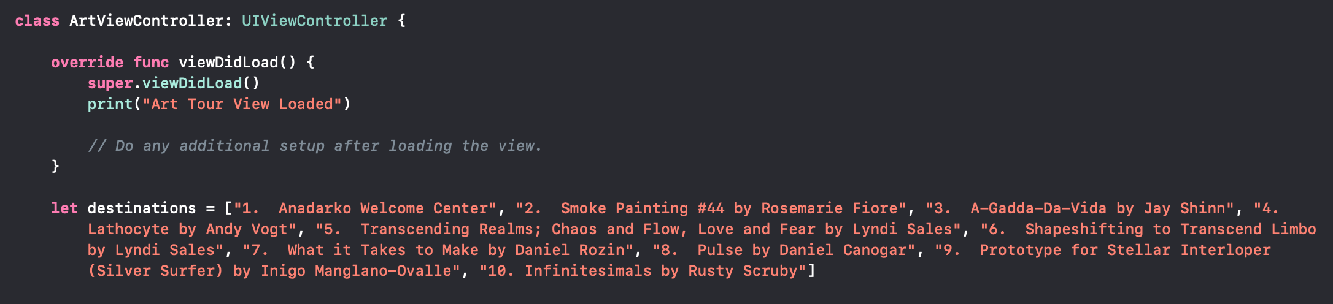

Figure 10: Load view function and art tour destinations defined

The start art button function is executed when the Start Art Tour button is pressed. This function checks to see if the drone is already connected to first, if the connected boolean value from the Client struct in the DroneViewController.swift file is true. If the connected value is true then the function will publish the message “art” to the topic used for this project, “zach/drone/rpi/tour”, send all the destinations in the array of strings to the same topic, print the client’s host name from the Client struct in the DroneViewController.swift file and art, and set the started boolean value from the Client struct in the DroneViewController.swift file to true. If the connected value is false then the function will print “Need to connect to drone first” for debugging and an alert will pop on screen to tell the user that they have to connect to the drone before doing anything else.

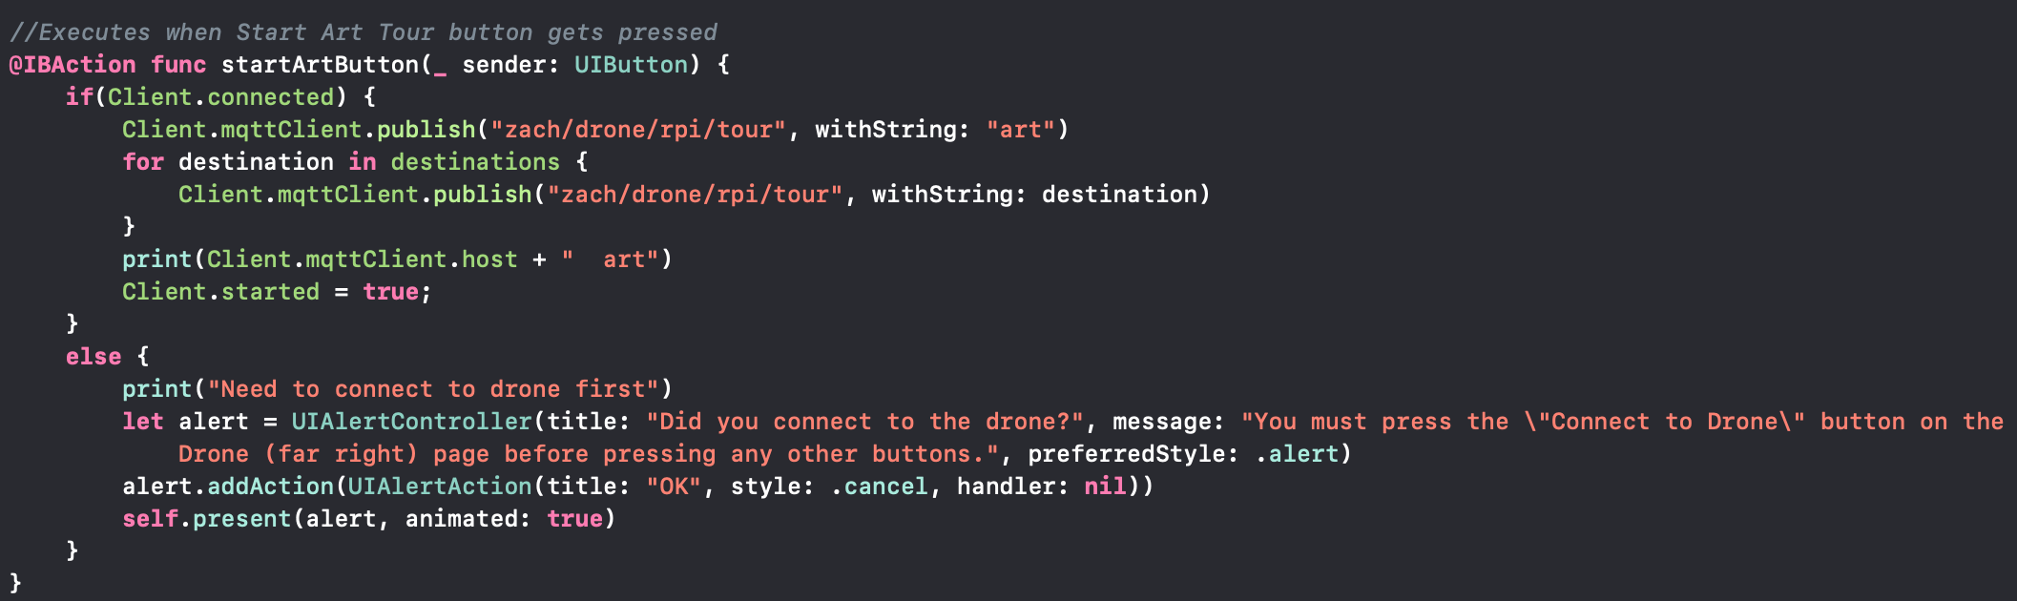

Figure 11: Art start function defined

#### ***3.1.4. ClassroomViewController.swift***

ClassroomViewController.swift contains two functions and an array of strings. The two functions are the view load and start classroom button functions. The array of strings contains the list of all the destinations that the classroom tour will visit. The load view function is the same as the load view function in MainViewController.swift, but it loads the classroom view instead of the main view.

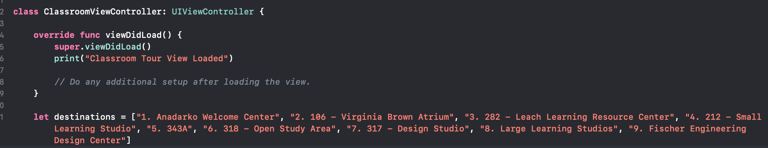

Figure 12: Load view function and classroom tour destinations defined

The start classroom button function is executed when the Start Classroom Tour button is pressed. This function checks to see if the drone is already connected to first, if the connected boolean value from the Client struct in the DroneViewController.swift file is true. If the connected value is true then the function will publish the message “classroom” to the topic used for this project, “zach/drone/rpi/tour”, send all the destinations in the array of strings to the same topic, print the client’s host name from the Client struct in the DroneViewController.swift file and classroom, and set the started boolean value from the Client struct in the DroneViewController.swift file to true. If the connected value is false then the function will print “Need to connect to drone first” for debugging and an alert will pop on screen to tell the user that they have to connect to the drone before doing anything else.

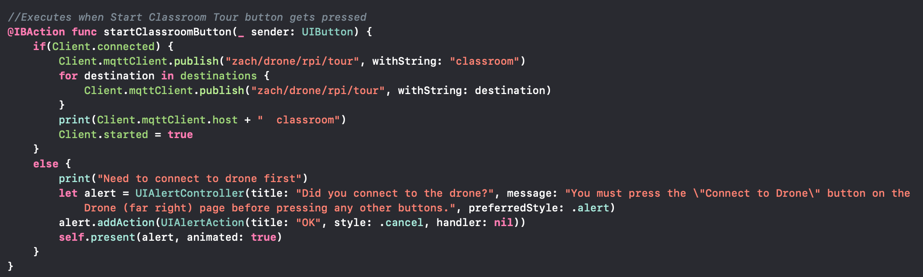

Figure 13: Classroom start function defined

#### ***3.1.5. BasicViewController.swift***

BasicViewController.swift contains two functions and an array of strings. The two functions are the view load and start basic button functions. The array of strings contains the list of all the destinations that the basic tour will visit. The load view function is the same as the load view function in MainViewController.swift, but it loads the basic view instead of the main view.

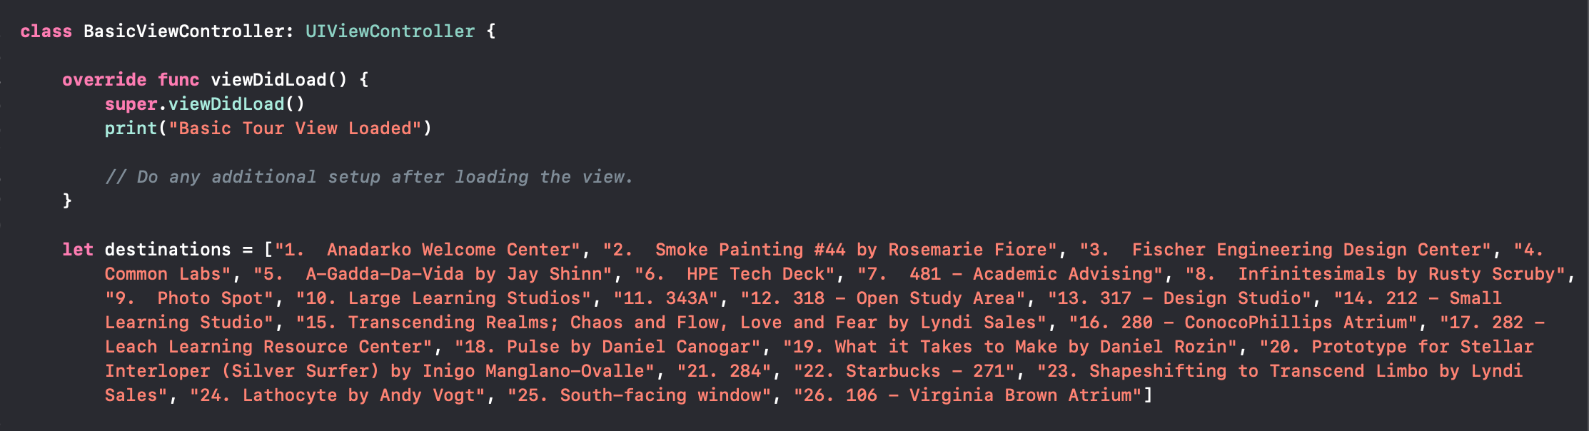

Figure 14: Load view function and basic tour destinations defined

The start basic button function is executed when the Start Basic Tour button is pressed. This function checks to see if the drone is already connected to first, if the connected boolean value from the Client struct in the DroneViewController.swift file is true. If the connected value is true then the function will publish the message “basic” to the topic used for this project, “zach/drone/rpi/tour”, send all the destinations in the array of strings to the same topic, print the client’s host name from the Client struct in the DroneViewController.swift file and basic, and set the started boolean value from the Client struct in the DroneViewController.swift file to true. If the connected value is false then the function will print “Need to connect to drone first” for debugging and an alert will pop on screen to tell the user that they have to connect to the drone before doing anything else.

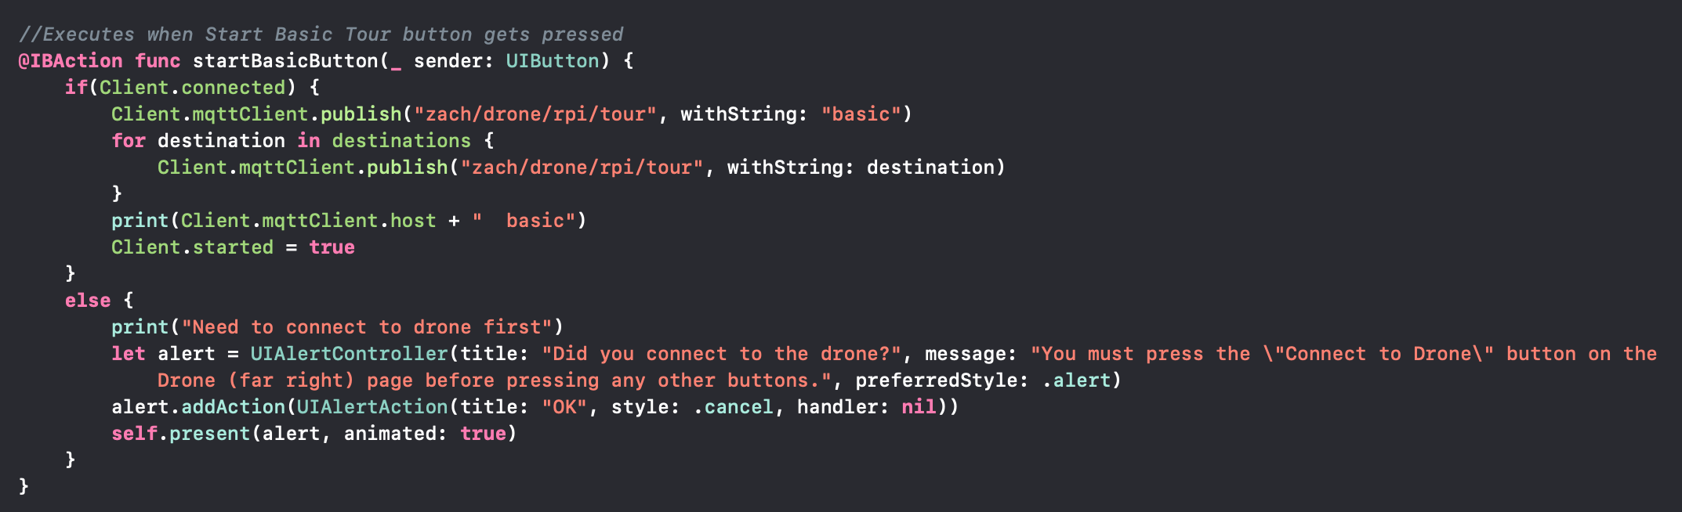

Figure 15: Basic start function defined

## ***3.2. Java Code***

The backend of the Android application is written using Android Studio in the Java programming language. The logic of the the following java files follows the logic defined in Figure 2 in the Theory section.

#### ***3.2.1. ArtActivity.java***

ArtActivity.java contains three strings, three boolean values, and two main functions, on create and art functions. The three strings are used to pass the boolean values between the different pages within the application. The three strings are ART_CONNECT, ART_START and ART_PAUSE. The ART_CONNECT string is used to store the connected boolean value. The ART_START string is used to store the started boolean value. The ART_PAUSE string is used to store the started boolean value. The three boolean values are used to make sure the user can online push certain buttons. The three boolean values are connected, started and paused. The connected value is used to make the user connect to the drone first before doing anything else. The paused value is used to make the user pause a tour first before resuming a tour. The started value is used to make the user start a tour first before pausing, resuming or ending a tour. The on create function has a sub-function in it that deals with the changing the pages within the application. The art function has a string array that has all of the destination that the art tour will visit.

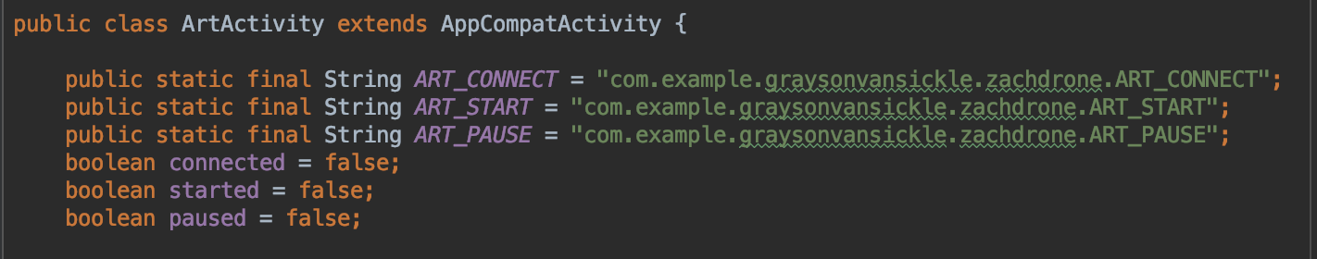

Figure 16: Art Activity strings and booleans defined

The on create function starts the art activity layout xml file and displays this layout to the application. The function then sets the art tour item in the bottom navigation bar to be the selected item. The function also checks to see if the intent has an extra named ART_CONNECT, ART_START or ART_PAUSE. If the intent has an ART_CONNECT extra then the connected boolean value is set to the value of the intent’s ART_CONNECT extra. If the intent has an ART_START extra then the started boolean value is set to the value of the intent’s ART_START extra. If the intent has an ART_PAUSE extra then the paused boolean value is set to the value of the intent’s ART_PAUSE extra. If the intent doesn’t have any of the extras then the boolean values will stay as false. The sub-function of the on create function takes the user input and then switches the current page of the application to the one the user selected.

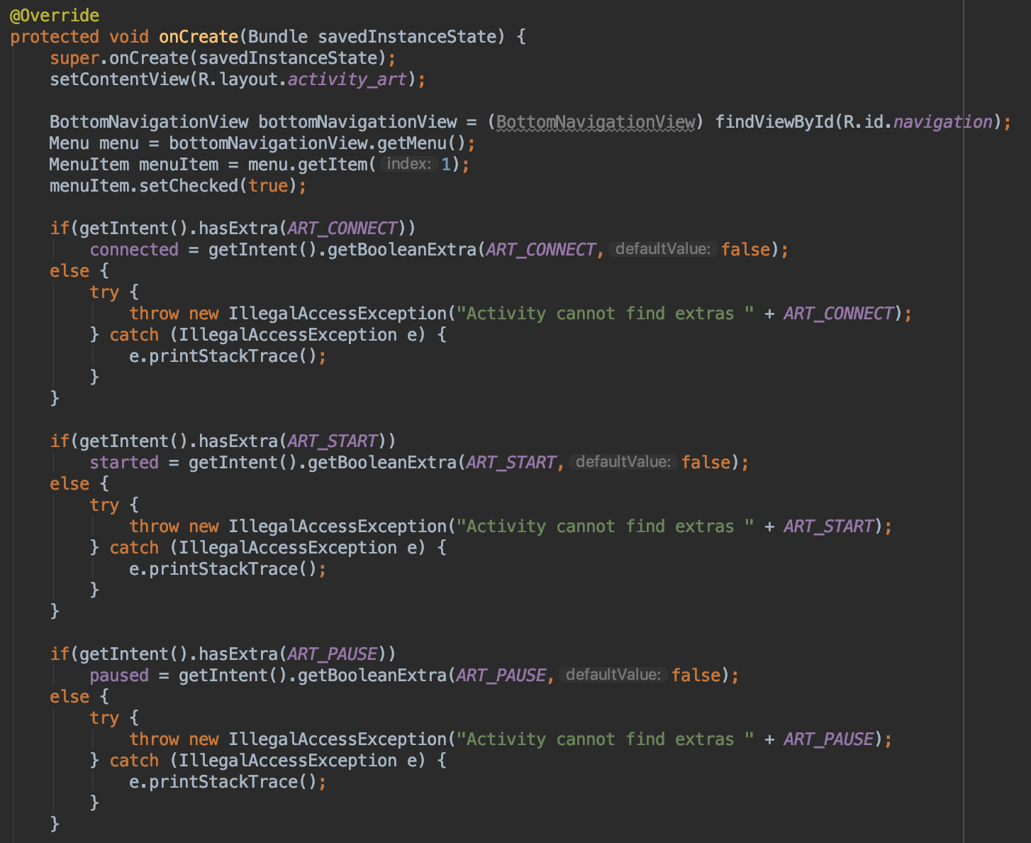

Figure 17: Art Activity on create function defined

If the user selected the Main page in the bottom navigation bar, then a new intent is made that connects the ArtActivity class to the MainActivity class. The connected boolean value is then added to this intent as an extra named MAIN_CONNECT. The started boolean value is then added to this intent as an extra named MAIN_START. The paused boolean value is then added to this intent as an extra named MAIN_PAUSE. The intent created from the ArtActivity class to the MainActivity class is then started so the application will then run the MainActivity.java file. If the user selected the Classroom Tour page in the bottom navigation bar, then a new intent is made that connects the ArtActivity class to the ClassroomActivity class. The connected boolean value is then added to this intent as an extra named CLASSROOM_CONNECT. The started boolean value is then added to this intent as an extra named CLASSROOM_START. The paused boolean value is then added to this intent as an extra named CLASSROOM_PAUSE. The intent created from the ArtActivity class to the ClassroomActivity class is then started so the application will then run the ClassroomActivity.java file. If the user selected the Basic Tour page in the bottom navigation bar, then a new intent is made that connects the ArtActivity class to the BasicActivity class. The connected boolean value is then added to this intent as an extra named BASIC_CONNECT. The started boolean value is then added to this intent as an extra named BASIC_START. The paused boolean value is then added to this intent as an extra named BASIC_PAUSE. The intent created from the ArtActivity class to the BasicActivity class is then started so the application will then run the BasicActivty.java file. If the user selected the Drone page in the bottom navigation bar, then a new intent is made that connects the ArtActivity class to the DroneActivity class. The connected boolean value is then added to this intent as an extra named DRONE_CONNECT. The started boolean value is then added to this intent as an extra named DRONE_START. The paused boolean value is then added to this intent as an extra named DRONE_PAUSE. The intent created from the ArtActivity class to the DroneActivity class is then started so the application will then run the DroneActivity.java file.

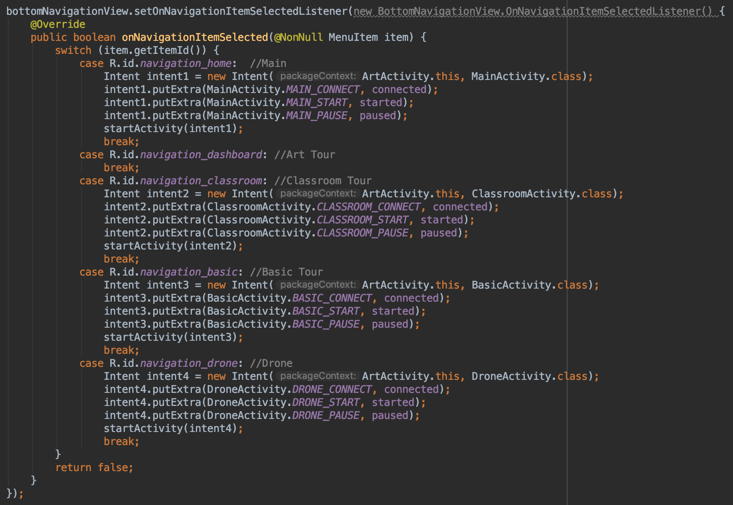

Figure 18: Art Activity switch pages function defined

The art function first checks to see if the connected boolean value is true. If connected is true then the function will create a new MqttMessage and this message is then set to art, an alert will pop up at the bottom of the screen that says art to tell the user that the art tour is start, and the started boolean value is set to true. The function then publishes the message to the topic and client defined in the DroneActivity class. The function then goes through the array of destinations and makes a new MqttMessage with each destination and publishes that message to the topic and client defined in the DroneActivity class. If connected is false then an alert will pop up at the bottom of the screen to tell the user that they must connect to the drone before starting the art tour.

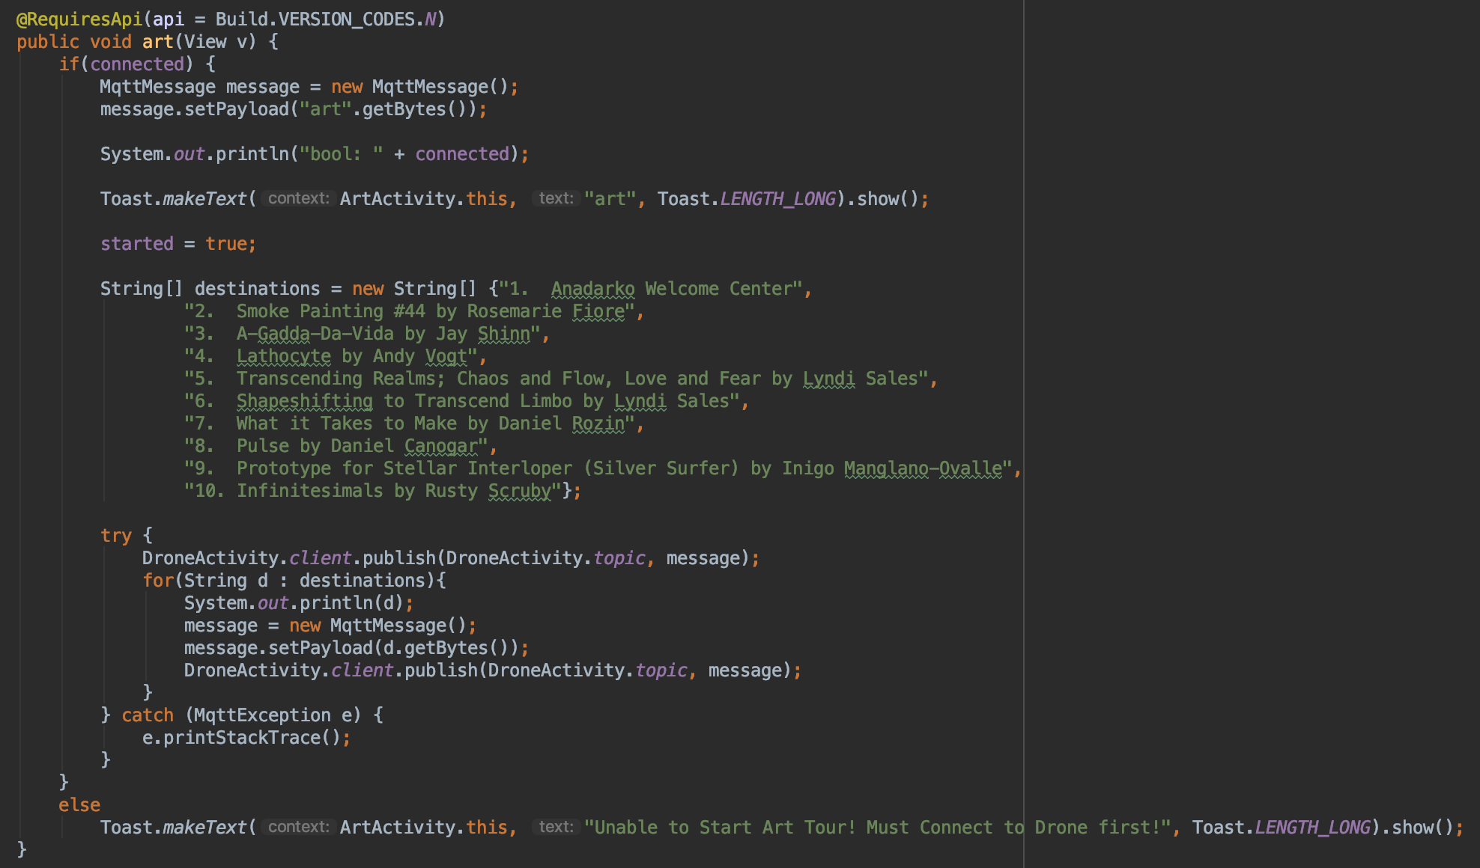

Figure 19: Art Activity art function defined

#### ***3.2.2. ClassroomActivity.java***

ClassroomActivity.java contains three strings, three boolean values, and two main functions, on create and classroom functions. The three strings are used to pass the boolean values between the different pages within the application. The three strings are CLASSROOM_CONNECT, CLASSROOM_START and CLASSROOM_PAUSE. The CLASSROOM_CONNECT string is used to store the connected boolean value. The CLASSROOM_START string is used to store the started boolean value. The CLASSROOM_PAUSE string is used to store the started boolean value. The three boolean values are used to make sure the user can online push certain buttons. The three boolean values are connected, started and paused. The connected value is used to make the user connect to the drone first before doing anything else. The paused value is used to make the user pause a tour first before resuming a tour. The started value is used to make the user start a tour first before pausing, resuming or ending a tour. The on create function has a sub-function in it that deals with the changing the pages within the application. The classroom function has a string array that has all of the destination that the classroom tour will visit.

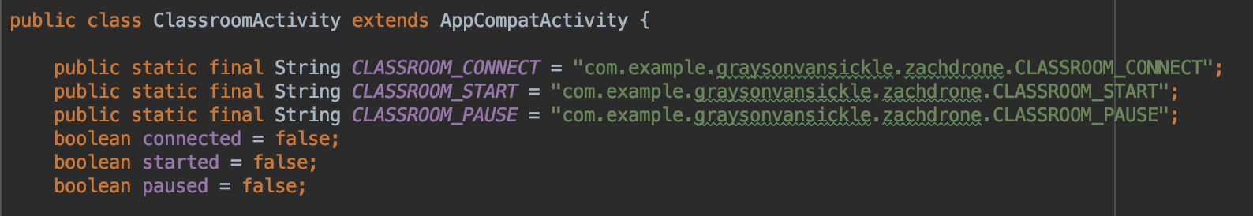

Figure 20: Classroom Activity strings and booleans defined

The on create function starts the classroom activity layout xml file and displays this layout to the application. The function then sets the classroom tour item in the bottom navigation bar to be the selected item. The function also checks to see if the intent has an extra named CLASSROOM_CONNECT, CLASSROOM_START or CLASSROOM_PAUSE. If the intent has an CLASSROOM_CONNECT extra then the connected boolean value is set to the value of the intent’s CLASSROOM_CONNECT extra. If the intent has an CLASSROOM_START extra then the started boolean value is set to the value of the intent’s CLASSROOM_START extra. If the intent has an CLASSROOM_PAUSE extra then the paused boolean value is set to the value of the intent’s CLASSROOM_PAUSE extra. If the intent doesn’t have any of the extras then the boolean values will stay as false. The sub-function of the on create function takes the user input and then switches the current page of the application to the one the user selected.

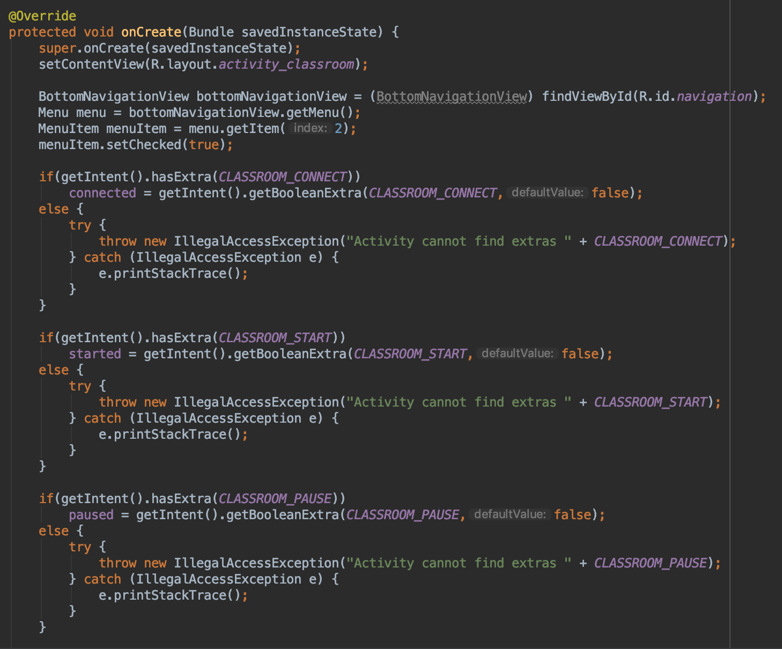

Figure 21: Classroom Activity on create function defined

If the user selected the Main page in the bottom navigation bar, then a new intent is made that connects the ClassroomActivity class to the MainActivity class. The connected boolean value is then added to this intent as an extra named MAIN_CONNECT. The started boolean value is then added to this intent as an extra named MAIN_START. The paused boolean value is then added to this intent as an extra named MAIN_PAUSE. The intent created from the ClassroomActivity class to the MainActivity class is then started so the application will then run the MainActivity.java file. If the user selected the Art Tour page in the bottom navigation bar, then a new intent is made that connects the ClassroomActivity class to the ArtActivity class. The connected boolean value is then added to this intent as an extra named ART_CONNECT. The started boolean value is then added to this intent as an extra named ART_START. The paused boolean value is then added to this intent as an extra named ART_PAUSE. The intent created from the ClassroomActivity class to the ArtActivity class is then started so the application will then run the ArtActivity.java file. If the user selected the Basic Tour page in the bottom navigation bar, then a new intent is made that connects the ClassroomActivity class to the BasicActivity class. The connected boolean value is then added to this intent as an extra named BASIC_CONNECT. The started boolean value is then added to this intent as an extra named BASIC_START. The paused boolean value is then added to this intent as an extra named BASIC_PAUSE. The intent created from the ClassroomActivity class to the BasicActivity class is then started so the application will then run the BasicActivty.java file. If the user selected the Drone page in the bottom navigation bar, then a new intent is made that connects the ClassroomActivity class to the DroneActivity class. The connected boolean value is then added to this intent as an extra named DRONE_CONNECT. The started boolean value is then added to this intent as an extra named DRONE_START. The paused boolean value is then added to this intent as an extra named DRONE_PAUSE. The intent created from the ClassroomActivity class to the DroneActivity class is then started so the application will then run the DroneActivity.java file.

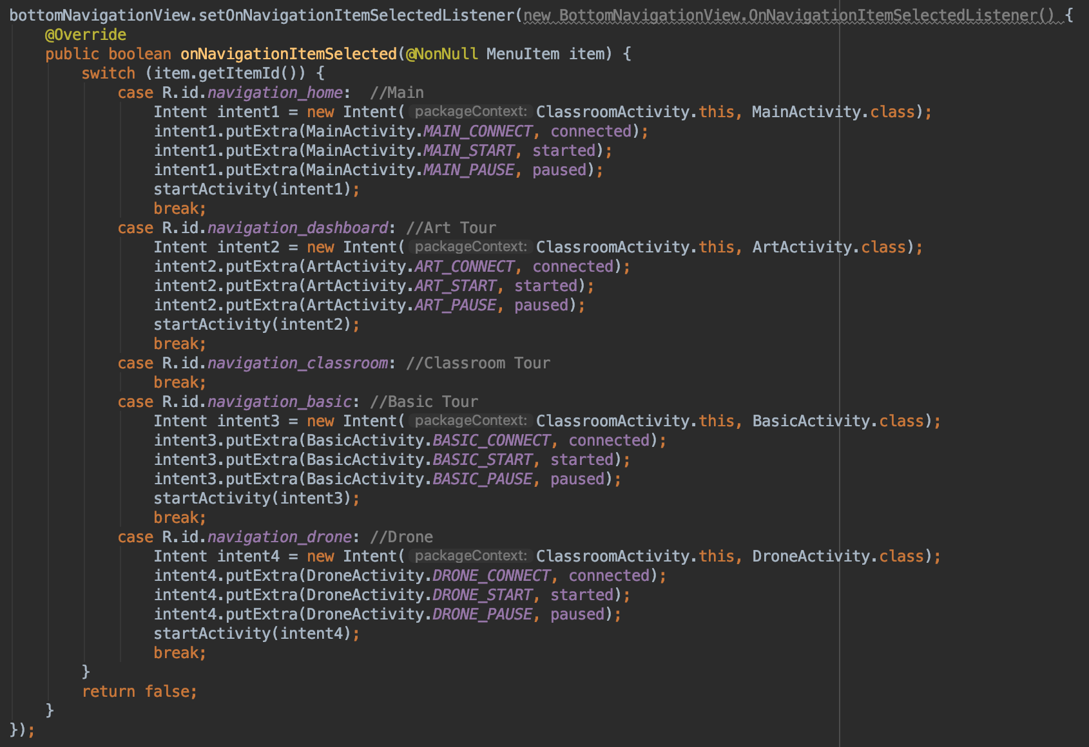

Figure 22: Classroom Activity switch pages function defined

The classroom function first checks to see if the connected boolean value is true. If connected is true then the function will create a new MqttMessage and this message is then set to classroom, an alert will pop up at the bottom of the screen that says classroom to tell the user that the classroom tour is start, and the started boolean value is set to true. The function then publishes the message to the topic and client defined in the DroneActivity class. The function then goes through the array of destinations and makes a new MqttMessage with each destination and publishes that message to the topic and client defined in the DroneActivity class. If connected is false then an alert will pop up at the bottom of the screen to tell the user that they must connect to the drone before starting the classroom tour.

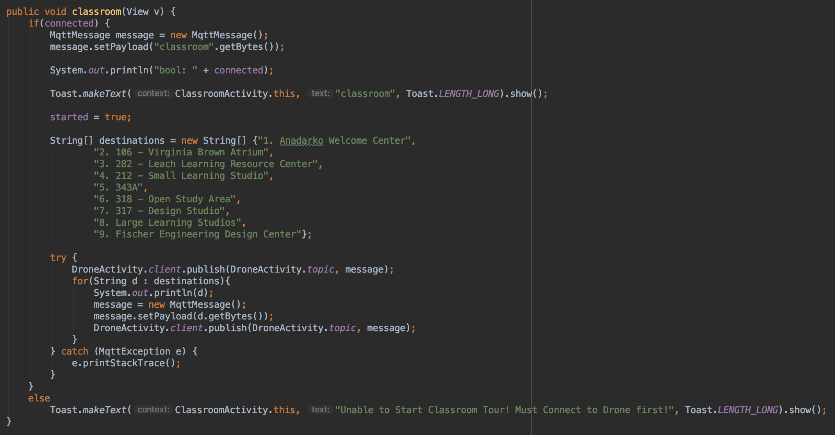

Figure 23: Classroom Activity classroom function defined

#### ***3.2.3. BasicActivity.java***

BasicActivity.java contains three strings, three boolean values, and two main functions, on create and basic functions. The three strings are used to pass the boolean values between the different pages within the application. The three strings are BASIC_CONNECT, BASIC_START and BASIC_PAUSE. The BASIC_CONNECT string is used to store the connected boolean value. The BASIC_START string is used to store the started boolean value. The BASIC_PAUSE string is used to store the started boolean value. The three boolean values are used to make sure the user can online push certain buttons. The three boolean values are connected, started and paused. The connected value is used to make the user connect to the drone first before doing anything else. The paused value is used to make the user pause a tour first before resuming a tour. The started value is used to make the user start a tour first before pausing, resuming or ending a tour. The on create function has a sub-function in it that deals with the changing the pages within the application. The classroom function has a string array that has all of the destination that the basic tour will visit.

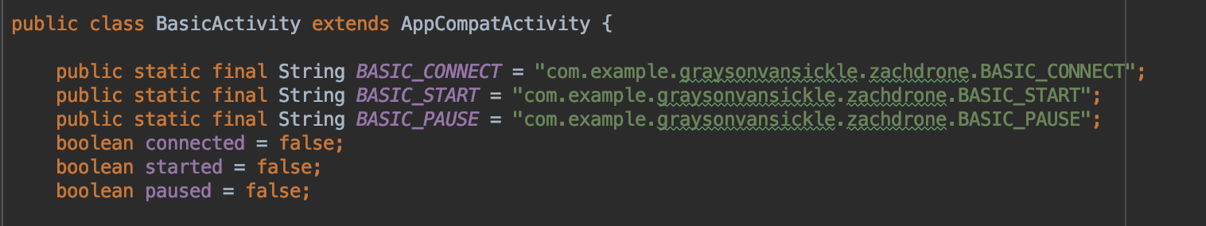

Figure 24: Basic Activity strings and booleans defined

The on create function starts the basic activity layout xml file and displays this layout to the application. The function then sets the basic tour item in the bottom navigation bar to be the selected item. The function also checks to see if the intent has an extra named BASIC_CONNECT, BASIC_START or BASIC_PAUSE. If the intent has an BASIC_CONNECT extra then the connected boolean value is set to the value of the intent’s BASIC_CONNECT extra. If the intent has an BASIC_START extra then the started boolean value is set to the value of the intent’s BASIC_START extra. If the intent has an BASIC_PAUSE extra then the paused boolean value is set to the value of the intent’s BASIC_PAUSE extra. If the intent doesn’t have any of the extras then the boolean values will stay as false. The sub-function of the on create function takes the user input and then switches the current page of the application to the one the user selected.

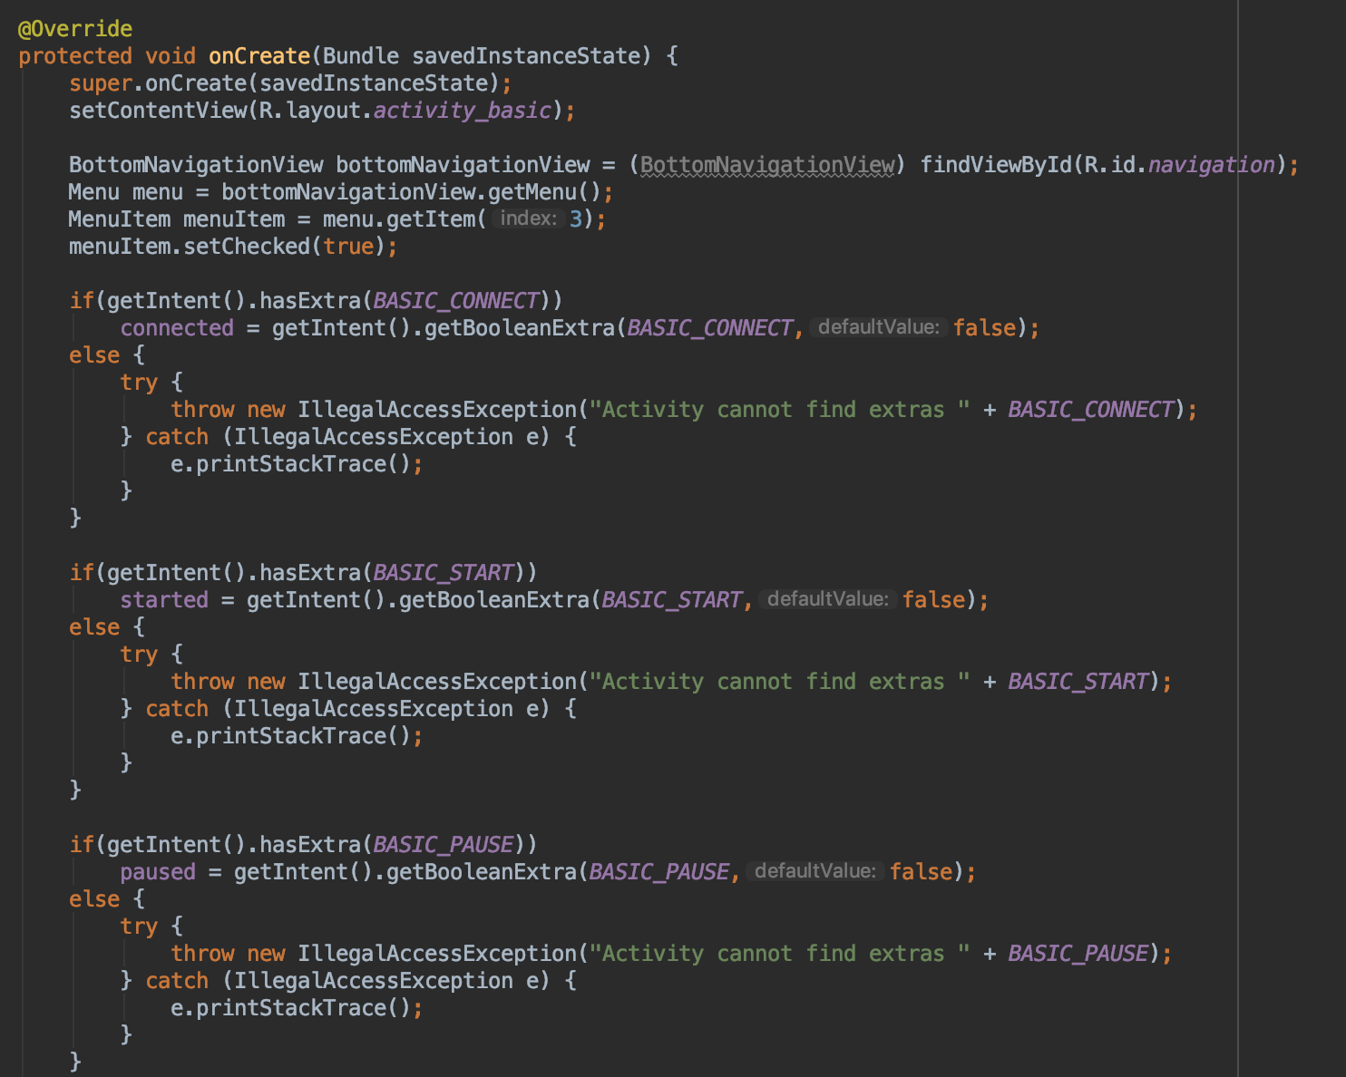

Figure 25: Basic Activity on create function defined

If the user selected the Main page in the bottom navigation bar, then a new intent is made that connects the BasicActivity class to the MainActivity class. The connected boolean value is then added to this intent as an extra named MAIN_CONNECT. The started boolean value is then added to this intent as an extra named MAIN_START. The paused boolean value is then added to this intent as an extra named MAIN_PAUSE. The intent created from the BasicActivity class to the MainActivity class is then started so the application will then run the MainActivity.java file. If the user selected the Art Tour page in the bottom navigation bar, then a new intent is made that connects the BasicActivity class to the ArtActivity class. The connected boolean value is then added to this intent as an extra named ART_CONNECT. The started boolean value is then added to this intent as an extra named ART_START. The paused boolean value is then added to this intent as an extra named ART_PAUSE. The intent created from the BasicActivity class to the ArtActivity class is then started so the application will then run the ArtActivity.java file. If the user selected the Classroom Tour page in the bottom navigation bar, then a new intent is made that connects the BasicActivity class to the ClassroomActivity class. The connected boolean value is then added to this intent as an extra named CLASSROOM_CONNECT. The started boolean value is then added to this intent as an extra named CLASSROOM_START. The paused boolean value is then added to this intent as an extra named CLASSROOM_PAUSE. The intent created from the BasicActivity class to the ClassroomActivity class is then started so the application will then run the ClassroomActivity.java file. If the user selected the Drone page in the bottom navigation bar, then a new intent is made that connects the BasicActivity class to the DroneActivity class. The connected boolean value is then added to this intent as an extra named DRONE_CONNECT. The started boolean value is then added to this intent as an extra named DRONE_START. The paused boolean value is then added to this intent as an extra named DRONE_PAUSE. The intent created from the BasicActivity class to the DroneActivity class is then started so the application will then run the DroneActivity.java file.

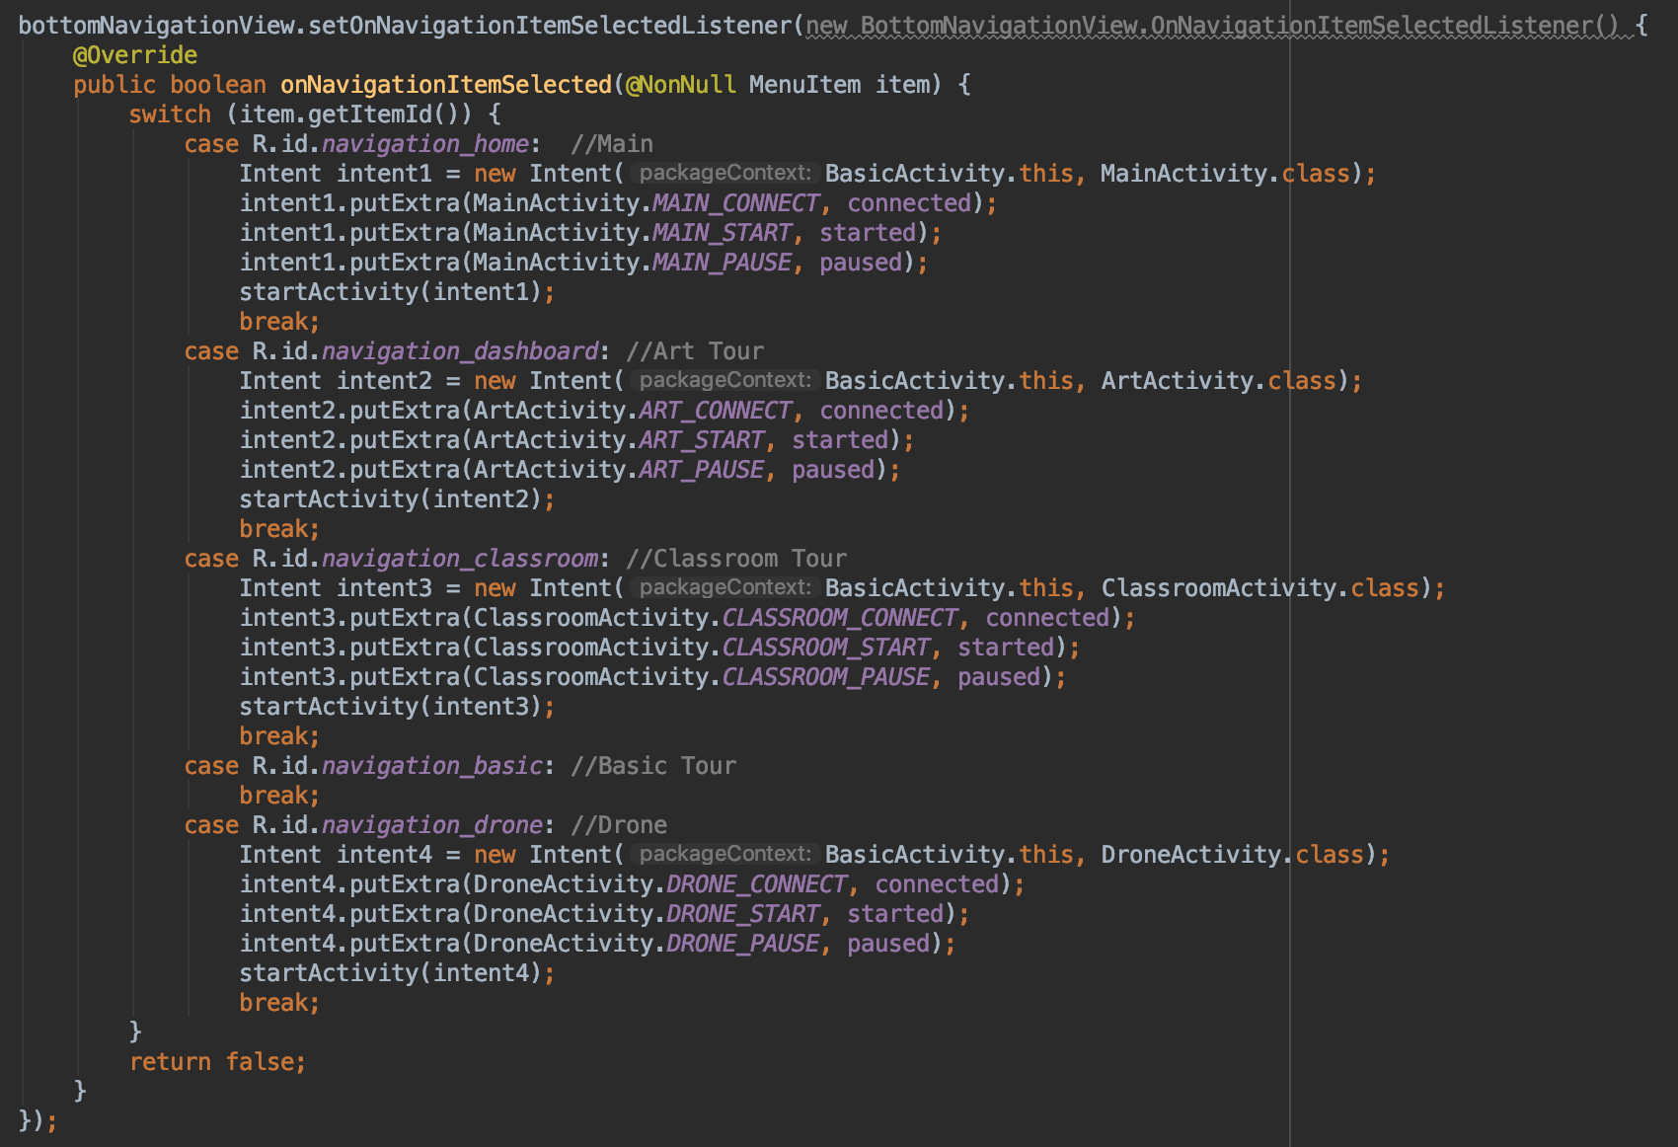

Figure 26: Basic Activity switch pages function defined

The basic function first checks to see if the connected boolean value is true. If connected is true then the function will create a new MqttMessage and this message is then set to basic, an alert will pop up at the bottom of the screen that says basic to tell the user that the basic tour is start, and the started boolean value is set to true. The function then publishes the message to the topic and client defined in the DroneActivity class. The function then goes through the array of destinations and makes a new MqttMessage with each destination and publishes that message to the topic and client defined in the DroneActivity class. If connected is false then an alert will pop up at the bottom of the screen to tell the user that they must connect to the drone before starting the basic tour.

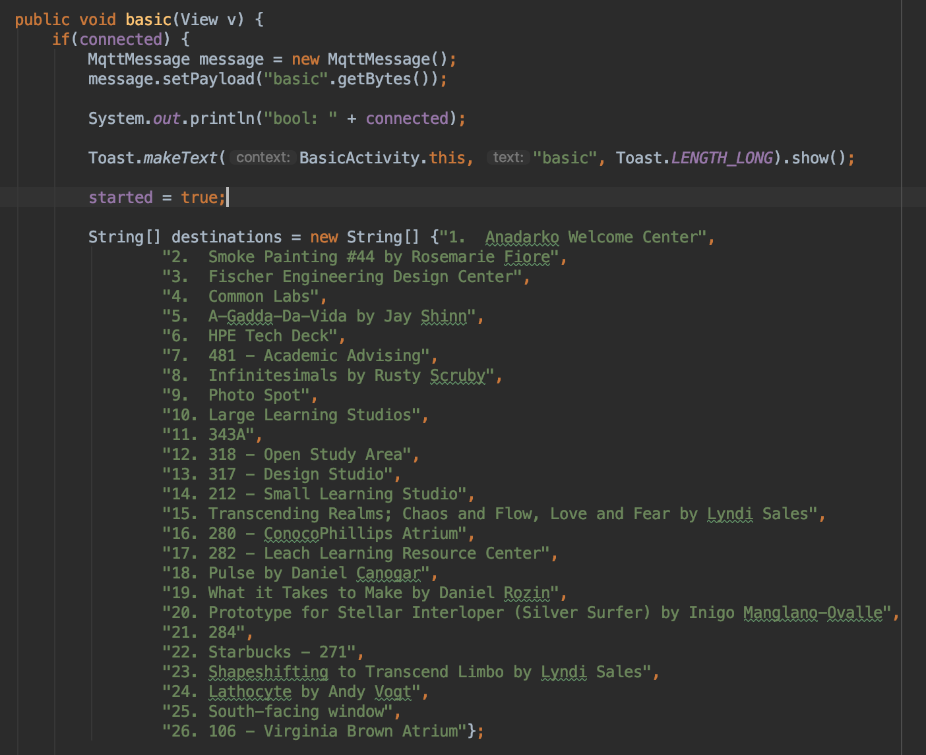

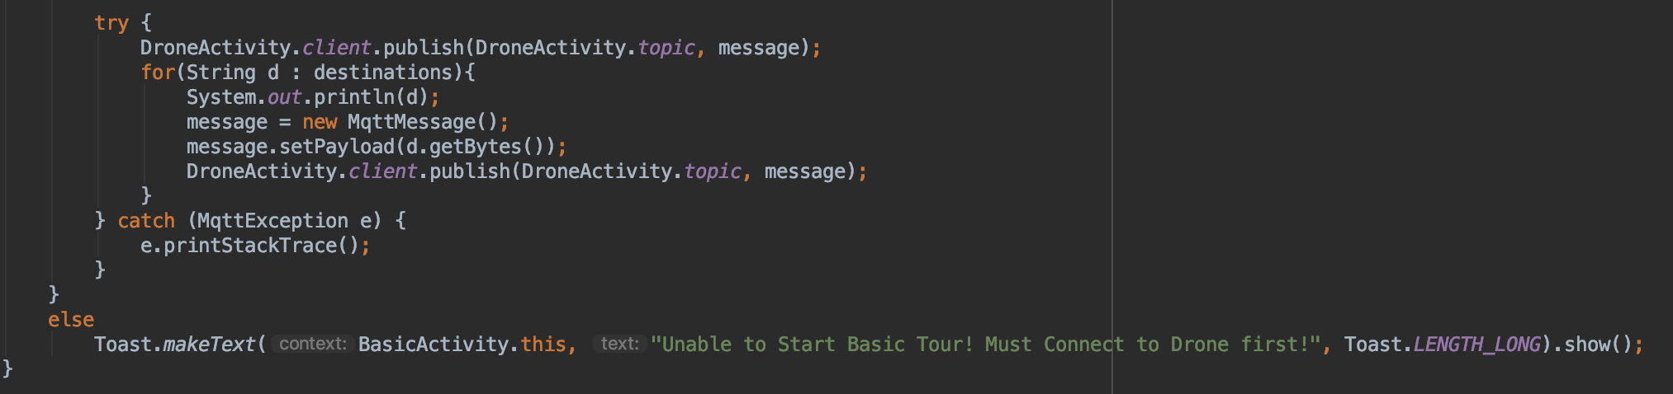

Figure 27: Basic Activity basic function defined

#### ***3.2.4. DroneActivity.java***

DroneActivity.java contains five strings, three boolean values, a MqttAndroidClient and six main functions. The three of the strings are used to pass the boolean values between the different pages within the application. The other two strings are used to store the client connection address and topic for the client. The six functions are on create, connect, pause, resume, end and disconnect functions. The three strings used to pass boolean values are DRONE_CONNECT, DRONE_START and DRONE_PAUSE. The two strings strings used to store the client information are MQTTHOST and topic. The DRONE_CONNECT string is used to store the connected boolean value. The DRONE_START string is used to store the started boolean value. The DRONE_PAUSE string is used to store the started boolean value. The MQTTHOST string is used to store the connection address for the client, which is a tcp connection to the ip address of the drone’s Raspberry Pi 3 B and the port number 1883. The topic string is used to store the topic used for this project, which is “zach/drone/rpi/tour”. The three boolean values are used to make sure the user can online push certain buttons. The three boolean values are connected, started and paused. The connected value is used to make the user connect to the drone first before doing anything else. The paused value is used to make the user pause a tour first before resuming a tour. The started value is used to make the user start a tour first before pausing, resuming or ending a tour. The on create function has a sub-function in it that deals with the changing the pages within the application. The classroom function has a string array that has all of the destination that the basic tour will visit.

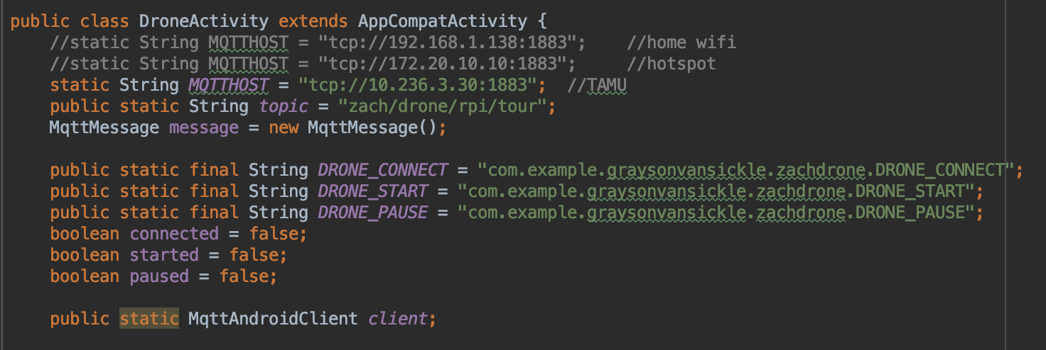

Figure 28: Drone Activity strings and booleans defined

The on create function starts the drone activity layout xml file and displays this layout to the application. The function then sets the drone item in the bottom navigation bar to be the selected item. The function also checks to see if the intent has an extra named DRONE_CONNECT, DRONE_START or DRONE_PAUSE. If the intent has an DRONE_CONNECT extra then the connected boolean value is set to the value of the intent’s DRONE_CONNECT extra. If the intent has an DRONE_START extra then the started boolean value is set to the value of the intent’s DRONE_START extra. If the intent has an DRONE_PAUSE extra then the paused boolean value is set to the value of the intent’s DRONE_PAUSE extra. If the intent doesn’t have any of the extras then the boolean values will stay as false. The sub-function of the on create function takes the user input and then switches the current page of the application to the one the user selected.

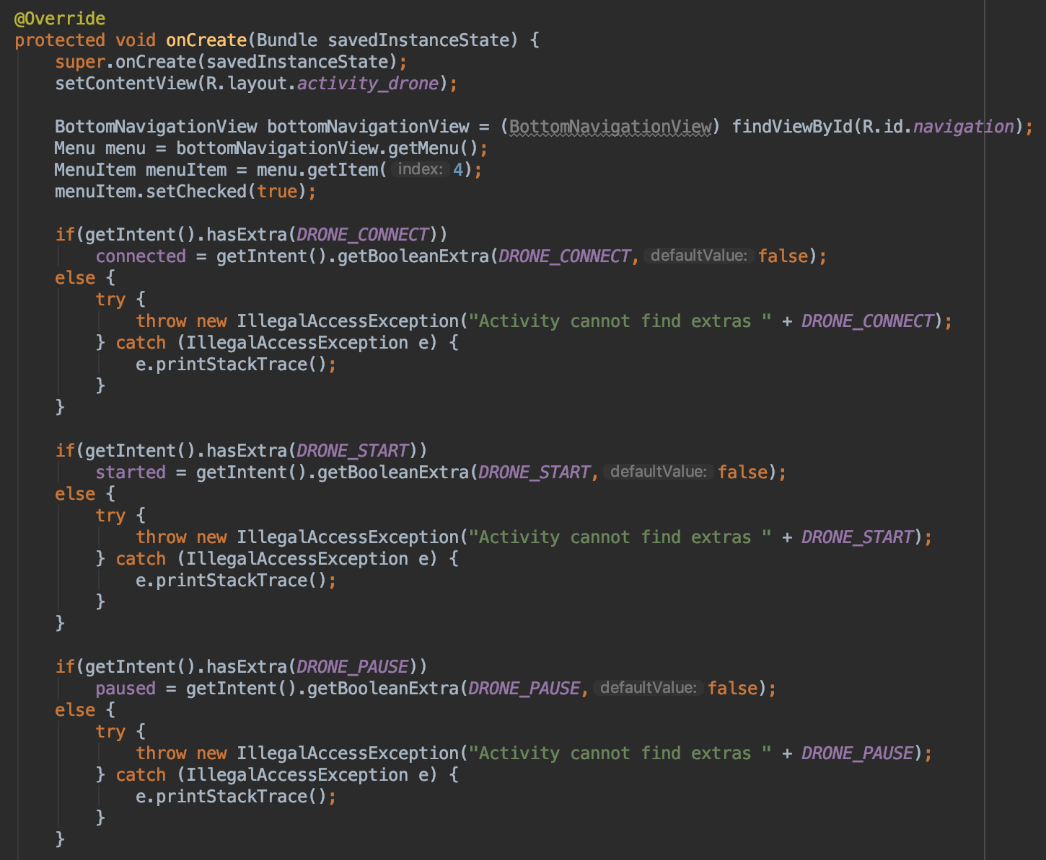

Figure 29: Drone Activity on create function defined

If the user selected the Main page in the bottom navigation bar, then a new intent is made that connects the DroneActivity class to the MainActivity class. The connected boolean value is then added to this intent as an extra named MAIN_CONNECT. The started boolean value is then added to this intent as an extra named MAIN_START. The paused boolean value is then added to this intent as an extra named MAIN_PAUSE. The intent created from the DroneActivity class to the MainActivity class is then started so the application will then run the MainActivity.java file. If the user selected the Art Tour page in the bottom navigation bar, then a new intent is made that connects the DroneActivity class to the ArtActivity class. The connected boolean value is then added to this intent as an extra named ART_CONNECT. The started boolean value is then added to this intent as an extra named ART_START. The paused boolean value is then added to this intent as an extra named ART_PAUSE. The intent created from the DroneActivity class to the ArtActivity class is then started so the application will then run the ArtActivity.java file. If the user selected the Classroom Tour page in the bottom navigation bar, then a new intent is made that connects the DroneActivity class to the ClassroomActivity class. The connected boolean value is then added to this intent as an extra named CLASSROOM_CONNECT. The started boolean value is then added to this intent as an extra named CLASSROOM_START. The paused boolean value is then added to this intent as an extra named CLASSROOM_PAUSE. The intent created from the DroneActivity class to the ClassroomActivity class is then started so the application will then run the ClassroomActivity.java file. If the user selected the Basic Tour page in the bottom navigation bar, then a new intent is made that connects the DroneActivity class to the BasicActivity class. The connected boolean value is then added to this intent as an extra named BASIC_CONNECT. The started boolean value is then added to this intent as an extra named BASIC_START. The paused boolean value is then added to this intent as an extra named BASIC_PAUSE. The intent created from the DroneActivity class to the BasicActivity class is then started so the application will then run the BasicActivity.java file.

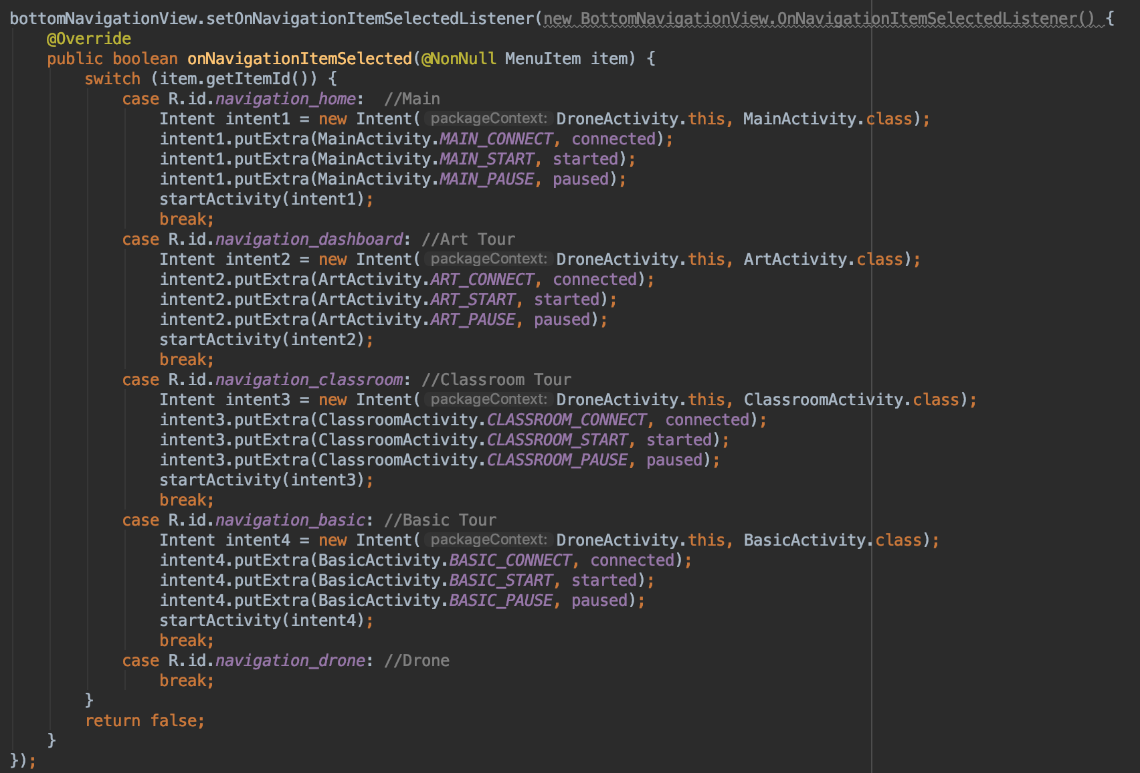

Figure 30: Drone Activity switch pages function defined

The connect function first checks to see if the connected boolean value is false. If connected is false then the function will create string for the client id of “Zach Drone Android Device”, create the MqttAndroidClient using the MQTTHOST and client id strings, set the connected boolean value to true, create a new MqttConnectOptions object, and then connect to the client using the options object. The function then checks if the connection was successful or not. If the connection was successful then the function creates a new MqttMessage that says connect, publishes that message to the topic defined earlier, and an alert will pop up at the bottom of the screen to tell the user the connection was successful. If the connection was unsuccessful then an alert will pop up at the bottom of the screen to tell the user the connection failed. If connected is true then an alert will pop up at the bottom of the screen to tell the user they are already connected to the drone.

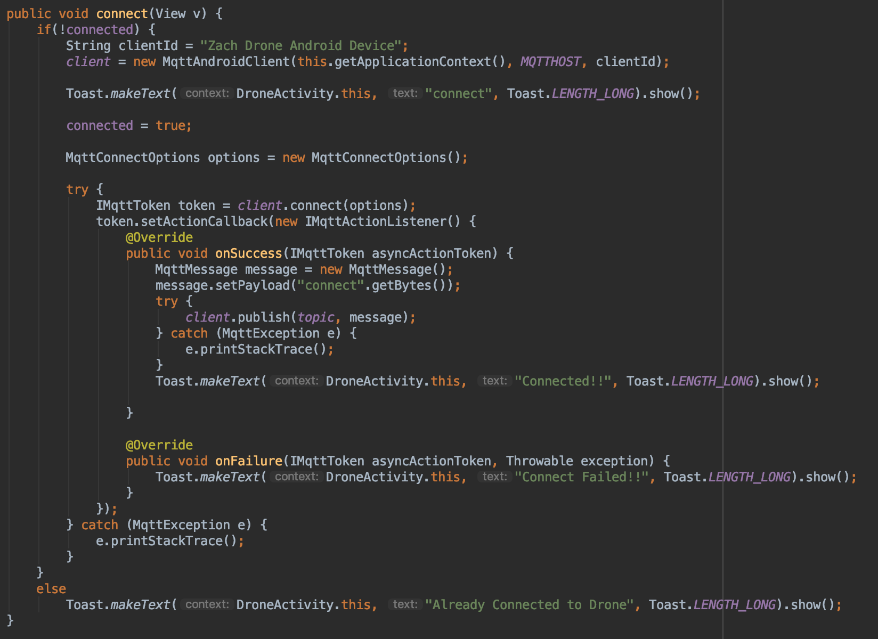

Figure 31: Drone Activity connect function defined

The pause function first checks to see if the connected and started boolean values are true, and the paused boolean value is false. If connected and started are true and pause is false then the function creates a new MqttMessage that says pause, an alert pops up at the bottom of the screen that says pause to tell the user the tour is paused, and the paused boolean value is set to true. The function then publishes the message to the topic defined earlier. If connected is true and started is false then an alert pops up at the bottom of the screen to tell the user to start a tour before pausing a tour. If connected and started are false then an alert pops up at the bottom of the screen to tell the user to connect to the drone and start a tour before pausing a tour.

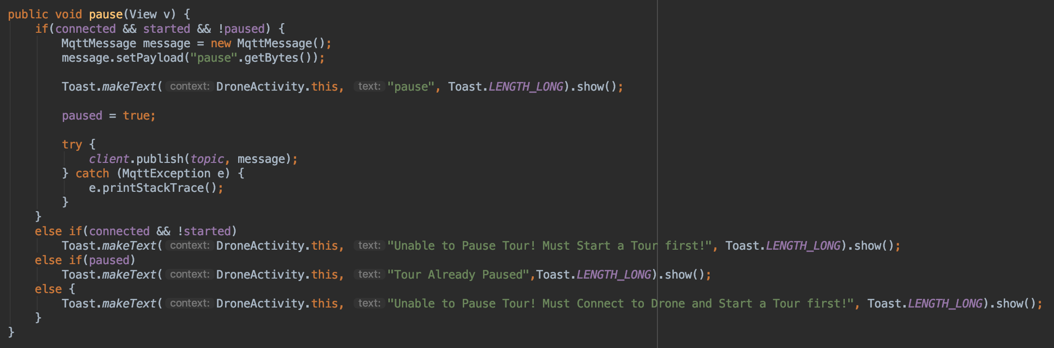

Figure 32: Drone Activity pause function defined

The resume function first checks to see if the connected and paused boolean values are true. If connected and paused are true then the function creates a new MqttMessage that says resume, an alert pops up at the bottom of the screen that says resume to tell the user the tour is resumed, and the paused boolean value is set to false. The function then publishes the message to the topic defined earlier. If connected is true and paused is false then an alert pops up at the bottom of the screen to tell the user to pause a tour before resuming a tour. If connected and paused are false then an alert pops up at the bottom of the screen to tell the user to connect to the drone and pause a tour before resuming a tour.

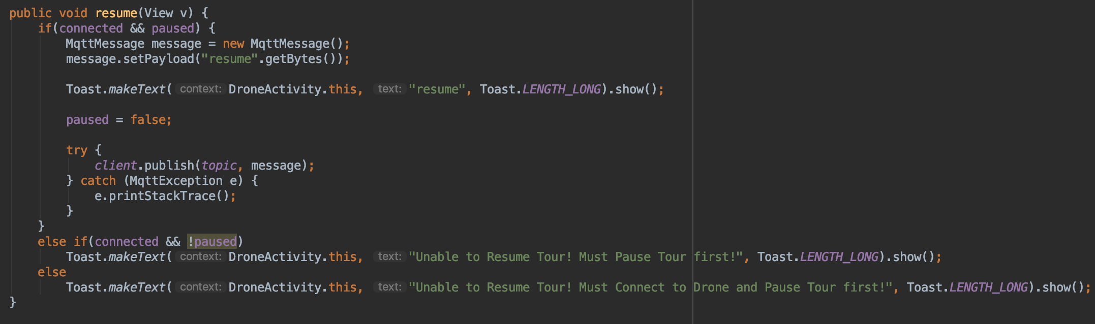

Figure 33: Drone Activity resume function defined

The end function first checks to see if the connected and started boolean values are true. If connected and started are true then then function creates a new MqttMessage that says end, an alert pops up at the bottom of the screen that says end to tell the user the tour is ended, and the started boolean value is set to false. The function then publishes the message to the topic defined earlier. If connected is true and started is false then an alert pops up at the bottom of the screen to tell the user to start a tour before ending a tour. If connected and started are false then an alert pops up at the bottom of the screen to tell the user to connect to the drone and start a tour before ending a tour.

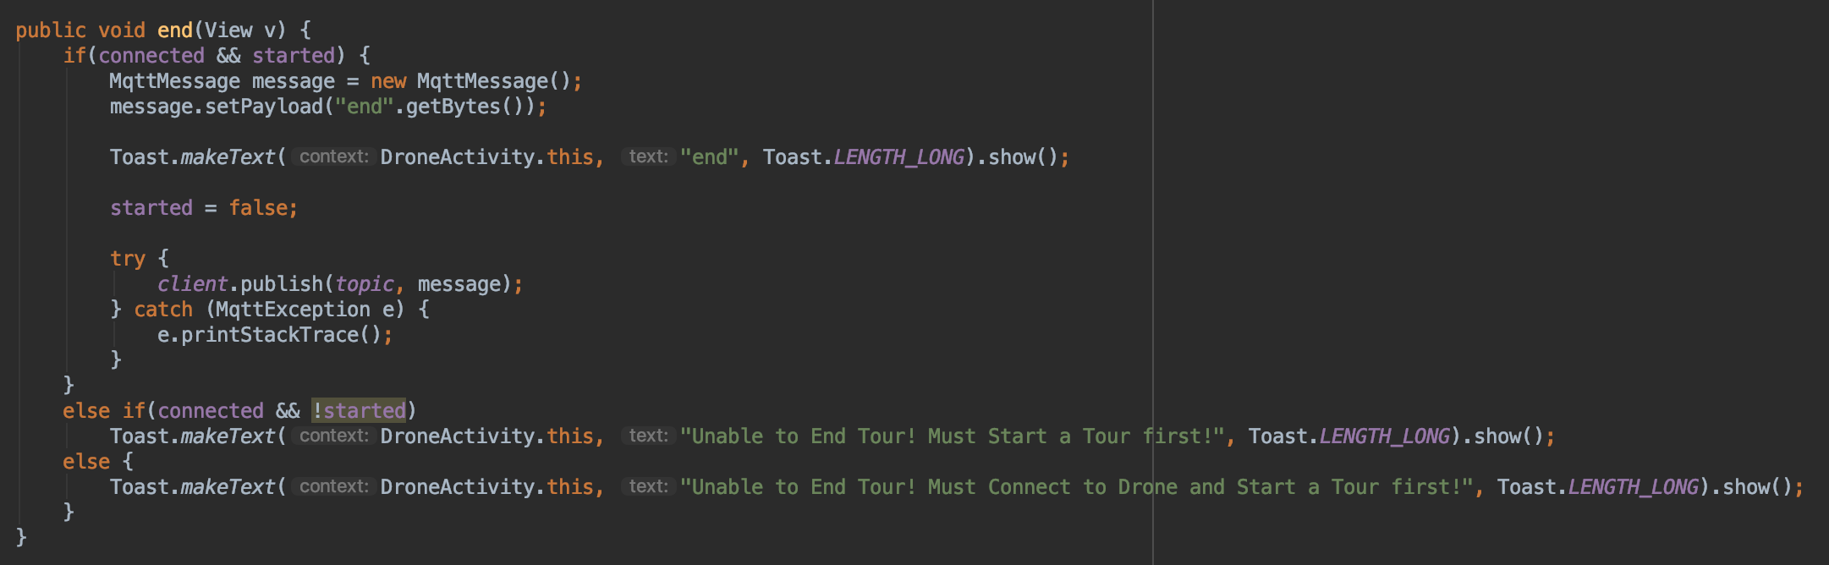

Figure 34: Drone Activity end function defined

The disconnect function first checks to see if the connected boolean value is true. If connected ist true then the function will create a new MqttMessage and this message is then set to disconnect, an alert will pop up at the bottom of the screen that says disconnect to tell the user that the application was disconnected from the drone, and the connected boolean value is set to false. The function then publishes the message to the topic defined earlier. The function then checks if the disconnection was successful or not. If the disconnection was successful then an alert will pop up at the bottom of the screen to tell the user the disconnection was successful. If the disconnection was unsuccessful then an alert will pop up at the bottom of the screen to tell the user the disconnection failed. If connected is false then an alert will pop up at the bottom of the screen to tell the user that they must connect to the drone before disconnecting from the drone.

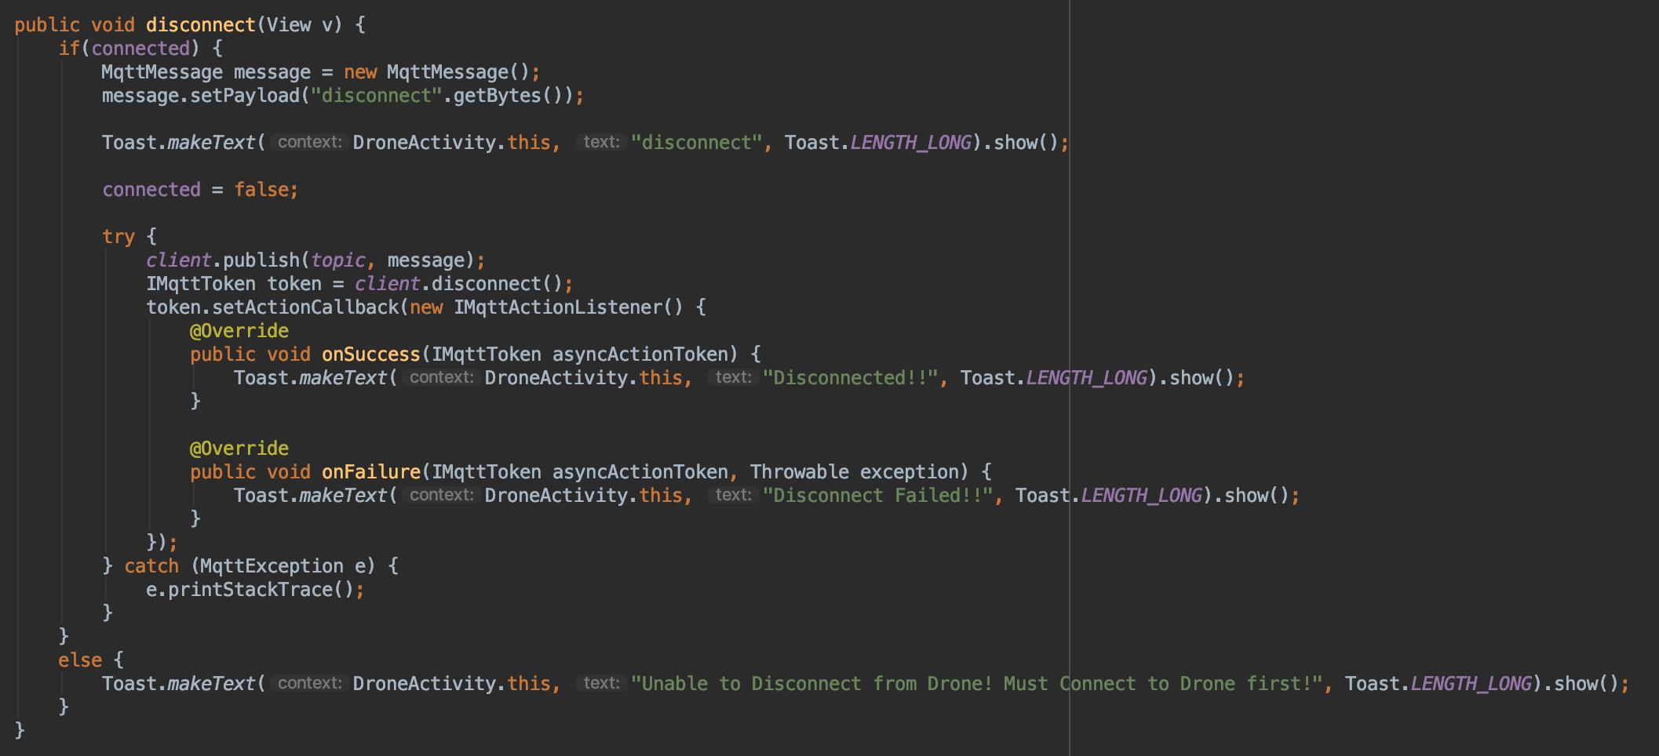

Figure 35: Drone Activity disconnect function defined

#### ***3.2.5. MainActivity.java***

MainActivity.java contains three strings, three boolean values, and one main function, on create function. The three strings are used to pass the boolean values between the different pages within the application. The three strings are MAIN_CONNECT, MAIN_START and MAIN_PAUSE. The MAIN_CONNECT string is used to store the connected boolean value. The MAIN_START string is used to store the started boolean value. The MAIN_PAUSE string is used to store the started boolean value. The three boolean values are used to make sure the user can online push certain buttons. The three boolean values are connected, started and paused. The connected value is used to make the user connect to the drone first before doing anything else. The paused value is used to make the user pause a tour first before resuming a tour. The started value is used to make the user start a tour first before pausing, resuming or ending a tour. The on create function has a sub-function in it that deals with the changing the pages within the application.

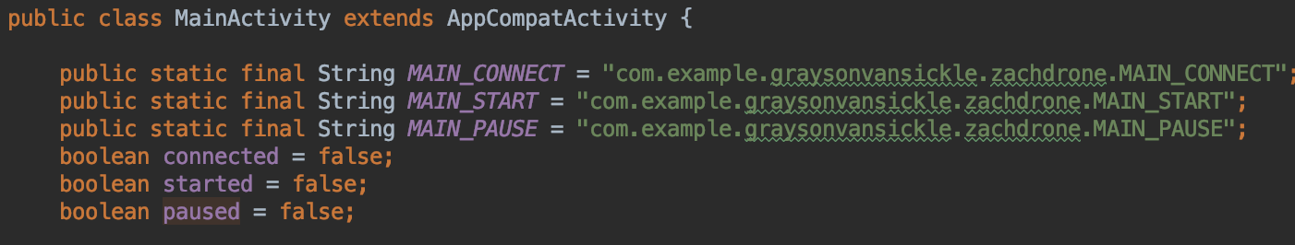

Figure 36: Main Activity strings and booleans defined

The on create function starts the main activity layout xml file and displays this layout to the application. The function then sets the main item in the bottom navigation bar to be the selected item. The function also checks to see if the intent has an extra named MAIN_CONNECT, MAIN_START or MAIN_PAUSE. If the intent has an MAIN_CONNECT extra then the connected boolean value is set to the value of the intent’s MAIN_CONNECT extra. If the intent has an MAIN_START extra then the started boolean value is set to the value of the intent’s MAIN_START extra. If the intent has an MAIN_PAUSE extra then the paused boolean value is set to the value of the intent’s MAIN_PAUSE extra. If the intent doesn’t have any of the extras then the boolean values will stay as false. The sub-function of the on create function takes the user input and then switches the current page of the application to the one the user selected.

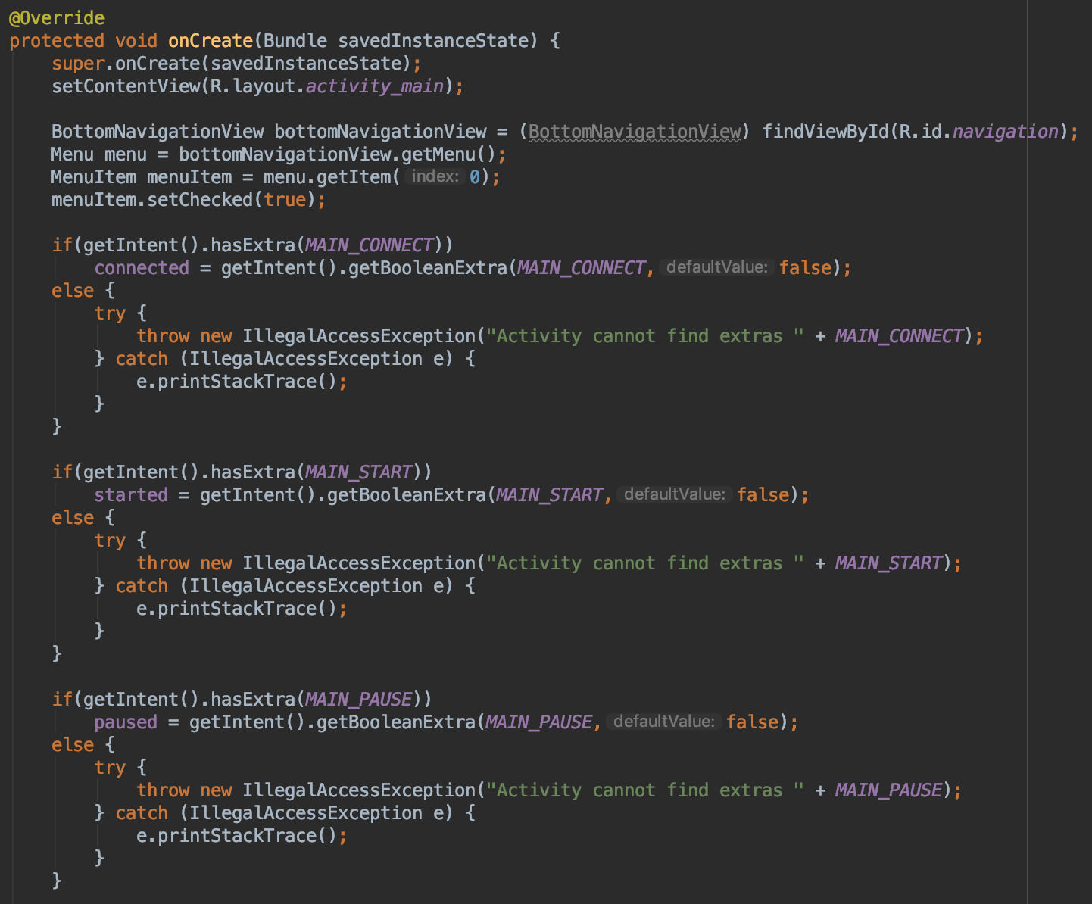

Figure 37: Main Activity on create function defined

If the user selected the Art Tour page in the bottom navigation bar, then a new intent is made that connects the MainActivity class to the ArtActivity class. The connected boolean value is then added to this intent as an extra named ART_CONNECT. The started boolean value is then added to this intent as an extra named ART_START. The paused boolean value is then added to this intent as an extra named ART_PAUSE. The intent created from the MainActivity class to the ArtActivity class is then started so the application will then run the ArtActivity.java file. If the user selected the Classroom Tour page in the bottom navigation bar, then a new intent is made that connects the MainActivity class to the ClassroomActivity class. The connected boolean value is then added to this intent as an extra named CLASSROOM_CONNECT. The started boolean value is then added to this intent as an extra named CLASSROOM_START. The paused boolean value is then added to this intent as an extra named CLASSROOM_PAUSE. The intent created from the MainActivity class to the ClassroomActivity class is then started so the application will then run the ClassroomActivity.java file. If the user selected the Basic Tour page in the bottom navigation bar, then a new intent is made that connects the MainActivity class to the BasicActivity class. The connected boolean value is then added to this intent as an extra named BASIC_CONNECT. The started boolean value is then added to this intent as an extra named BASIC_START. The paused boolean value is then added to this intent as an extra named BASIC_PAUSE. The intent created from the MainActivity class to the BasicActivity class is then started so the application will then run the BasicActivity.java file. If the user selected the Drone page in the bottom navigation bar, then a new intent is made that connects the MainActivity class to the DroneActivity class. The connected boolean value is then added to this intent as an extra named DRONE_CONNECT. The started boolean value is then added to this intent as an extra named DRONE_START. The paused boolean value is then added to this intent as an extra named DRONE_PAUSE. The intent created from the MainActivity class to the DroneActivity class is then started so the application will then run the DroneActivity.java file.

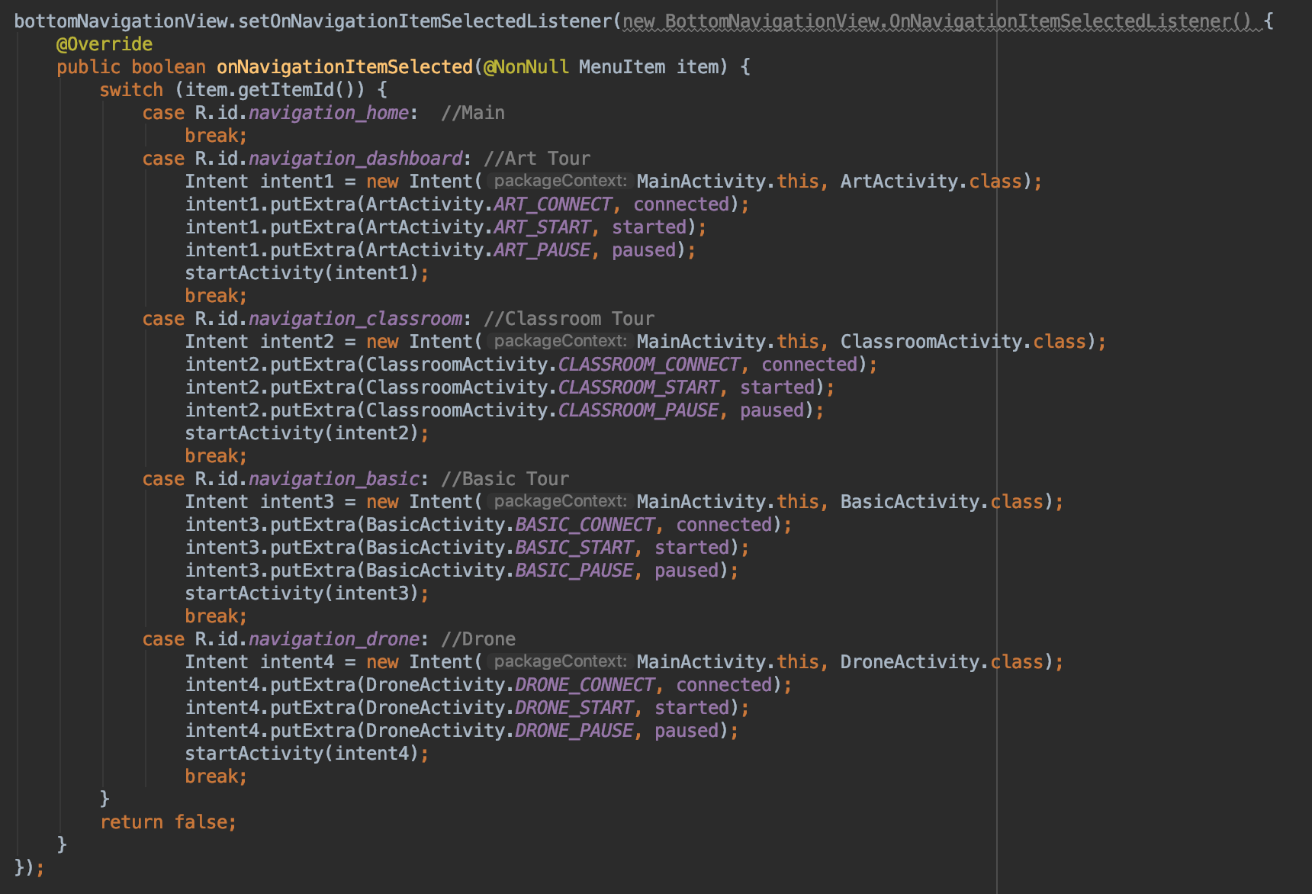

Figure 38: Main Activity switch pages function defined

## ***3.3. Python*** C***ode***

The message decoder for the mobile application subsystem is written in python and takes in messages from the Mosquitto server. These messages are then decoded in the python program and outputs an appropriate message that will be later sent to the navigation subsystem.

#### ***3.3.1. Client.py***

Client.py contains two functions. These two functions are the message decoder and the connection status. The message decoder takes the message received from the client and then outputs the correct action based on the message received. The connection status function subscribes the client to the correct topic so that the client can see the messages that are published to this topic. The client is created using Eclipse Paho given the client name, which in this case is just Zach Drone Raspberry PI. The client is connected to the defined server address, which is the IP address of the Raspberry Pi on the WiFi. When the client is connected to the server, the program runs the connection status function. When the client receives a message from the server, the program runs the message decoder function. The client runs forever, unless the user connects to the Raspberry Pi and terminates the program.

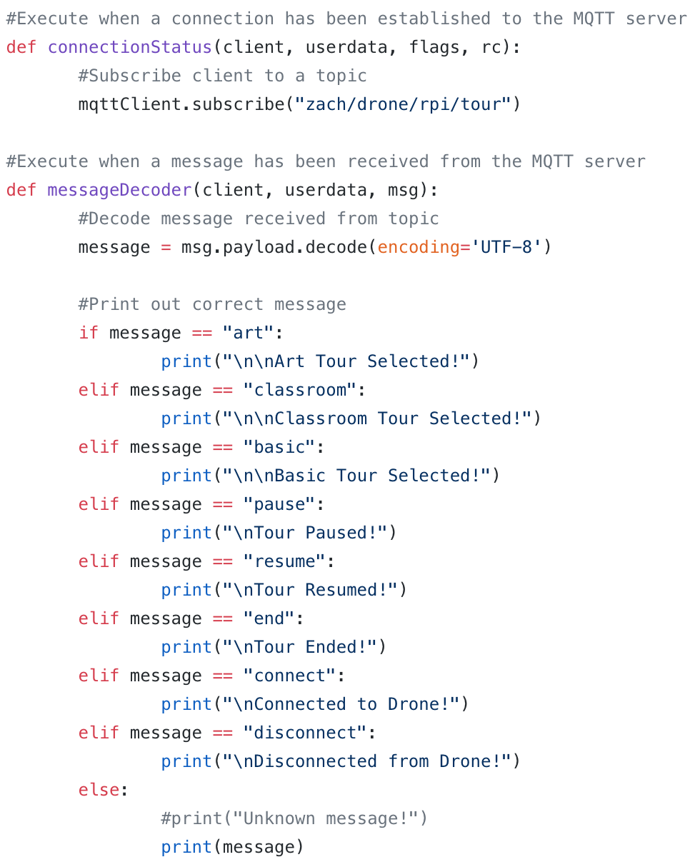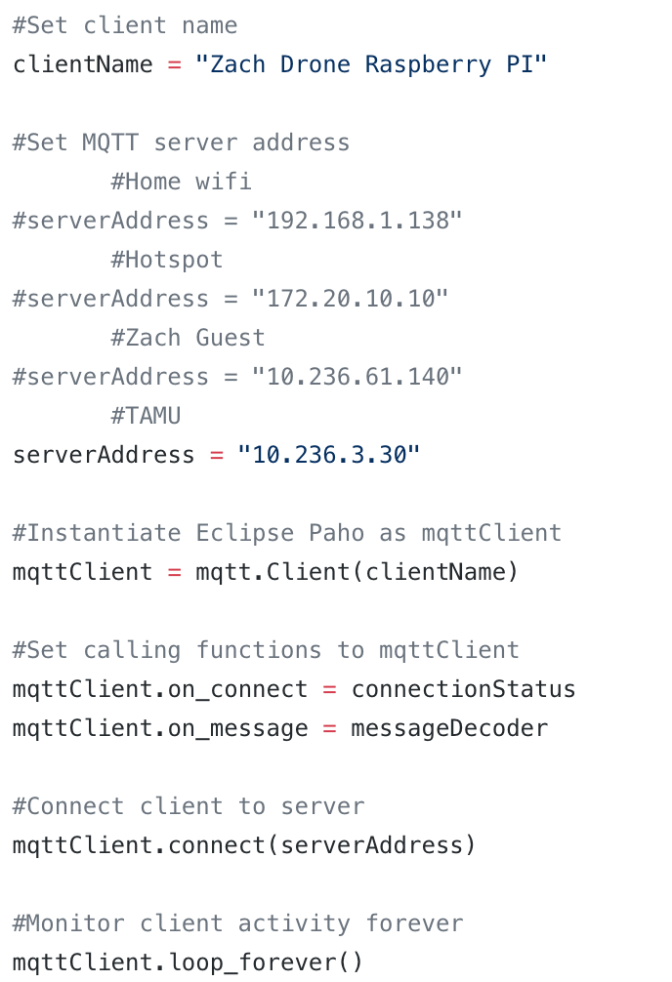

Figure 39: Defined functions (left) and variables (right) for the client.py code

## ***3.4. Mobile Application Layout***

The mobile application subsystem is dependent on the layout of the application to make the app easy for the user to interact with. The application takes input from the user and then outputs the correct action to the drone’s microcontroller. The application is written for both Android and iOS platforms.

#### ***3.4.1. Android Application Layout***

The layout of the Android application is written using the Android Studio application on a Macbook Pro. The application is separated into 5 different pages, which in Android Studio are written as xml files. On the main page there is just the name of the project and the team member’s names. On the art tour, classroom tour and basic tour pages the list of all the destinations for that particular tour are listed in order and there is a button that will start that tour. On the drone page there are buttons to connect to and disconnect from the drone, along with buttons to pause, resume and end the current tour. All the buttons on the pages follow the app logic in figure 2 and will send the correct information to the message decoder on the drone’s Raspberry Pi 3 B.

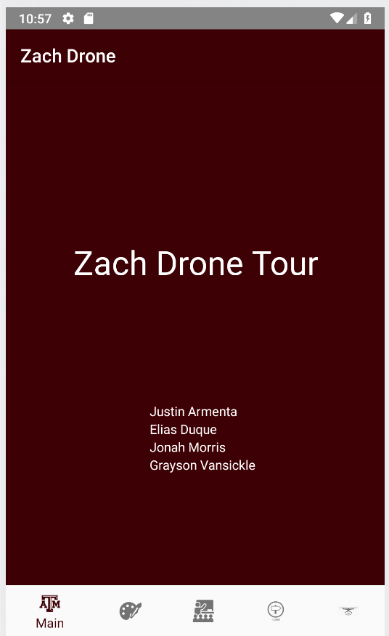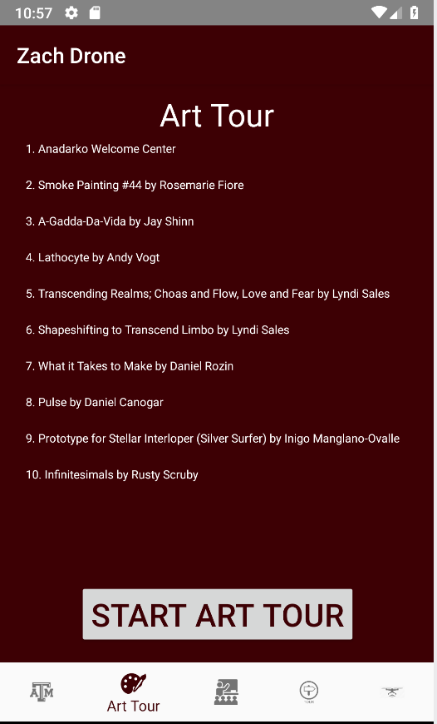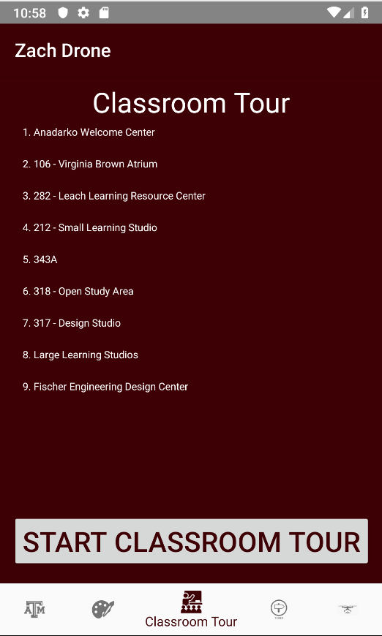

Figure 40: Android Application Layout (Main, Art Tour and Classroom Tour pages above; Basic Tour and Drone pages below)

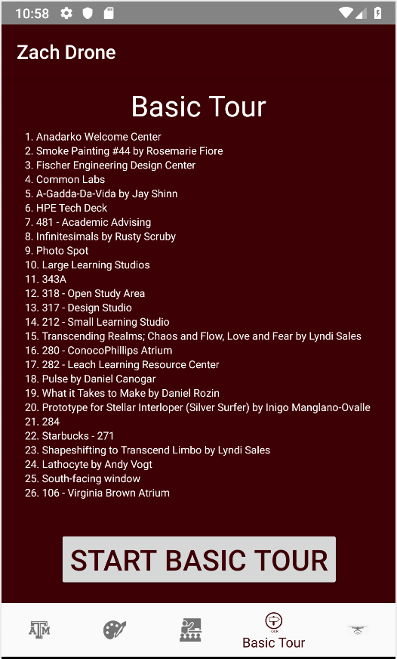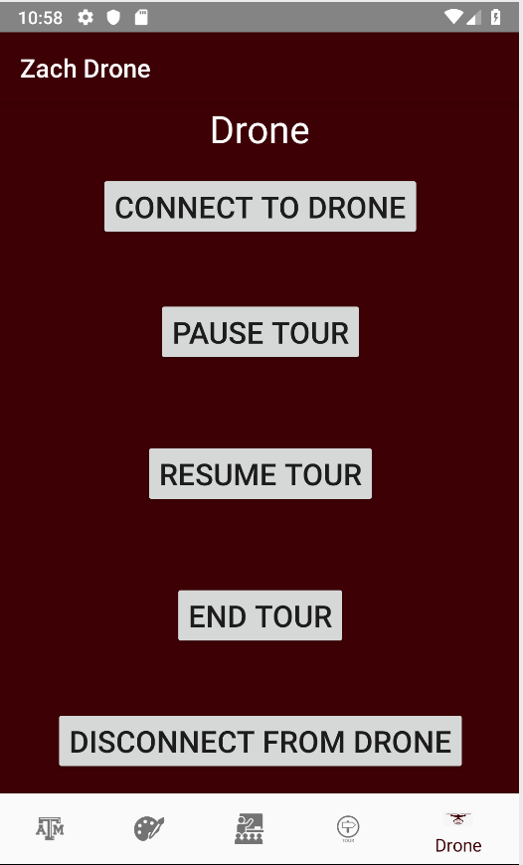

#### ***3.4.2. iOS Application Layout***

The layout of the iOS application is written using the Xcode application on a Macbook Pro. The application is separated into 5 different pages, which in Xcode are written one Main.storyboard file and given separate view controllers. On the main page there is just the name of the project and the team member’s names. On the art tour, classroom tour and basic tour pages the list of all the destinations for that particular tour are listed in order and there is a button that will start that tour. On the drone page there are buttons to connect to and disconnect from the drone, along with buttons to pause, resume and end the current tour. All the buttons on the pages follow the app logic in figure 2 and will send the correct information to the message decoder on the drone’s Raspberry Pi 3 B.

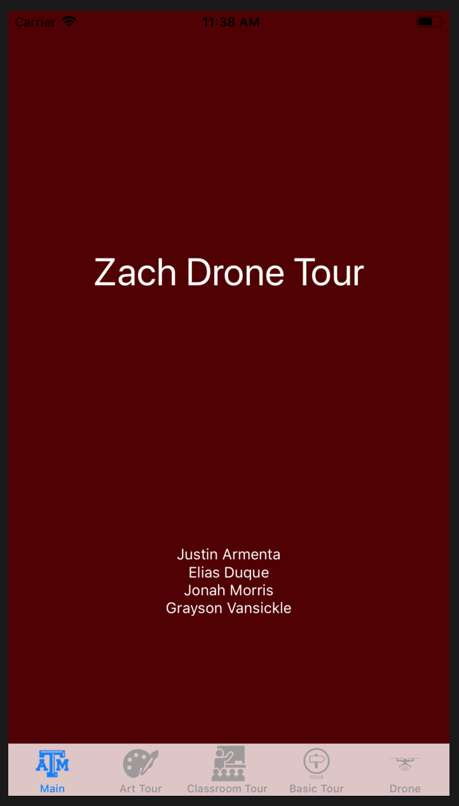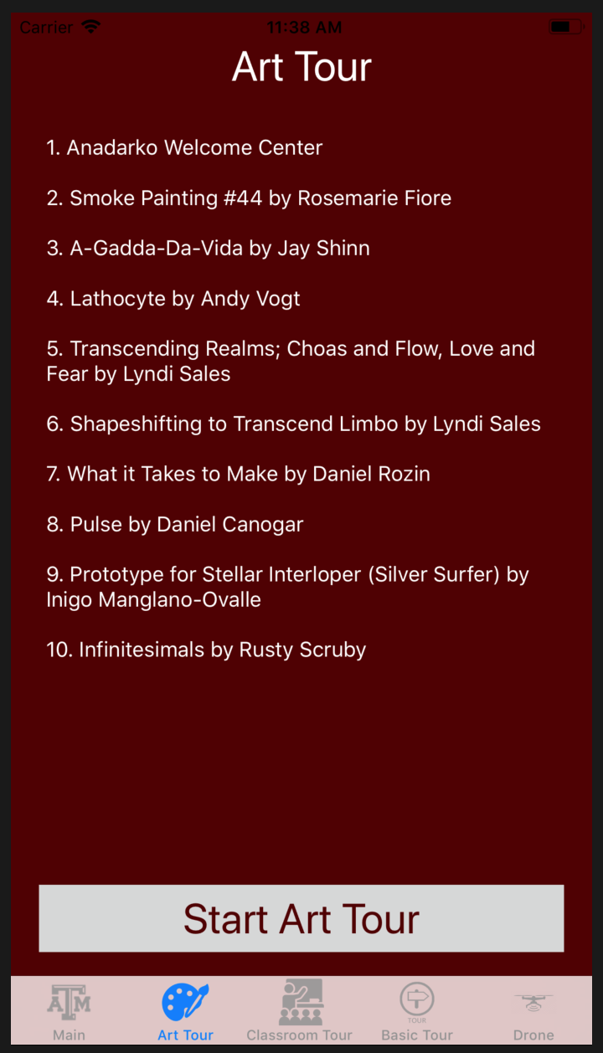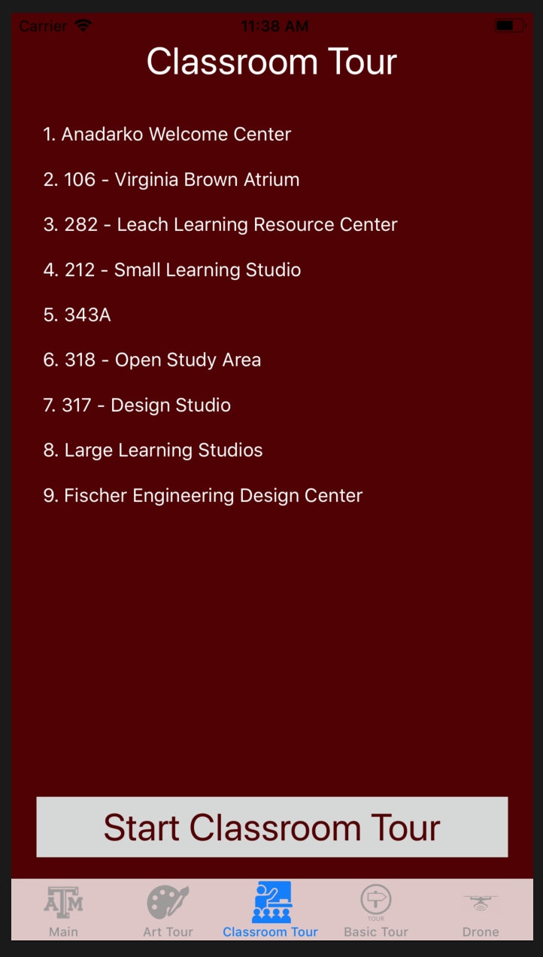

Figure 41: iOS Application Layout (Main, Art Tour and Classroom Tour pages above; Basic Tour and Drone pages below)

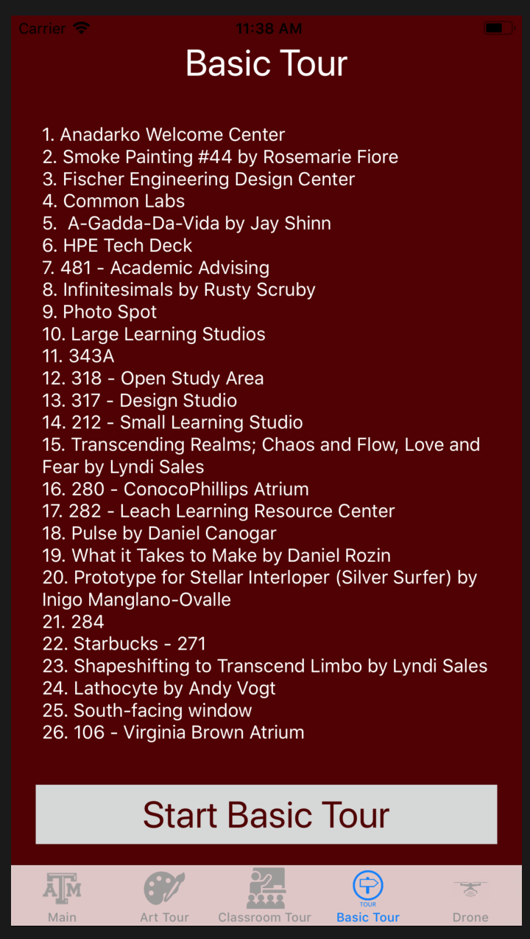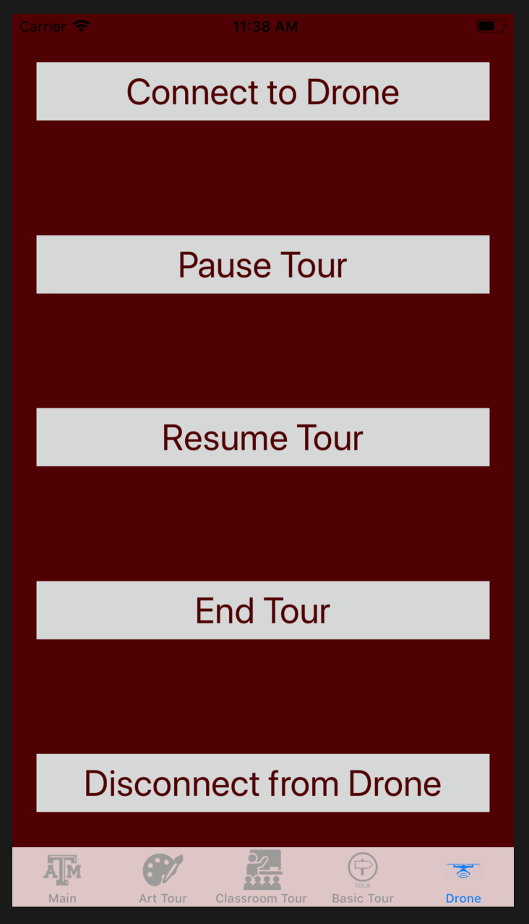

# **4. Operation**

In order to show the mobile application subsystem working without connecting it to the other subsystems, statements were printed to the console to show the buttons working as expected. The statements were added to both the iOS and Android applications. A python code file was written to show that the buttons sent the right messages to the drone’s Raspberry Pi 3 B.

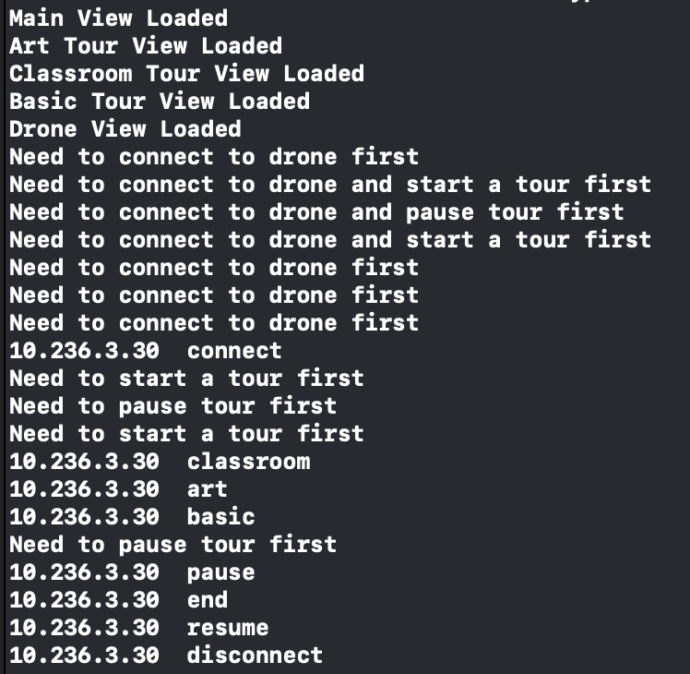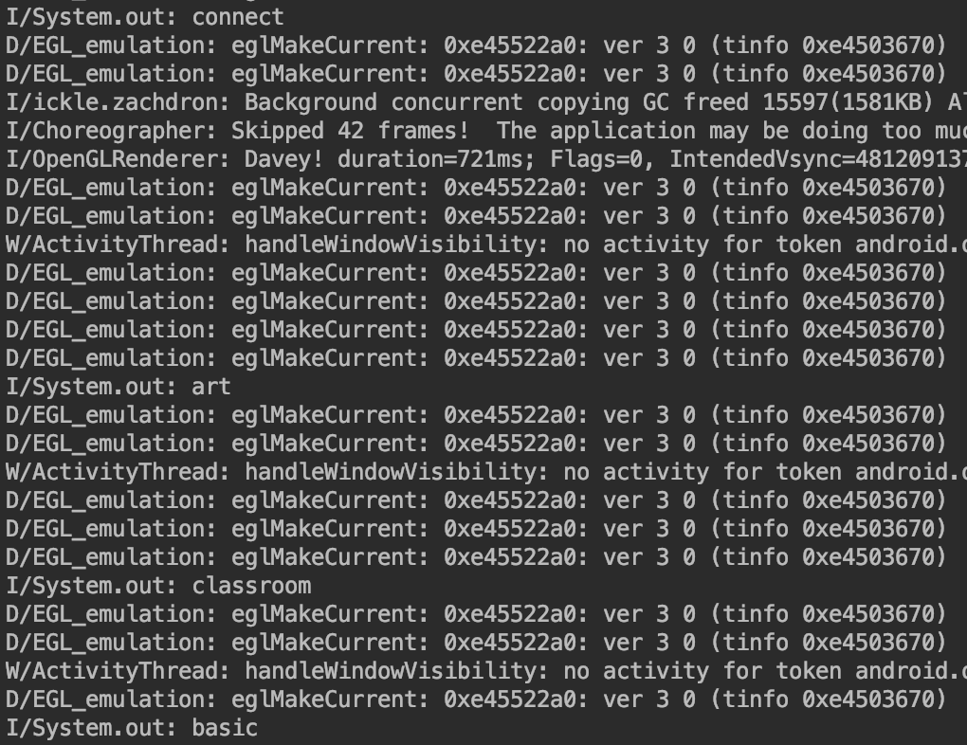

Figure 42: Terminal output for iOS (left) and Android (right) applications

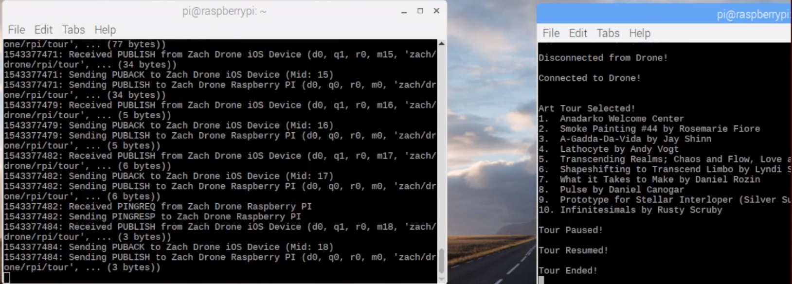

Figure 43: Terminal output for Raspberry Pi 3 B on drone

# **5. Data Collection**

Since this application wasn’t connected to any of the other subsystems, there wasn’t any actual data since all the application does is send a string to the drone. The string sent to the drone will eventually be passed into the navigation subsystem’s function so that the correct tour is started on the drone. However, when sending the destinations to the drone multiple times there was sometimes missing destinations on the drone.

# **6. Accomplishments**

Throughout the semester, the mobile application subsystem reached many accomplishments. The mobile apps were able to be loaded onto test iOS and Android devices. Using the applications on the devices, the apps were able to connect to the drone’s onboard Raspberry Pi 3 B. The applications were also able to send the three different tours to the Pi and send commands to pause, resume and end a tour. The user was able to communicate with the drone and send it messages that will be used to control the drone.

# **7. Future Work**

Although the mobile application was able to send messages to the drone’s Raspberry Pi 3 B, there are some changes that needed to be made to make the mobile application easier to incorporate with the other subsystems. The application will need to made faster to connect to the drone and send messages to the drone. The message decoder function on the drone’s Raspberry Pi needs to be changed to better decode the incoming messages on the drone. The main focus of next semester in ECEN 404 is to combine the mobile application with the other three subsystems of the Zach Drone project, the subsystem that will be most closely related to the mobile application is the navigation subsystem.

# **8. Conclusion**

The iOS and Android applications performed very well and sent the messages to the drone quicker than I expected. The applications performed all of the functions it was supposed to and sent the correct messages to the drone. When the application is combined with the drone, there might need to be slight changes to the way the messages are sent or the message decoder to allow the drone to work efficiently. Looking forward to the next semester there is still work that needs to be done to make this a complete working project, but the mobile application subsystem was a great success for the amount of time in this semester. The task at hand for next semester isn’t an easy one, but completing the mobile application takes one thing off the list that needs to be finished next semester.

**Zach Drone**

Justin Armenta

###### **Navigation Subsystem Report**

REVISION – 1.2

5 December 2018

**Table of Contents**

**Table of Contents 91**

**List of Tables 92**

**List of Figures 92**

**1. Introduction 93**

**2. Theory 93**

2.1. Tracking Location of Drone 93

2.2. Outputting Speed Commands to PixHawk 93

**3. Design 95**

3.1. Python Codes

3.1.1. Map_Model.py

3.1.2. Navigation_Test.py

**4. Operation 96**

**5. Data Collection 100**

**6. Accomplishments 100**

**7. Future Work 101**

**8. Conclusion 101**

# **List of Figures**

**Figure 1 - Navigation Subsystem** **94**

**Figure 2 - Checkpoint Algorithm** **95**

**Figure 3 - Declaring Dictionaries** **96**

**Figure 4 - Attributes of Destinations and Checkpoints** **96**

**Figure 5 - Beginning of Navigation Simulation** **97**

**Figure 6 - Data from Transition from Checkpoint A to Checkpoint B** **97**

**Figure 7 - Results at the End of Destination A** **98**

**Figure 8 - Results at the Beginning of Destination B 98**

**Figure 9 - End of Tour Simulation Results** **100**

# 

# **List of Tables**

No tables in this document.

# **1. Introduction**

The purpose of the navigation system is to determine the drone’s location within Zachry and navigate to the next destination based on this information. This subsystem will consist of six ultrasonic sensors that will be placed on the top, bottom, front, back, left, and right of the drone, as well as a Raspberry Pi 3 B to run the Python code, which takes the distance information from the sensors to navigate. Based on the current and previous values of the ultrasonic sensors the Raspberry Pi will determine if a new checkpoint has been reached using an algorithm that compares the sensor values to the map model or if it was a false reading and should be ignored. Based on the determined location a command for the forward speed, sideways speed, and up and down speed will be given to the flight controller. A model of Zachry has been written into the Raspberry Pi that gives the dimensions of all hallways that the drone will fly near. This will help the drone determine if it is at a new checkpoint or if a sensor value has made an error and should be ignored.

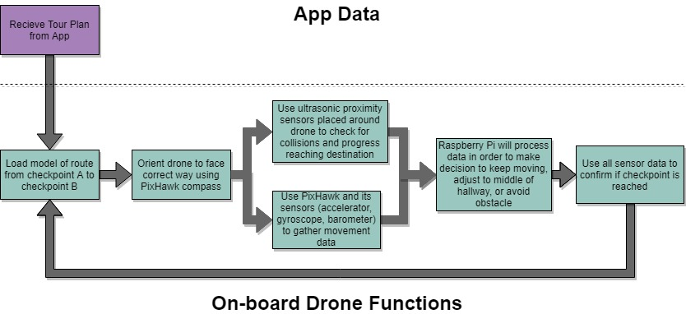

###### Figure 1: Navigation Subsystem

# **2. Theory**

## ***2.1. Tracking Location of Drone***

All hallways within Zachry have been inserted into the Raspberry Pi with different areas called “checkpoints” that make up the hallway. A “checkpoint” is an area with unique dimensions within the hallway, such as the area before a divot for a doorway appears on the right side of the wall. The key thing to note about every checkpoint is that there is a significant change to a particular side of a wall. Checkpoints were created as a point where ultrasonic sensors can see a large enough change that a flag can be thrown which starts the process of determining if this change in value was a sensor misreading or a new checkpoint being reached. Dimensions on each checkpoint were manually entered in the Raspberry Pi such as: the change in the left and right wall compared to the previous checkpoint, the distance from the beginning of the destination to the beginning of the checkpoint, the ceiling height, and wall width at the beginning of the checkpoint. All of this data is used in a checkpoint algorithm to determine which checkpoint the drone is located in. The Raspberry Pi will check to see if there is greater than 0.6 m change in the ultrasonic sensors compared to their last readings. If a large difference is detected the rest of the algorithm is ran to determine the checkpoint the drone is in. Since the ultrasonic sensors can only be relied on up to about 4 m away and some hallways are much wider than 12 m, every destination has a “side reliance” which basically means the drone will stay near one side of the hallway and rely on the ultrasonic sensor on the reliant side more than the other. The algorithm is shown below in figure 1.

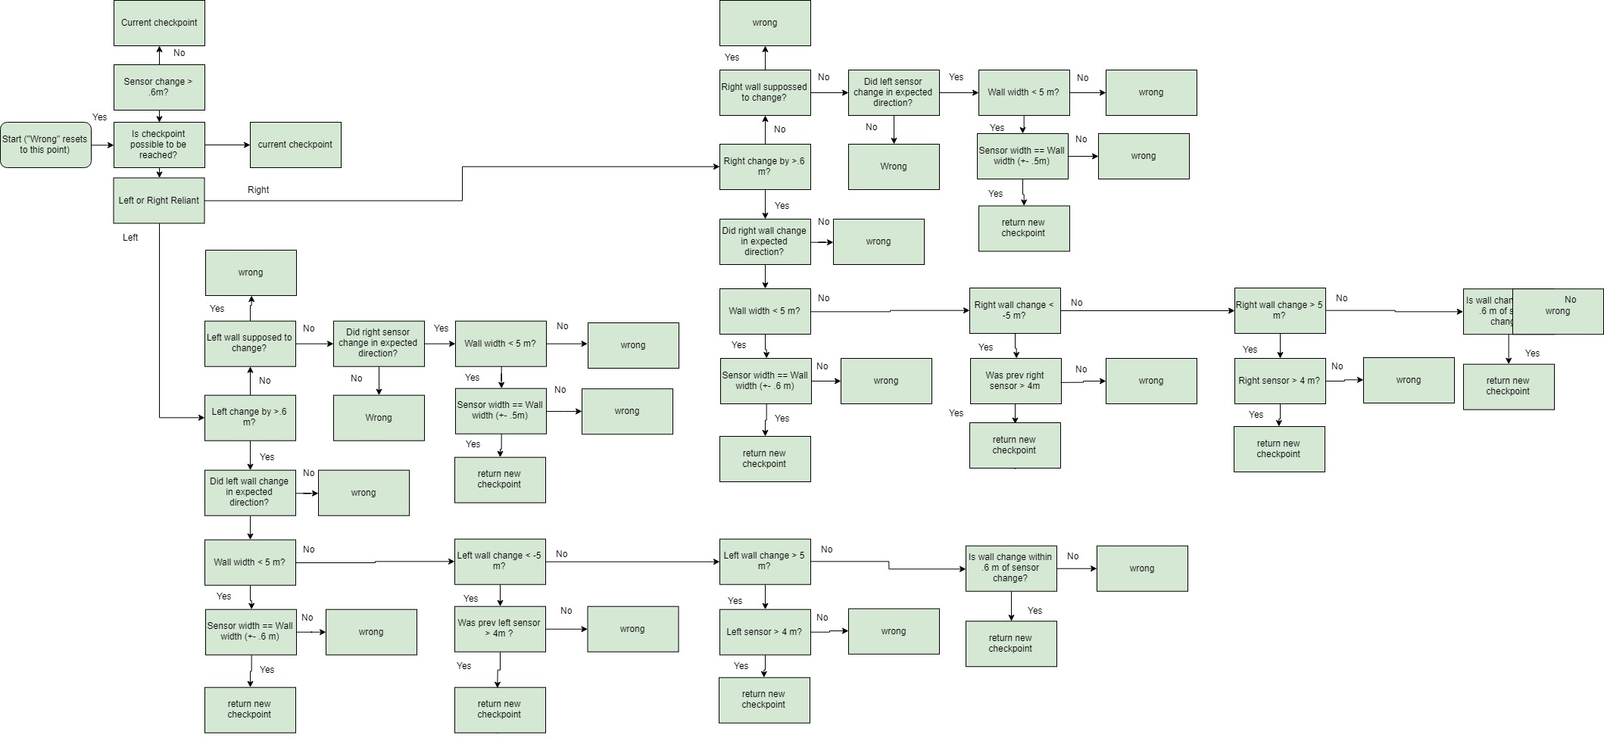

###### Figure 2: Checkpoint Algorithm

Once the last checkpoint has been reached within a destination, the “attraction” has been reached, which means the drone will give a speech about the attraction. At this point the drone will orient itself and load a new destination with all new checkpoints. When the last destination is reached this will signal the end of the tour.

## ***2.2. Outputting Speed Commands to PixHawk***

The drone speed is split into three different numbers based on which axes needs to move. The “z speed” is meant to be the forward/backward speed, the “x speed” is meant to be left/right speed, and the “y speed” is meant to be up/down speed. The z speed is defaulted to 2 (m/s) and will only change when an obstacle is detected in front of the drone, the destination has been reached and the drone needs to be stopped, or the tourists are too far/close and the drone needs to change speed. The y speed will be at 0 most of the time and it will be up to the flight controller to maintain altitude. The only time the y speed won’t be 0 is when the drone is actively changing floors and the drone needs to elevate to reach the next floor. The x speed will be determined by how close the drone thinks the left and right walls are to the drone. By default the x speed will be 0, but if the ultrasonic sensor on the left or right detects a wall within 1.2 m of the drone it will move away from the wall. Based on the side reliance it can also move towards the wall if there is supposed to be a wall closer than the sensor reads.

# **3. Design**

## ***3.1. Python Codes***

The navigation subsystem is entirely in python code and takes ultrasonic inputs and outputs speeds to the flight controller. The two main programs that will be used are the Map_Model.py and Navigation_Test.py.

#### ***3.1.1. Map_Model.py***

Map_Model.py contains only three actual functions. They all are very trivial functions that simply point to the next checkpoint or destination. The rest of the code is stating the dimensions of the building so Navigation_Test.py can call on that information later when the navigation function needs it to determine the current checkpoint. Dictionaries were used to create the attributes of the tour. The tour choice will be populated first between the art tour, class tour, or the basic tour. Then within a specific tour, all destinations within that tour’s dictionary will be declared. Then all the checkpoints within the destination will be declared. Shown below in figure 3 is the different dictionaries being declared.

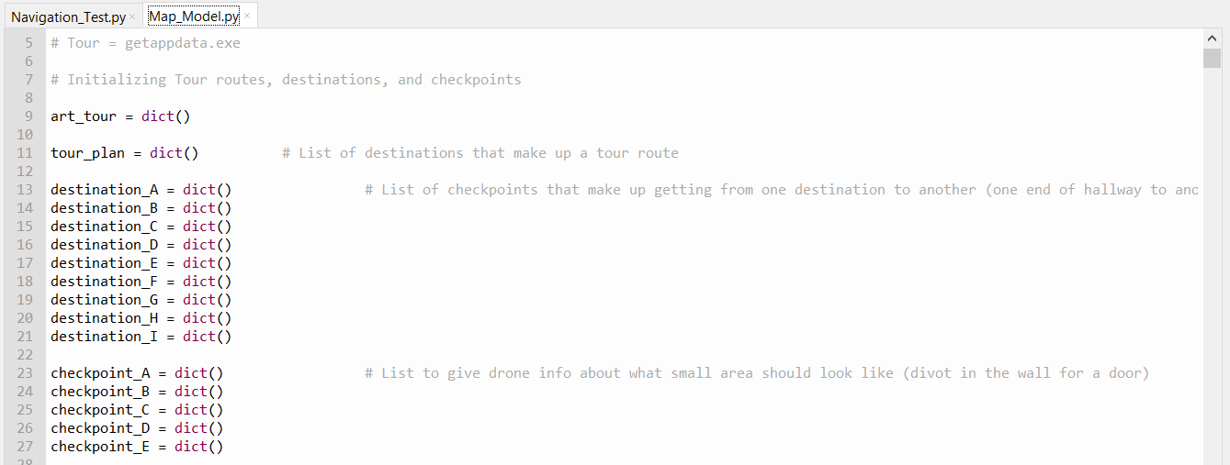

###### Figure 3: Declaring Dictionaries

In figure 4 the different attributes that go inside checkpoint and destination are shown. As you can see checkpoints are put inside unique destinations. Together any attribute of a checkpoint can be found as long as you have the tour, the destination, and the checkpoint.

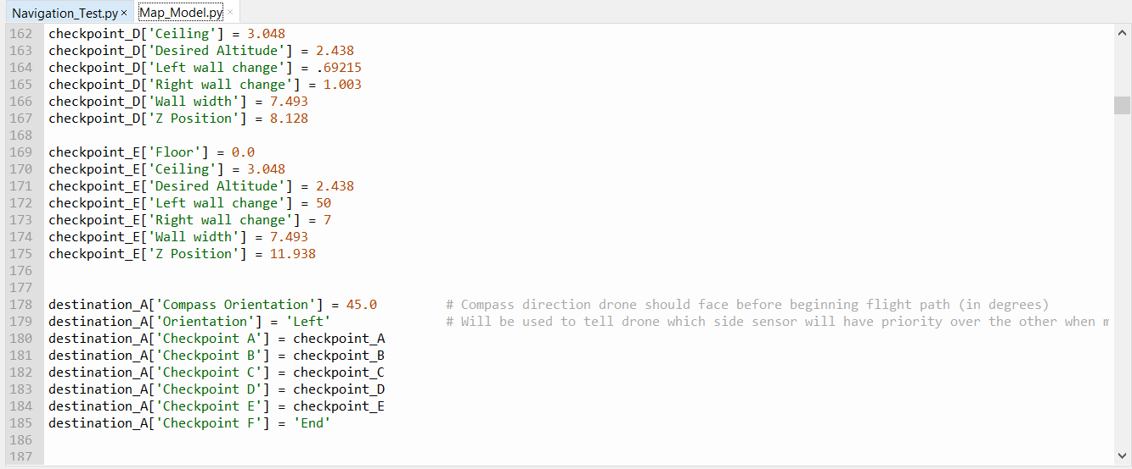

###### Figure 4: Attributes of destinations and checkpoints

#### ***3.1.2. Navigation_Test.py***

Navigation_Test.py is where the important functions associated to finding the location, determining the speeds, and changing from one destination to the next is found. Once the drone has taken off, the sensors gather data every .3 seconds. At that time the checkpoint algorithm is used, using the function named “checkpoint_checker”, to determine which checkpoint the drone is at. If a new checkpoint is found then the “current checkpoint” variable will become this new checkpoint and the drone will change it’s “guessed z position” variable to the value stated in the new checkpoint’s z position. This “guessed z position” also changes based on the z speed to keep track of the likely z position of the drone, unless a new checkpoint is found then the z position will be changed to the value stored inside the new checkpoint dictionary. This guessed z position variable is important when determining whether it is actually possible for the drone to be at the next checkpoint. Once the “checkpoint_checker” function is ran the “x_speed_chooser”, “z_speed_chooser”, and “y_speed_chooser” functions are ran. These functions take the current checkpoint and the ultrasonic sensor data in order to determine what speed each function should output to the flight controller.

# **4. Operation**

In order to show the navigation subsystem working without flying the actual drone a simulation program had to be created to imitate the walls of the building, calculate what the sensors would output, and calculate where the drone would be based on speed outputs. A GUI was also created to show where the walls are and the drone would be. When the simulation started it was assumed that the drone would be placed in an exact location. The GUI began and the simulation looked like figure 5, where the drone is the red box and the black lines are the walls.

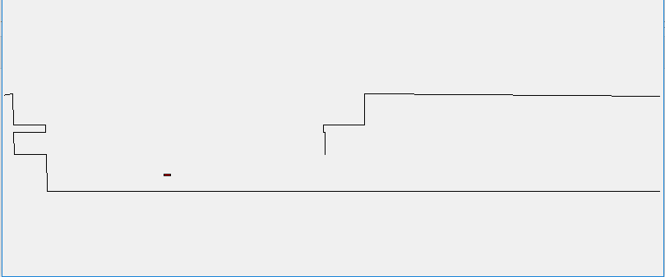

###### Figure 5: Beginning of navigation simulation

As the drone reached the first divot outward change of the left wall it changed in the correct way which was change to checkpoint B and the left sensor increased. As the drone hit the beginning of the checkpoints it changed correctly for wall checkpoints.

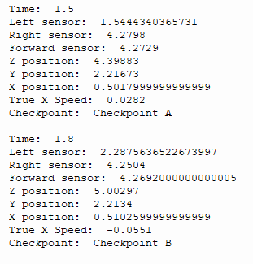

###### Figure 6: Data from transition from checkpoint A to checkpoint B

When the last checkpoint is reached, the new destination is loaded along with all of its new checkpoints. The drone’s coordinates inside the simulation were then converted as the drone changed front facing direction based on compass orientation. This can be seen in the transition between figure 7 and figure 8.

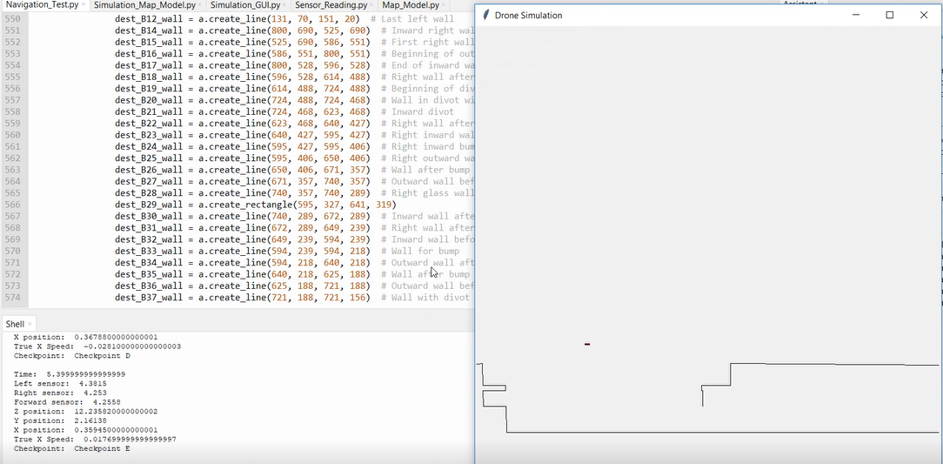

###### Figure 7: Results at the end of destination A of the art tour

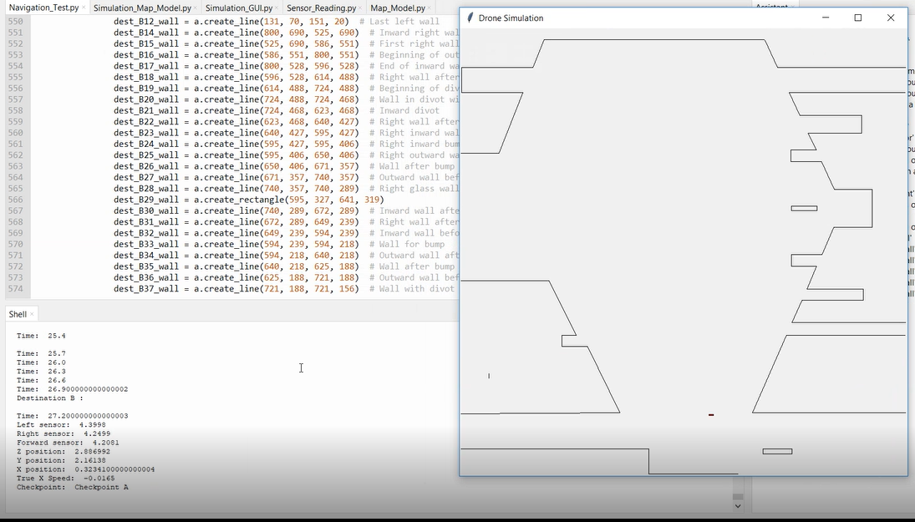

###### Figure 8: Results at the beginning of destination B of the art tour

The drone continues down the hallway in the same fashion as destination A, then it changes to destination C and returns back down the hallway. The rest of the simulation runs in this fashion going from destination to destination until the tour is over.

# **5. Data Collection**

Since this was a simulation of how a code full of algorithms that only outputted commands functioned when data was given to it, there was no real data to be found. However, when the simulation was ran 10 times, there were no checkpoints missed and the drone chose the correct z, x, and y speed for the entirety of the simulation. This is significant because the speed and sensor values were given error elements to help give the code conditions that were closer to what would actually happen. The speed value was given an random error of up to ±10% and the sensor readings were given a multiple realistic conditions. First, if the sensor reading was less than 40 cm the sensor would output a value near 40 cm as it would in a real situation, if the sensor was greater than 4.2m it would give a random value from 4.2m to 4.56m, and if the sensors were any value in between there would be a random error of up to ± 6 cm. So although there was error that attempted to emulate the actual restrictions of the drone and sensors, the code still performed its function as intended in all the simulations.

# **6. Accomplishments**

Over the course of the semester the navigations subsystem had many accomplishments. The code was able to take only the tour plan from the app and the outputs from the sensors and give correct speed commands and correct checkpoints. A simulation was also created so that future test can be ran if the code needs to be changed to account for unforeseen issues that may come up in the future. Dimensions of many parts of Zachry have been found in order to easier model different hallways in the future without having the remeasure. A GUI was also created that successfully simulated the flight path of the drone while also outputting which checkpoint the drone thought it was at. This accomplishment helped debug issues and helped visualize where the drone was in the building at any given time. A picture of the end of the tour with the output and GUI simulation is shown below in figure 9.

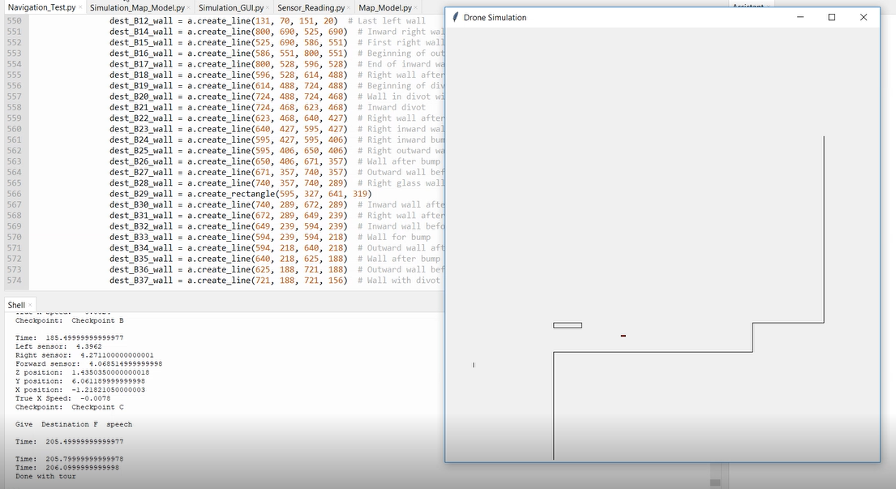

###### Figure 9: End of tour simulation result

# **7. Future Work**

Although the simulation worked there may need to be changes to some error tolerances in the future when the actual drone is used instead of a simulation with fixed error bounds. The entire tour was never fully simulated because creating a model for all of Zachry would be a very long process. This is because there is no way to find the blueprint of Zachry since that information won’t be released to the public until next year. So the only way to find the dimensions of the hallways was to hand measure it myself with a tape measure. This took me hours to do for the first floor and the very beginning of the second floor so doing all of the second and third floor became an impossible task because between measuring the walls, recording that data, and then inserting this data into the model that would take up dozens of hours. The code is also still written to coordinate with the simulation and will need to be tweaked when the actual flight controller and ultrasonics are interfacing with it.

# **8. Conclusion**

The code for navigating the drone performed very well and exceeded my own expectations. It did everything it was supposed to do in terms of figuring out where it is within the building and outputting the correct speeds based on that information. However when this code is actually used with the drone it may need slight adjustments to run as well since even though error was added to the drone speed to account for realistic cases, we don’t know how accurately the real drone will handle these speed commands. Looking forward there is still work to be done making this a working project, but I believe that this subsystem was a huge success this semester. Looking back at choosing this project I believe that it is a lot for four undergraduate students to handle. This was an important lesson in learning just how much work, time, and brain power any real engineering project requires to become a success. Flying a drone autonomously with no GPS is a massive task in itself, and asking it to also lead a crowd, and get to each destination in a timely manner is massive undertaking.

**Zach Drone**

Jonah Morris

###### **Drone Subsystem**

REVISION – 1.2

5 December 2018

# **Table of Contents**

**Table of Contents 103**

**List of Tables 104**

**List of Figures 104**

**1. Introduction 105**

**2. Theory 105**

2.1. Drone 105

2.2. Ultrasonic Sensors 105

**3. Design 105**

3.1. Power Connections 105

3.2. Ultrasonic Sensors 106

3.3. Flight Time 107

3.4. Raspberry Pi to Pixhawk Connection 107

**4. Operation 108**

4.1. Ultrasonic Sensors 108

4.2. Power Connections 108

4.3. Raspberry Pi to Pixhawk Connection 109

**5. Data Collection 109**

5.1. Ultrasonic Sensors 109

**6. Accomplishments 111**

**7. Future Work 111**

**8. Conclusion 111**

# **List of Figures**

**Figure 1 - Power Connection Diagram 106**

**Figure 2 - Ultrasonic to Raspberry Pi Connections 107**

**Figure 3 - Pixhawk to Raspberry Pi Connection 108**

# 

# **List of Tables**

**Table 1 - Single Ultrasonic Sensor Characteristic Data 109**

**Table 2 - Multiple Ultrasonic Sensor Test 110**

# **1. Introduction**

The Zach drone tour will need a functioning drone to implement a tour. The drone subsystem consists of all the of the hardware aspects of this project. This subsystem includes the drone frame, battery, power converter, motors, electric speed converters, propellers, Pixhawk, Raspberry Pi and ultrasonic sensors.

# **2. Theory**

The scope of this subsystem is to provide all of the hardware aspects of the project needed by the other subsystems. There are essentially two subsystems of this subsystem, the ultrasonic sensors and the drone.

## ***2.1. Drone***

Our drone uses a battery that is connected to a power distributor that supplies the motor ESCs, Pixhawk and Raspberry Pi with power. When powered on the Raspberry Pi controls the Pixhawk using the MAVlink protocol over serial connection giving it the direction and speed to move. The Pixhawk will then tell the electronic speed converters (ESC) how much trust to give the motors.

## ***2.2. Ultrasonic Sensors***

There are six ultrasonic sensors connected to the Raspberry Pi via GPIO pins. These sensors send out ultrasonic sound and measure the time it takes to receive the sound back. It then converts that time into a high voltage pulse that is high for 1 µs per 1 mm to the nearest detectable object is. This data is used by the navigation subsystem to determine where the drone is inside of the building based on a model.

# **3. Design**

## ***3.1. Power Connections***

A single four cell Lipo battery will power the entire drone and all microcontrollers. The drone uses a TATTU 8000mAh lipo battery plugged into a PDB-XT60 power regulator through the Pixhawk’s own power converter connection. The motor electronic speed converters are powered from the ESC tabs and the Raspberry Pi is powered from the 5V tab on the PDB-XT60. The six ultrasonic sensors are powered from the Raspberry Pi’s 5V pin. Voltage and current flow is shown in the following figure.



###### Fig. 1: Power connections of the drone subsystem with maximum voltage and current ratings

## ***3.2. Ultrasonic Sensors***

Ultrasonic sensors are used to detect the drones distance from nearby objects. The drone uses six Maxbotix HRLV-EZ0 ultrasonic rangefinders connected to the Raspberry Pi to determine the distance to the nearest object. These sensors are rated for distances of 30 cm to 5m. The Raspberry Pi uses these sensors in a trigger then receive relationship allowing for readings to only be requested when they are needed by the navigation subsystem. Ultrasonics sensor were chosen over infrared sensors because many walls inside of Zachry are glass which does not reflect infrared well. The following figure displays the connections made between the Raspberry Pi and ultrasonic sensors.

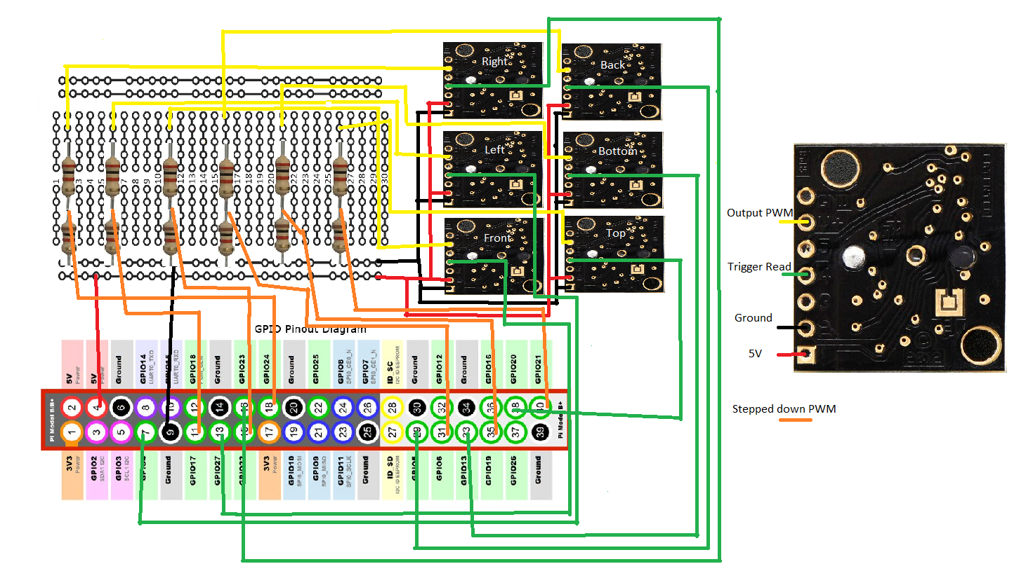

###### Fig. 2: Connections between raspberry pi GPIO pins and ultrasonic sensors.

The Raspberry Pi gathers ranging data by sending a 25us pulse to the trigger pin and waits for a PWM signal from the output pin. This signal is stepped down using a resistor divider to match the 3.3V GPIO input voltage. The signal output is 1us long per 1 mm distance sensed.

## ***3.3. Flight Time***

We would like our flight time of the drone to be as long as possible to allow for longer tours. To calculate our estimated time of flight we used the following formula:

$Flight time (t)=\frac{Battery Capacity * Discharge}{Weight * Light Power }*Voltage$

The combined weight of all components is 1.5kg. The calculated estimated time of flight is 22.3 minutes. We limit the time of tours to be 15 minutes so that the drone has time to fly back to the starting position before it’s battery life fails.

## ***3.4. Raspberry Pi to Pixhawk Connection***

The Raspberry Pi tells the Pixhawk which direction to fly and how fast whereas the Pixhawk sends information to the Raspberry Pi about the orientation of the drone and its altitude. This is done by using a serial connection as show in the following figure.

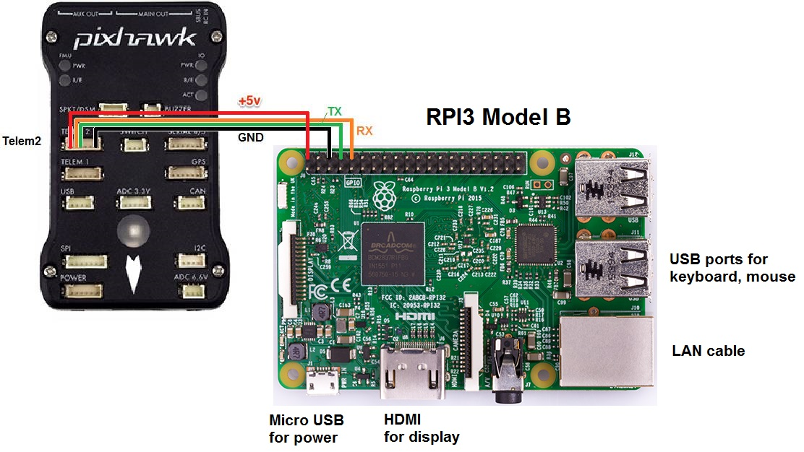

###### Fig. 3: Pixhawk to Raspberry Pi serial connection

This connection in conjunction with Dronekit and GUIDED_NOGPS flight mode will be used give directional commands to the drone for takeoff and flight.

# **4. Operation**

## 4.1. Ultrasonic Sensors

The ultrasonic sensors were validated by first connecting one sensor to the Raspberry Pi and placing an object at incremental distances from the sensor and reading the outputs. The sensor proved to be within 5 centimeters of the expected value for up to 4.3 meters. Next, the six sensors were attached to the drone and connected to the Raspberry Pi. They were tested by placing the drone in the center of a room and placing objects around the drone and testing the Raspberry Pi output to the actual distance. Further testing of the six ultrasonic sensor during flight needs to be conducted.

## ***4.2. Power connections***

The power connections were tested by attaching all components to the drone and turning them all on using only the battery. The functionality of the Raspberry Pi to Pixhawk connection and ultrasonic sensors were tested again while the battery powered the system. Further testing of the battery life under load of the motors still needs to be tested and quantified.

## 4.3. Raspberry Pi to Pixhawk Connection

The connection between the Raspberry Pi and Pixhawk was validated by sending flight commands to the Pixhawk through the Raspberry Pi terminal. Changing flight modes and arming the throttle were both tested and validated. Further testing of Guided_NOGPS flight commands to control the drone still need to be simulated and tested.

# **5. Data Collection**

***5.1. Ultrasonic Sensors***

To characterize typical accuracy of the ultrasonic sensors I tested one sensor by placing it at the end of an empty table and placing a small box in front of it and taking many distance reading at different distances. Below is an excel sheet showing the average distance sensed, the width of the beam at that distance and the standard deviation.

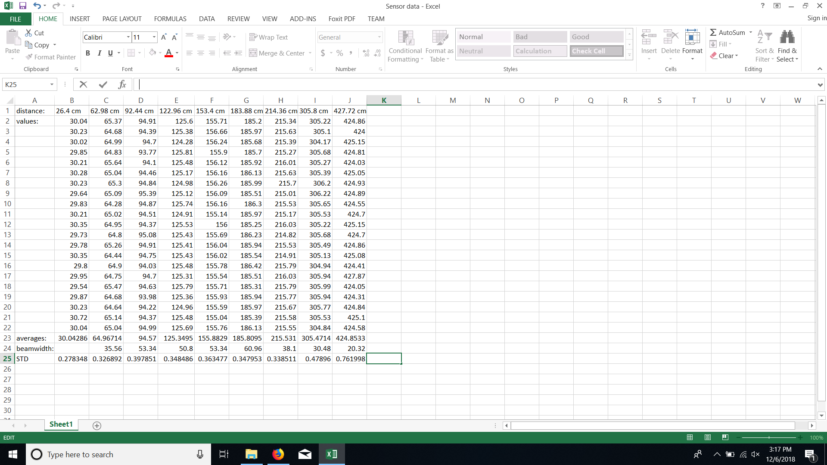

###### Table 1: Characteristics of the Maxbotix HRLV-EZO ultrasonic sensors.

Included in the data is the measured distance using a tape measure, the values output from the ultrasonic sensor 20 times, the averages, the beamwidth and the standard deviation. This data helped characterize the sensors and gave the navigation subsystem more guidelines as to how accurate its distance reading are going to be.

After attaching and connecting all six ultrasonic sensors I ran 8 tests with objects at different distance in the four x and y directions and compared them to expected results. The following table contains the list of the tests, the results and the results were within 5 cm accuracy.

|  |  |  |
| --- | --- | --- |
| Measure Distances | Distance Results | Within 5cm? |
| L = 120cm  R = 120cm  F = 120cm  B = 120cm | L = 118.4cm  R = 120.5cm  F = 119.4cm  B = 120.1cm | Yes |
| L = 180cm  R = 180cm  F = 180cm  B = 180cm | L = 178.7cm  R = 181.3cm  F = 180.9cm  B = 179.1cm | Yes |
| L = 250cm  R = 250cm  F = 250cm  B = 250cm | L = 250.1cm  R = 247.6cm  F = 250.2cm  B = 248.5cm | Yes |
| L = 400cm  R = 400cm  F = 400cm  B = 400cm | L = 404.4cm  R = 402.1cm  F = 401.6cm  B = 402.4cm | Yes |
| L = 60cm  R = 60cm  F = 150cm  B = 150cm | L = 59.3cm  R = 60.3cm  F = 58.8cm  B = 59.1cm | Yes |
| L = 20cm  R = 20cm  F = 20cm  B = 20cm | L = 30.1cm  R = 30.4cm  F = 30.2cm  B = 30.2cm | No, Range must be greater than 30cm |
| L = 200cm  R = 250cm  F = 120cm  B = 180cm | L = 199.2cm  R = 251.1cm  F = 117.3cm  B = 178.7cm | Yes |
| L = 90cm  R = 90cm  F = 60cm  B = 60cm | L = 87.4cm  R = 88.6cm  F = 58.7cm  B = 156.4cm | Yes |

###### Table 2: This table shows the rangefinding data for four sensors placed on the drone.

# **6. Accomplishments**

This semester I was successfully able to create all power connection and communication connections for the drone to be able to control its flight using the ultrasonic sensors, gyroscope and compass on the Pixhawk. I tested and validated that all of the work that I accomplished on this subsystem was functional to the specification outlined in the CONOPS, FSR and ICD. I also wrote sample flight code code but was unable to test and validate this semester.

# **7. Future Work**

Simulation and testing of actual flight without GPS will need to be conducted before any further work on navigation can be done. I will be working over the break to simulate flight with GUIDED_NOGPS mode so that at the start of next semester we can get the drone through some test flights. Further testing of the sensors will need to be conducted during flight to ensure that the propellers do not affect the accuracy of the sensors.

# **8. Conclusion**

Creating this subsystem put into perspective the amount of work that goes into designing, testing and documenting a full project. This being my first time working with drones I did not know how difficult it would be to simulate and fly the drone without GPS. In hindsight I should have focused more on getting a working simulation and flight test for no gps flight before working on the sensors. Through working on this subsystem I learned the values of planning ahead and being thorough with research and design so that implementation comes more smoothly. I look forward to next semester where we will integrate our subsystems.